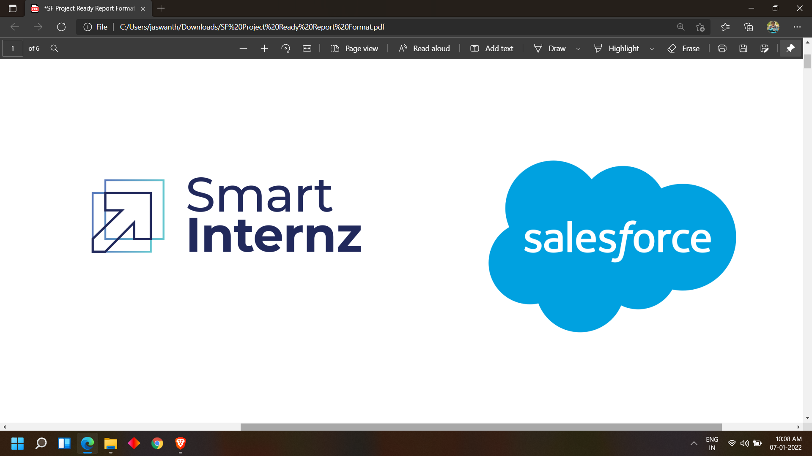

**SALESFORCE PROJECT READY**

**ENTRY LEVEL TRAINING AND PROFESSIONAL DEVELOPMENT**

**PROGRAM**

**PROJECT TITLE: COLLEGE APPLICATION MANAGEMENT**

**DAY 1:**

**Topic: Milestone / Activities:** Intro to Salesforce, Cloud Computing, Trail head Carr er Fair

**Detailed Description:**

**Ram-ya Mam** started the program of Salesforce Project ready and introduce the program and tells what this program is and introduce **Ms. Renita Ferreira** and **Mr. Nitin Jain** to us. Over 230 students join the program.

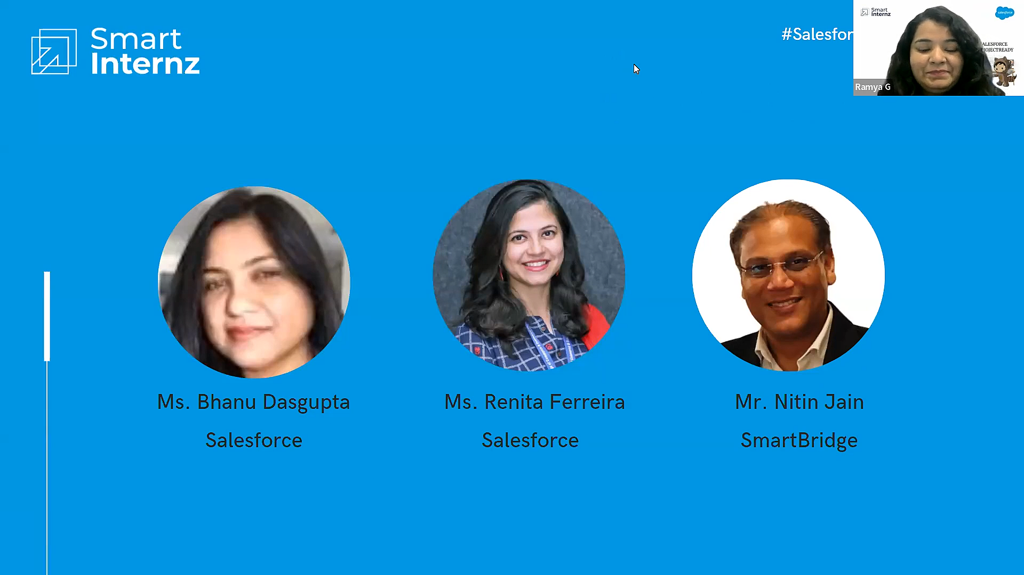

Later Renita Mam tells us the opportunities which are usable for us and the benefits of completing this project

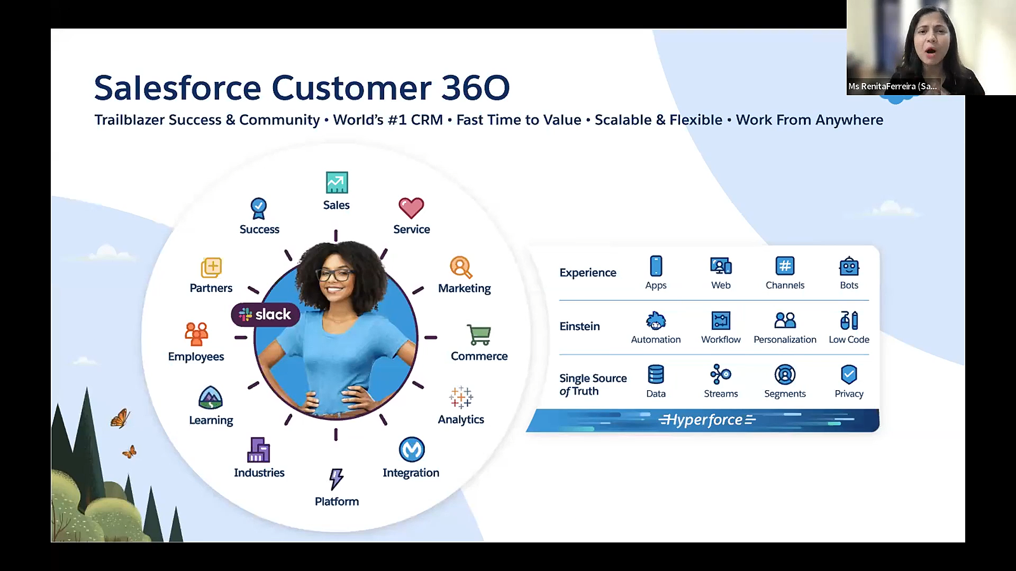

Later after Mr. Vinay help us to login in Smartinternz website by given credentials and explain

each and every element in the website

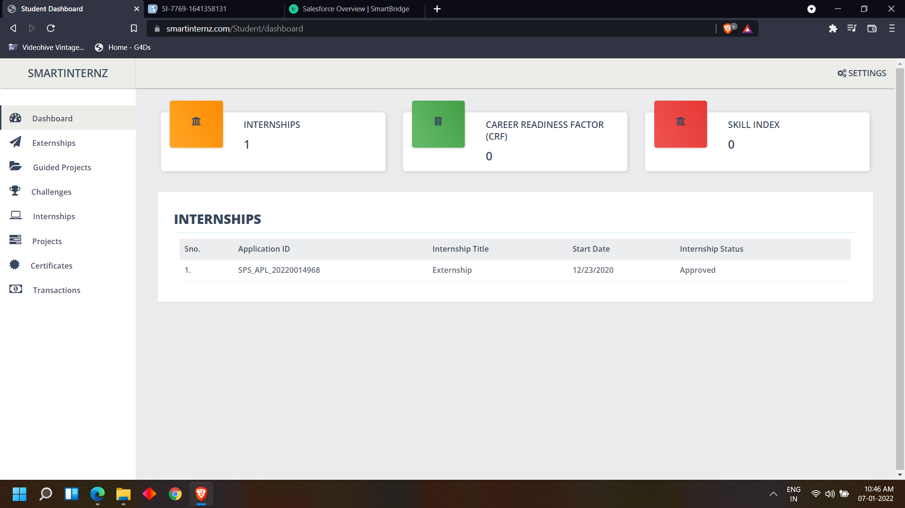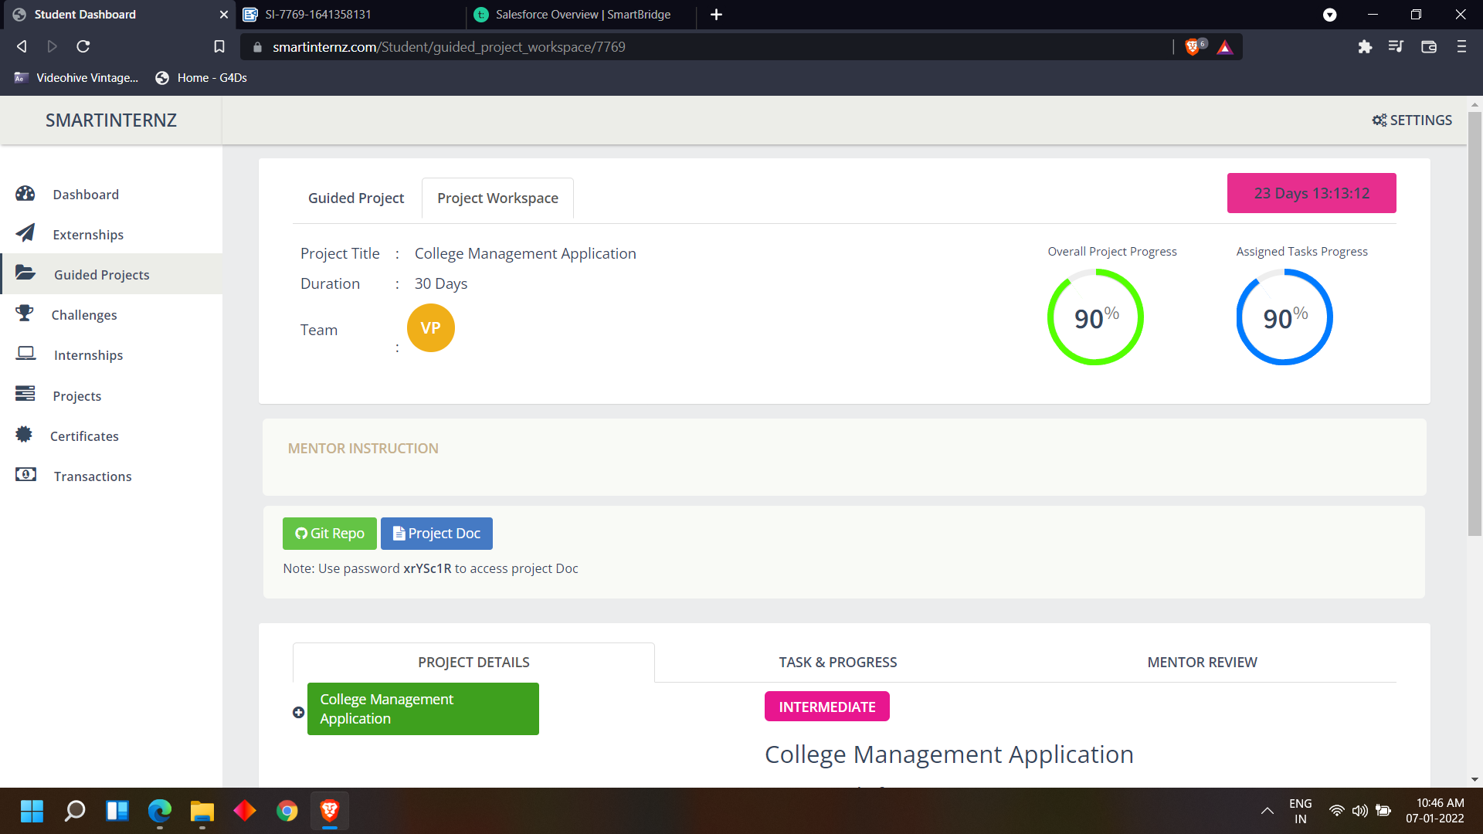Later Mr. Tushar started the class by starting the introduction of Cloud Computing

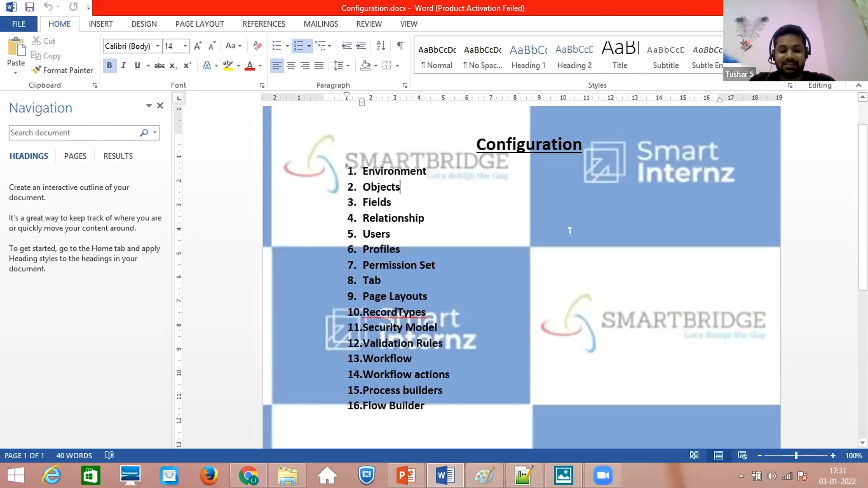

What is Salesforce?

Salesforce is a CRM Platform

Why Salesforce?

We have so many CRM Platforms in the market but Salesforce is best of them because

salesforce provides us some functionalities which helps us our work to be easy

1.Scalability

2.Customization

3.Security

4.With best Features for market and salespersons

5.Cheaper

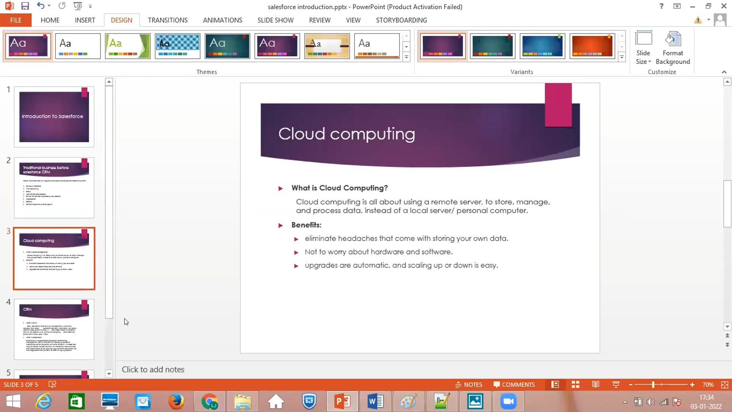

**Create Your Salesforce Developer Organization To Get Started**

Creating a developer org in salesforce.

1. Go to [developers.salesforce.com/](https://developer.salesforce.com/)
2. Click on sign up.
3. On the sign up form, enter the following details :
   1. First name & Last name
   2. Email
   3. Role : Developer
   4. Company : College Name
   5. County : India
   6. Postal Code : pin code
   7. Username : should be a combine of your name and company

This need not be an actual email id, you can give anything in the format :

[username@system.com](mailto:username@organization.com)

Login into Trail head with salesforce account

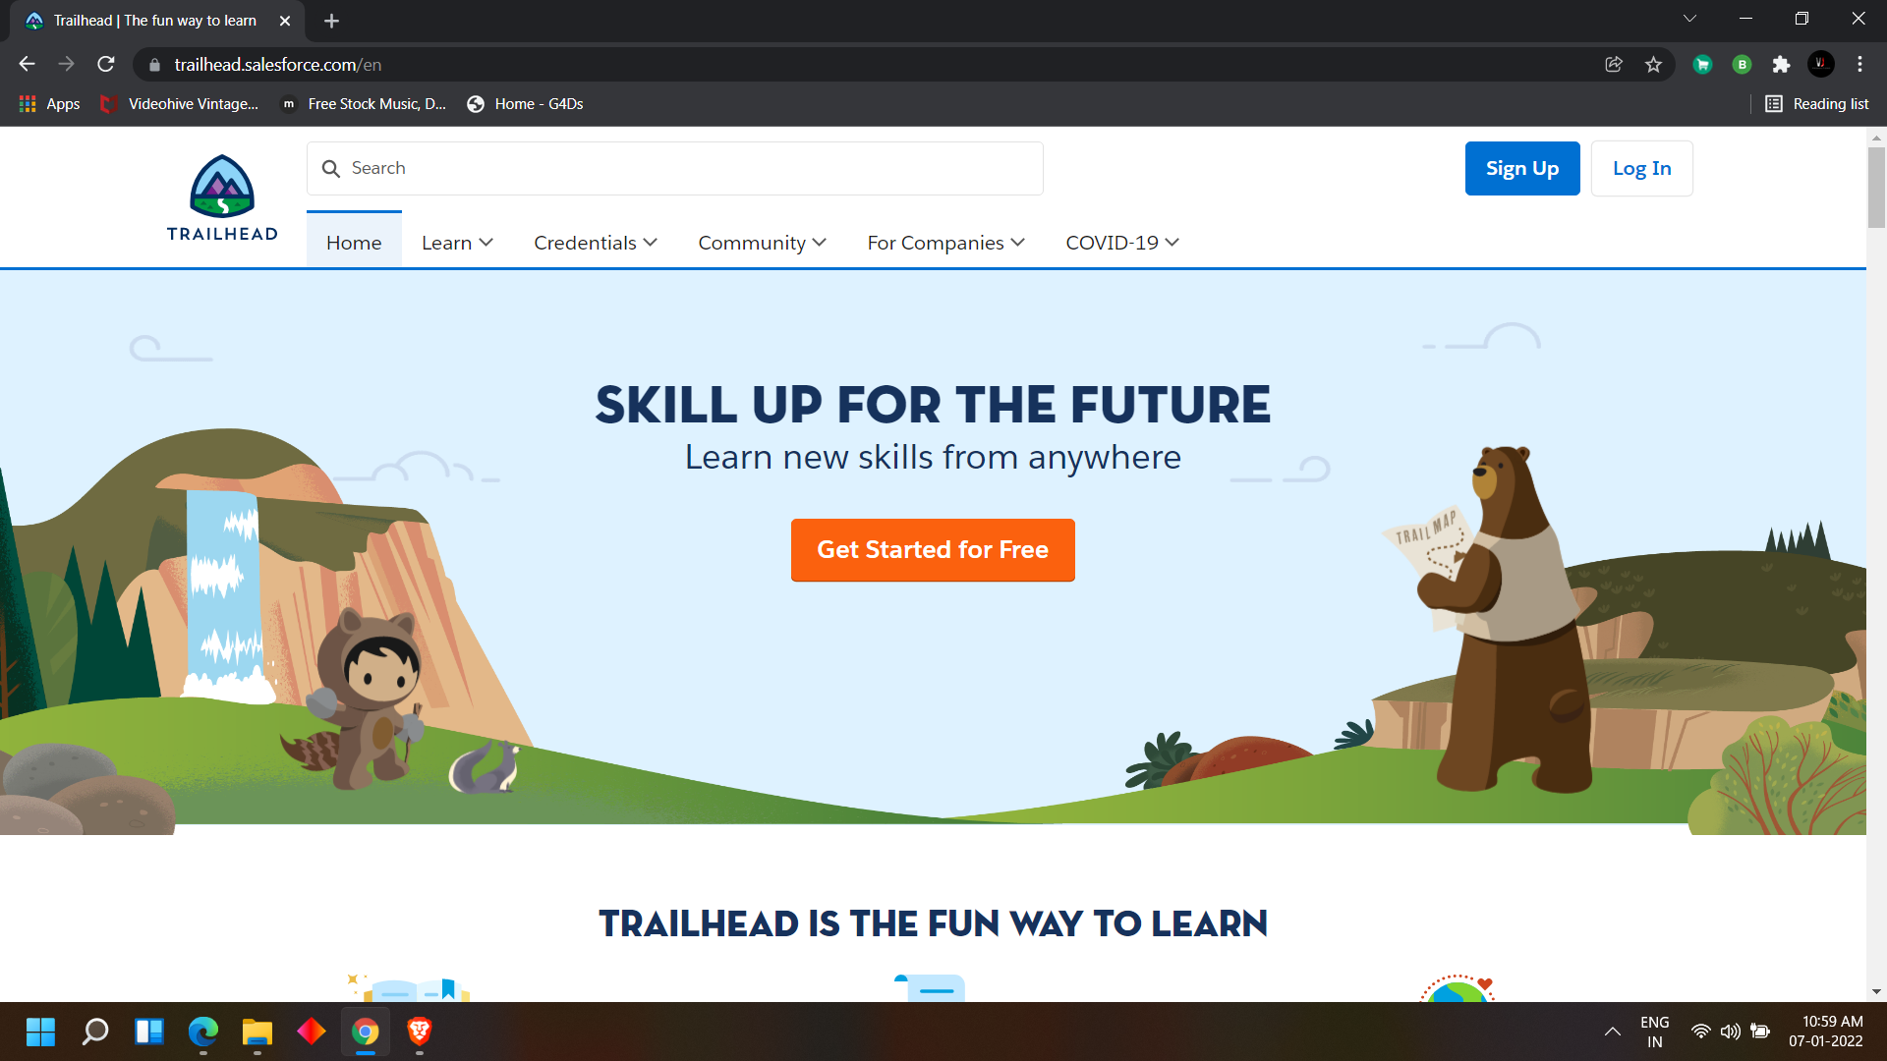

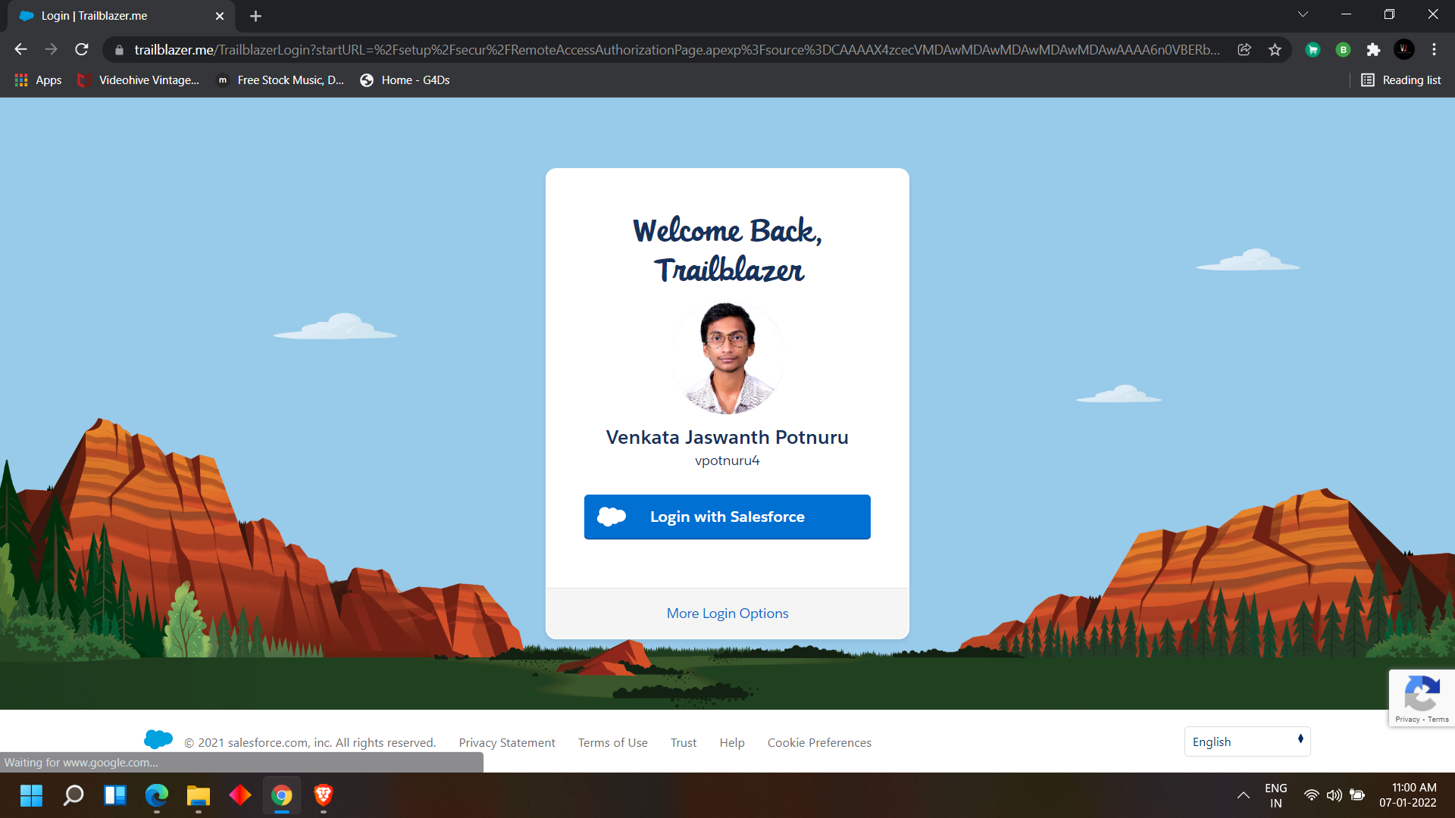

Login To Your Salesforce Account

1.Go to salesforce.com and click on login.

2.Enter the username and password that you just created.

3.After login this is the home page which you will see.

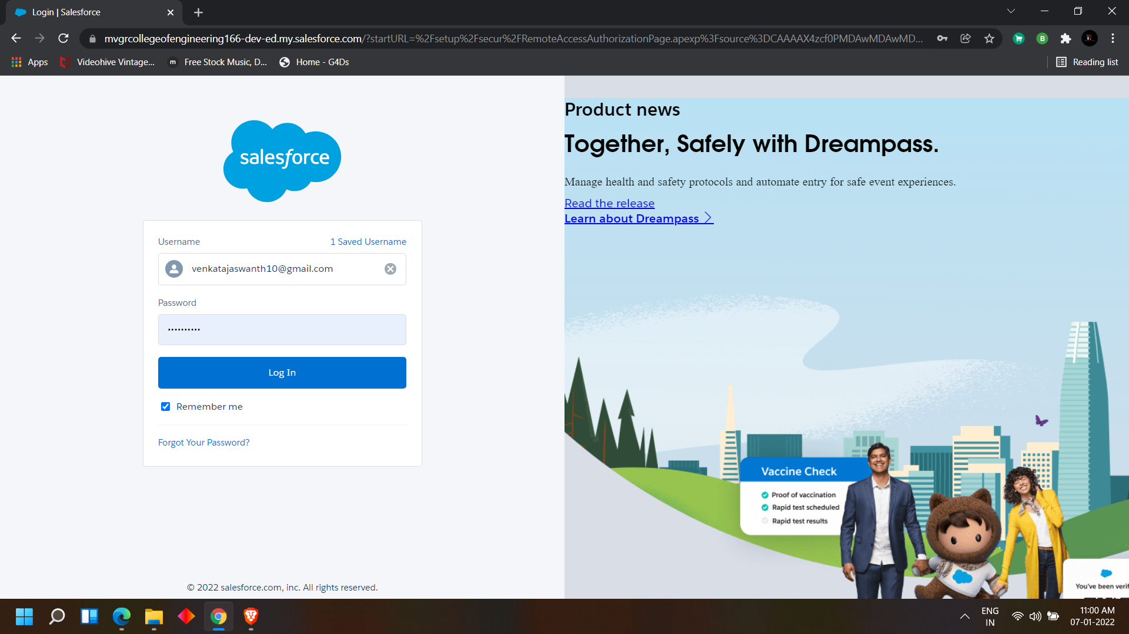

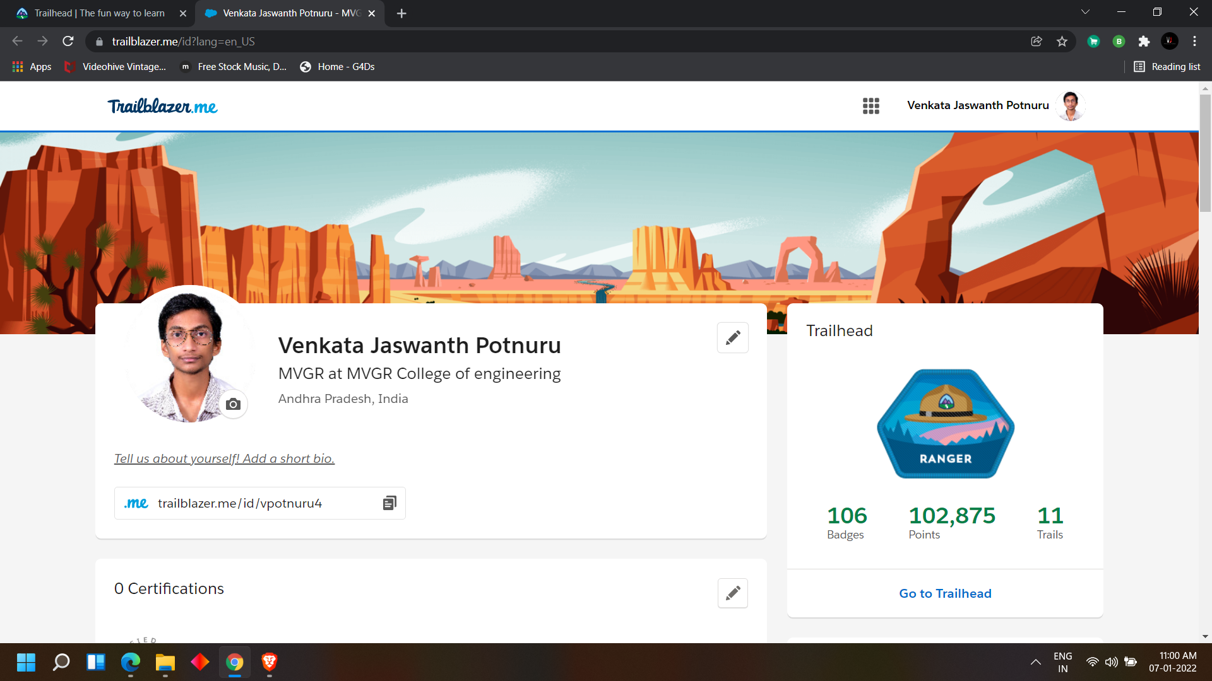

**DAY 2:**

**Topic: Milestone / Activities:** Creating Objects, and creating tabs

**Detailed Description:**

#### Custom Object Creation:

1. College
2. Application Form
3. Students
4. Subjects

To create an object click on the gear button > click on set up

There you can find the object manager > create > custom object

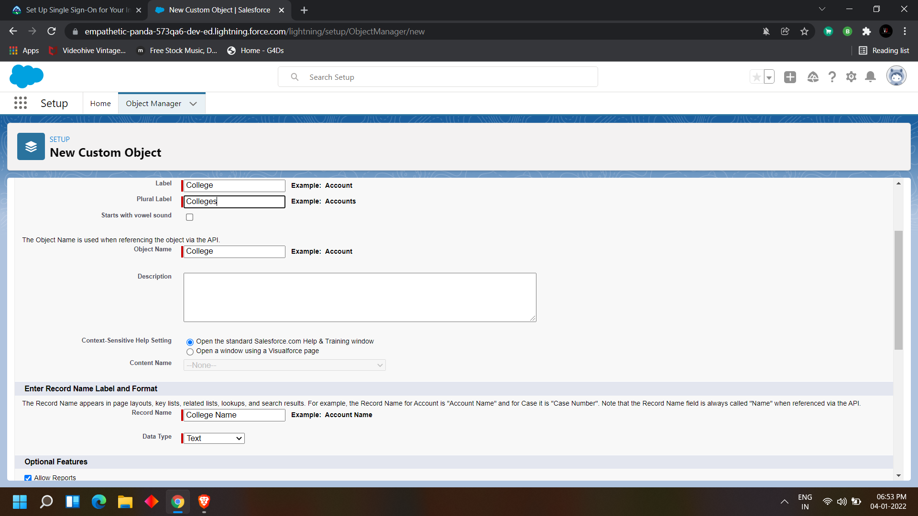

College object:

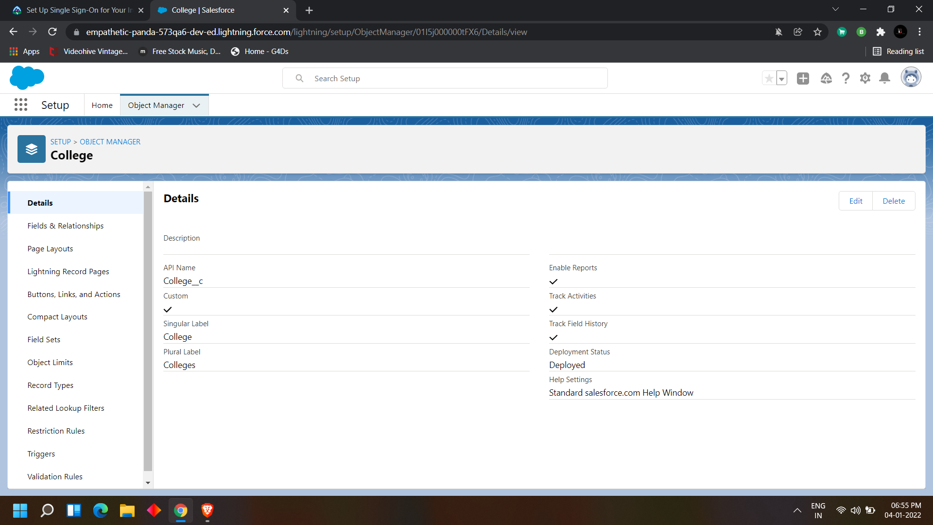

Application Form:

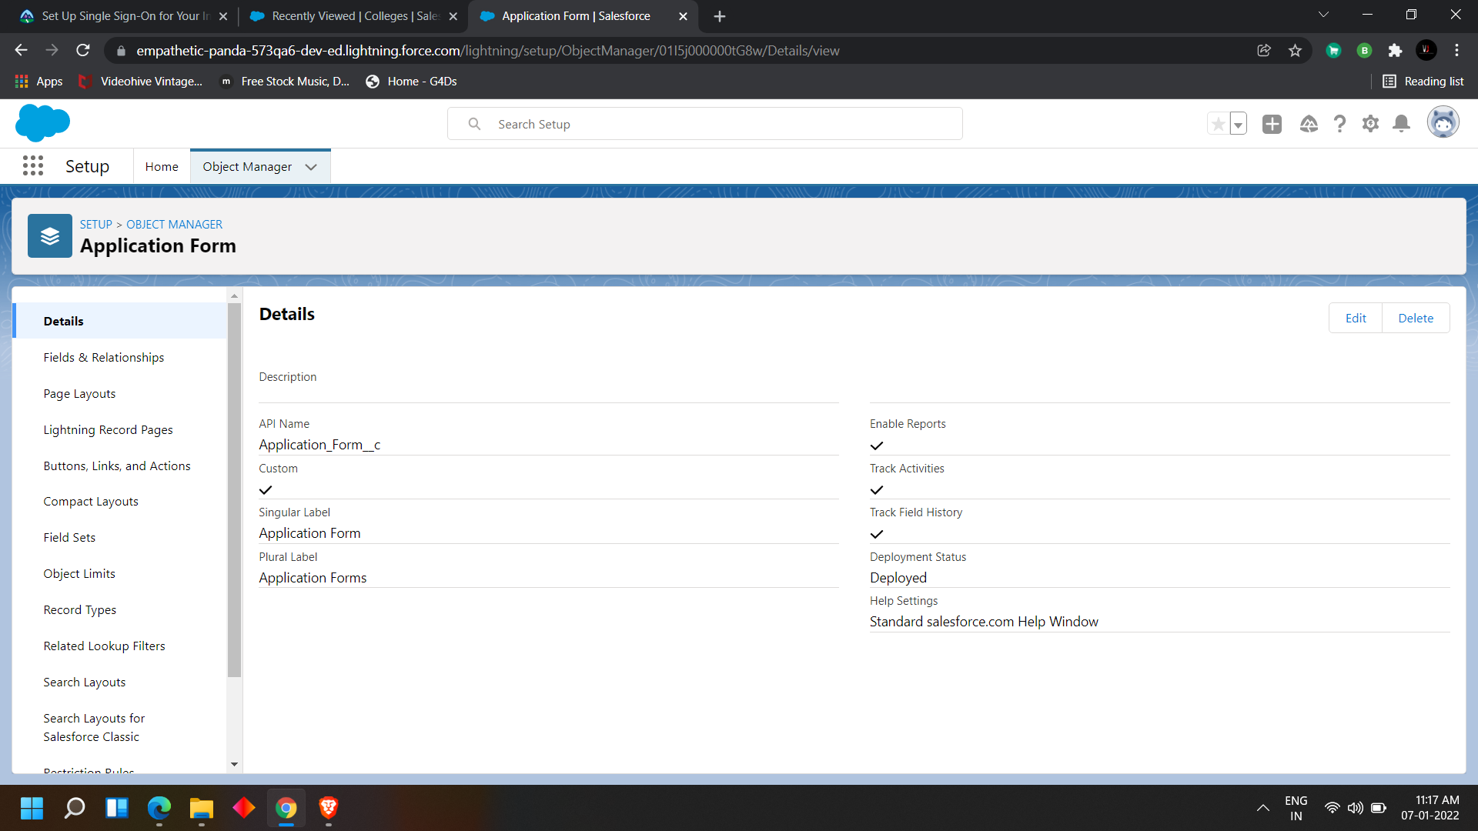

Students:

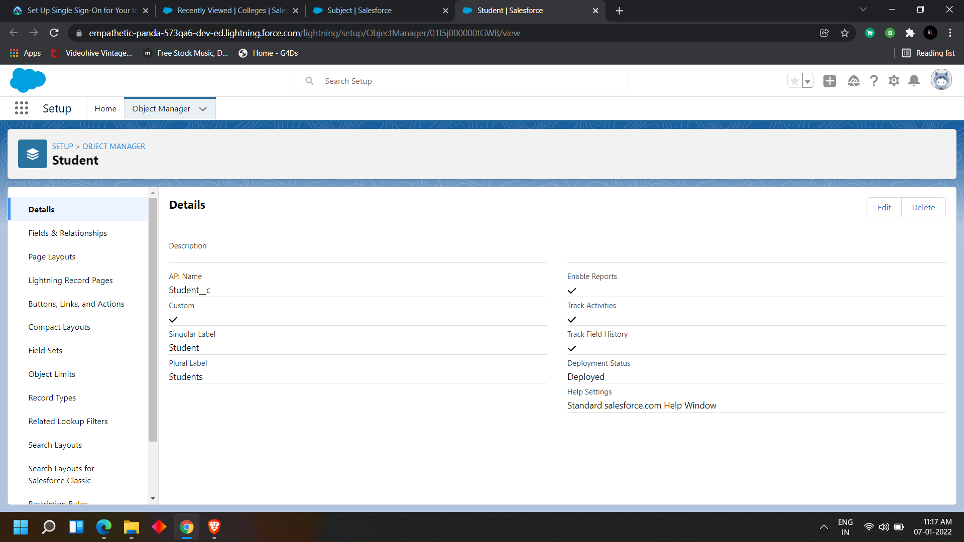

Subjects:

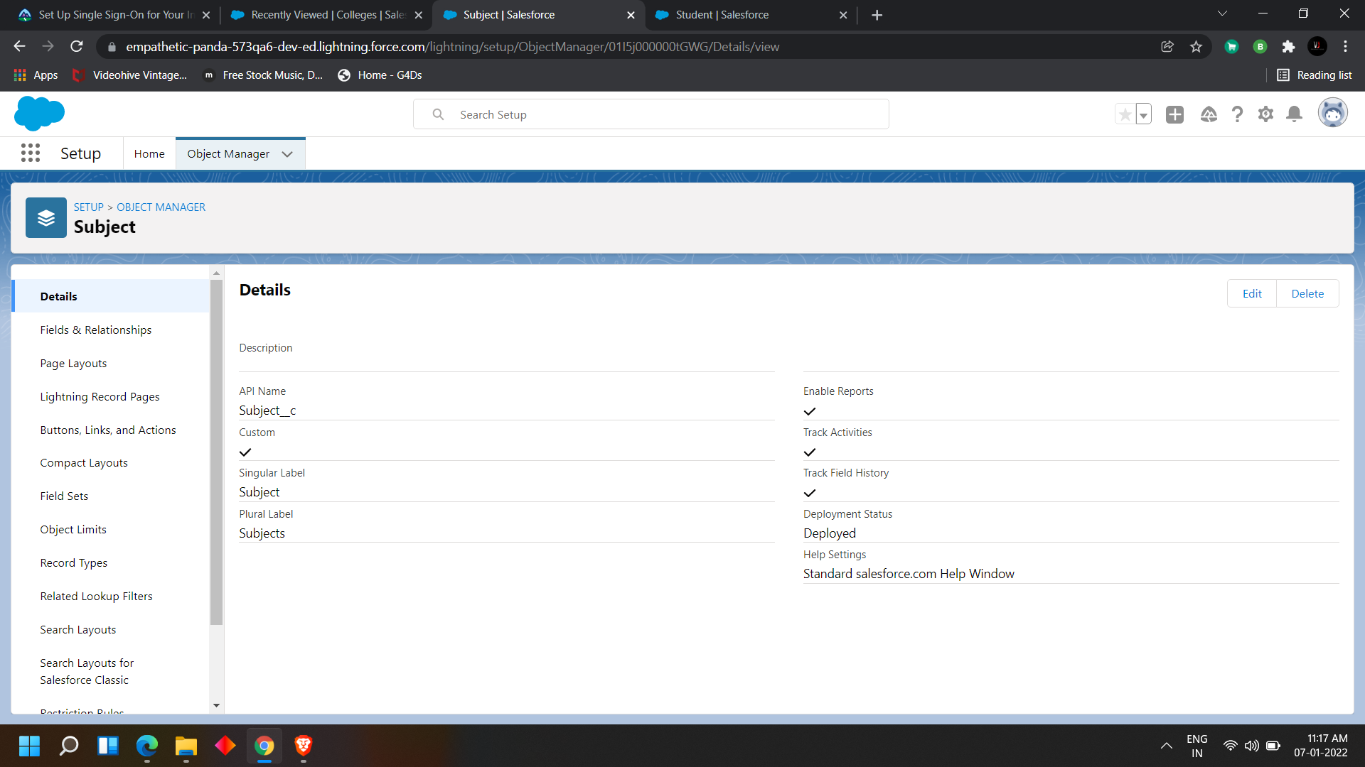

## 

## Now creating Tabs to the objects which we have created

click on the gear button> there we can find the quick find box >

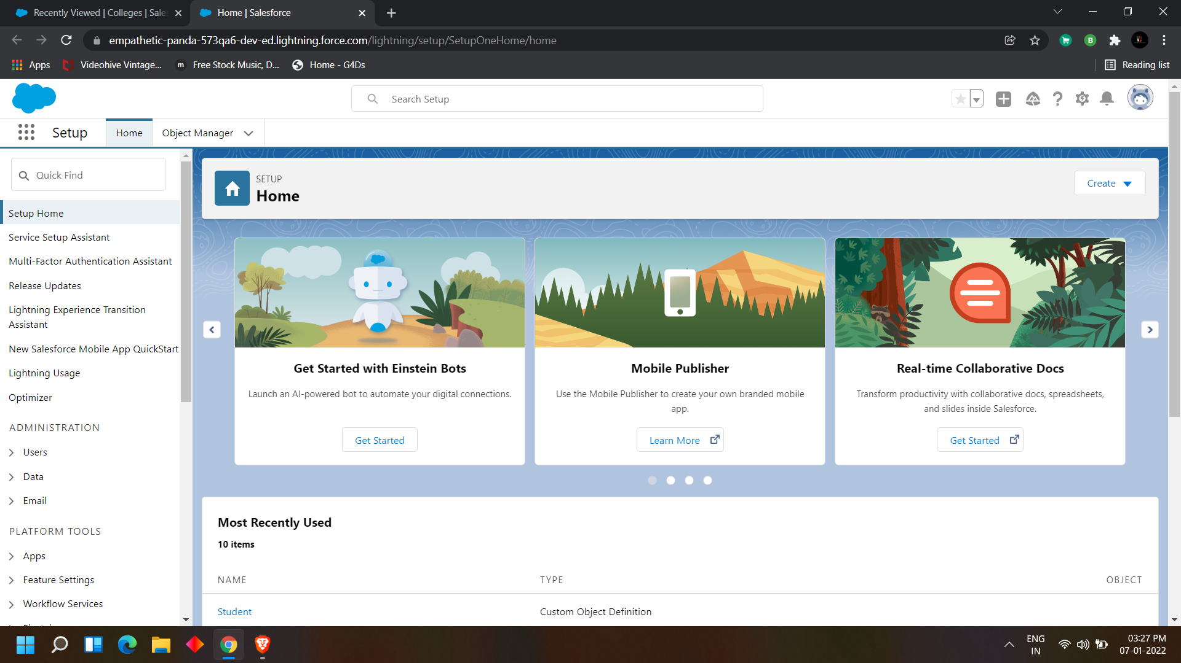

search for tabs> click on tabs

here in tabs we can find different types like:

* Custom Object Tabs
* Visual force Tabs
* Lightning Componenet Tabs
* Lightning Page Tabs

we need to create in Custom Object Tabs becaus ewe have created custom objects for the app manager

|  |
| --- |
|  |

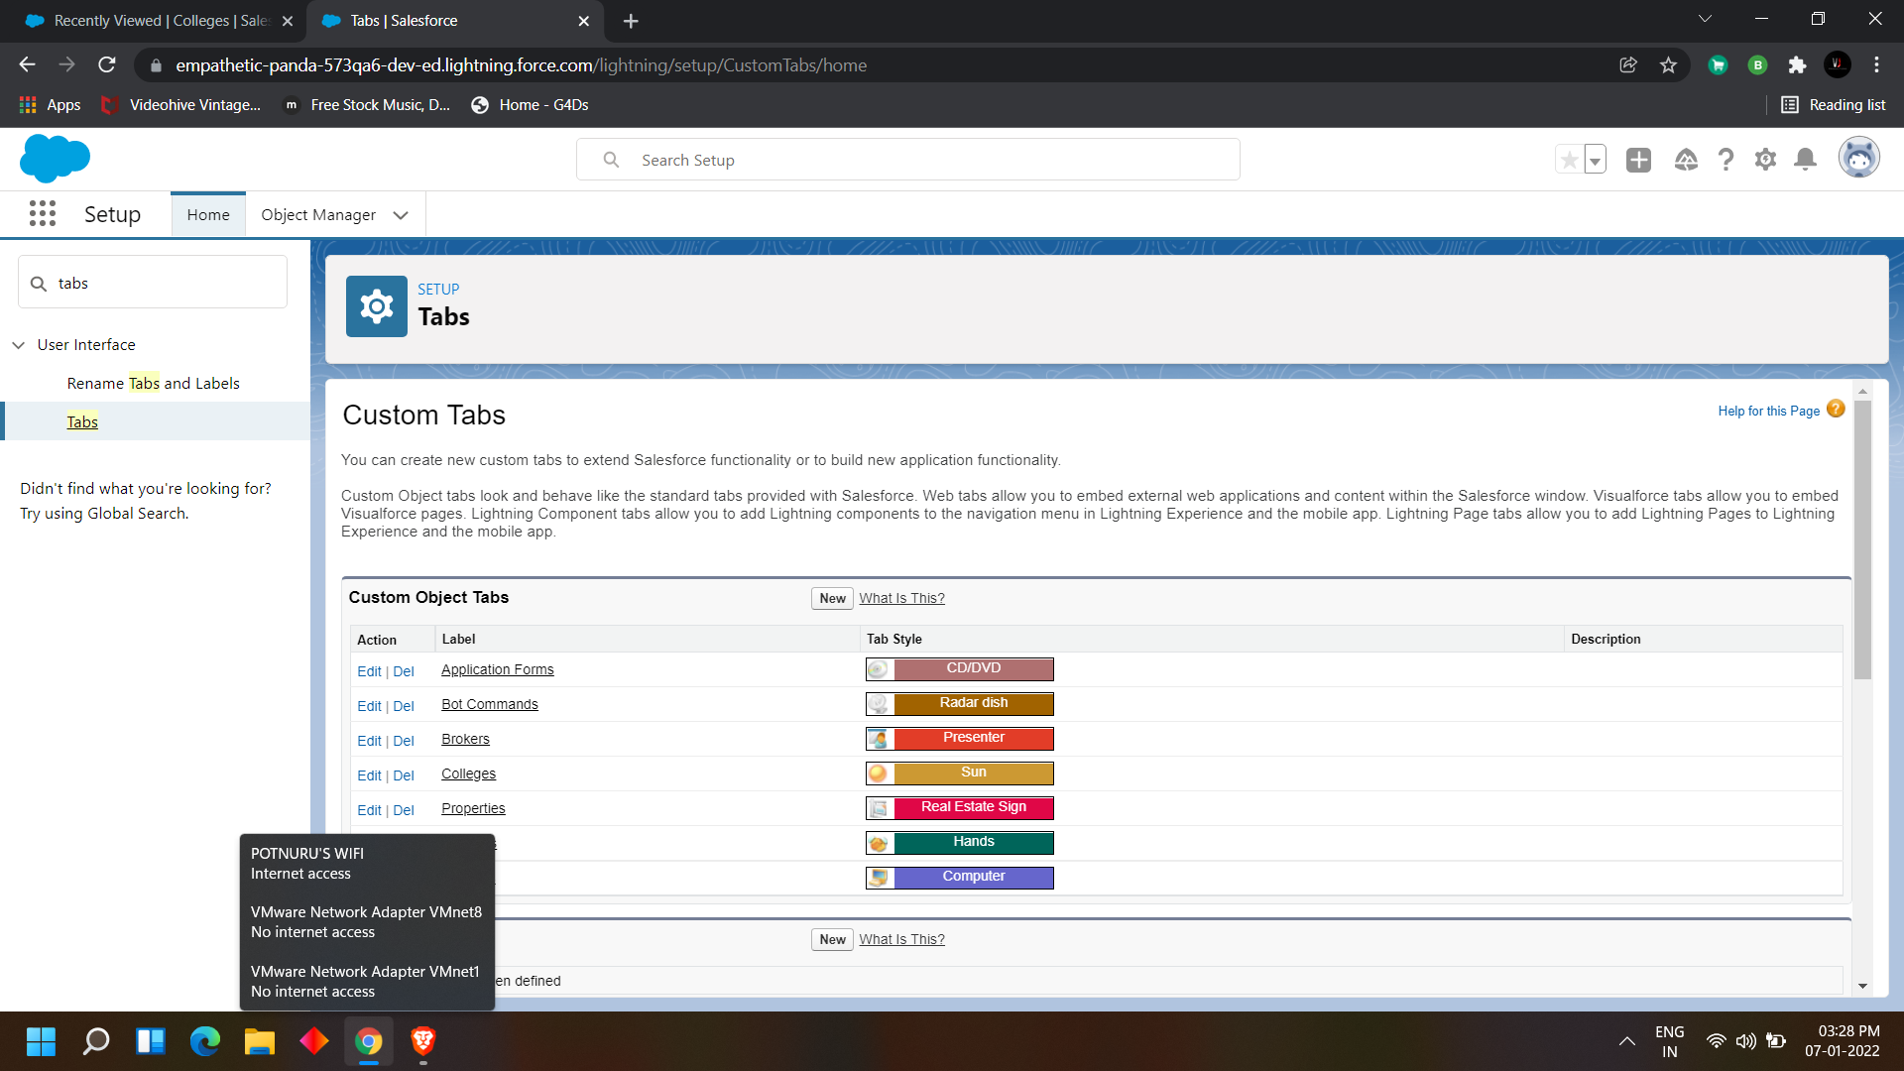

we need to create a new tab so click on new in custom object tabs> select the object form the

given list>select a icon for the object >

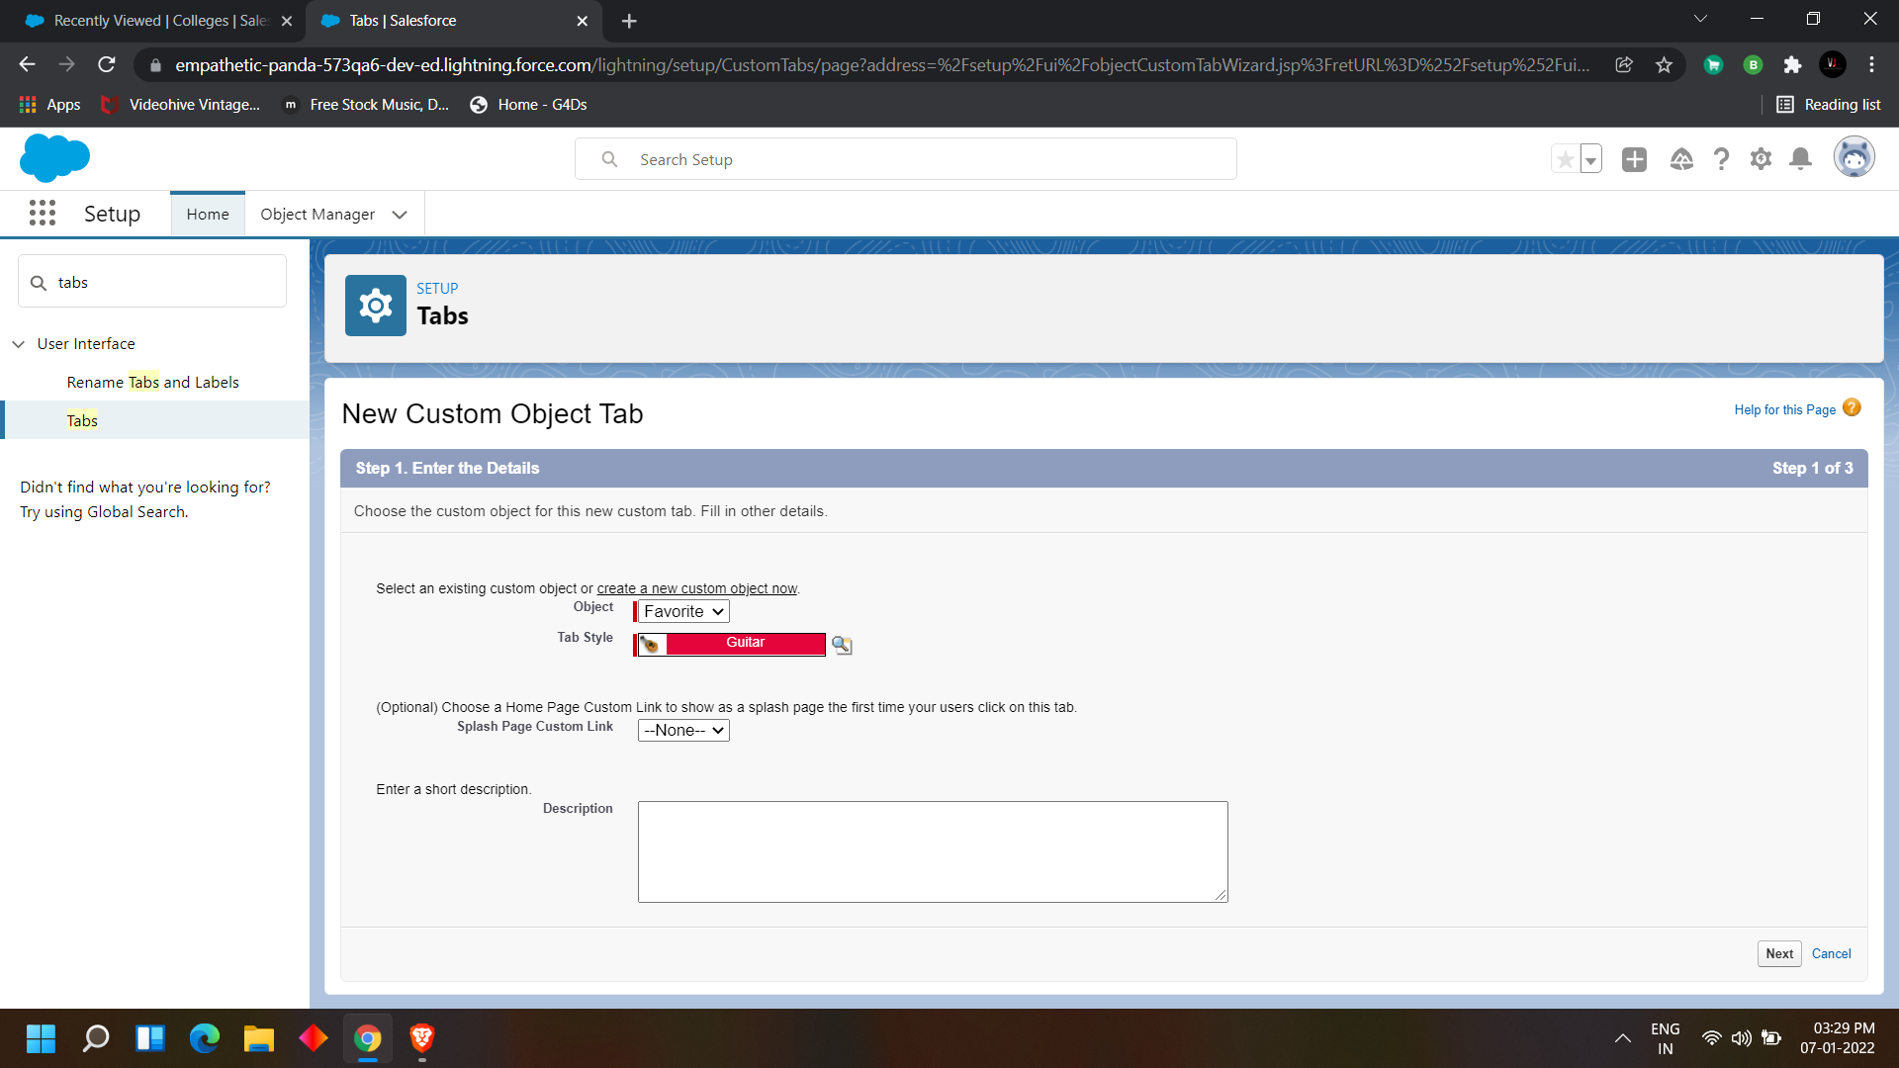

click next> next> save

In the same way create tabs for all the 4 objects ( College, Application form, Students and Subjects)

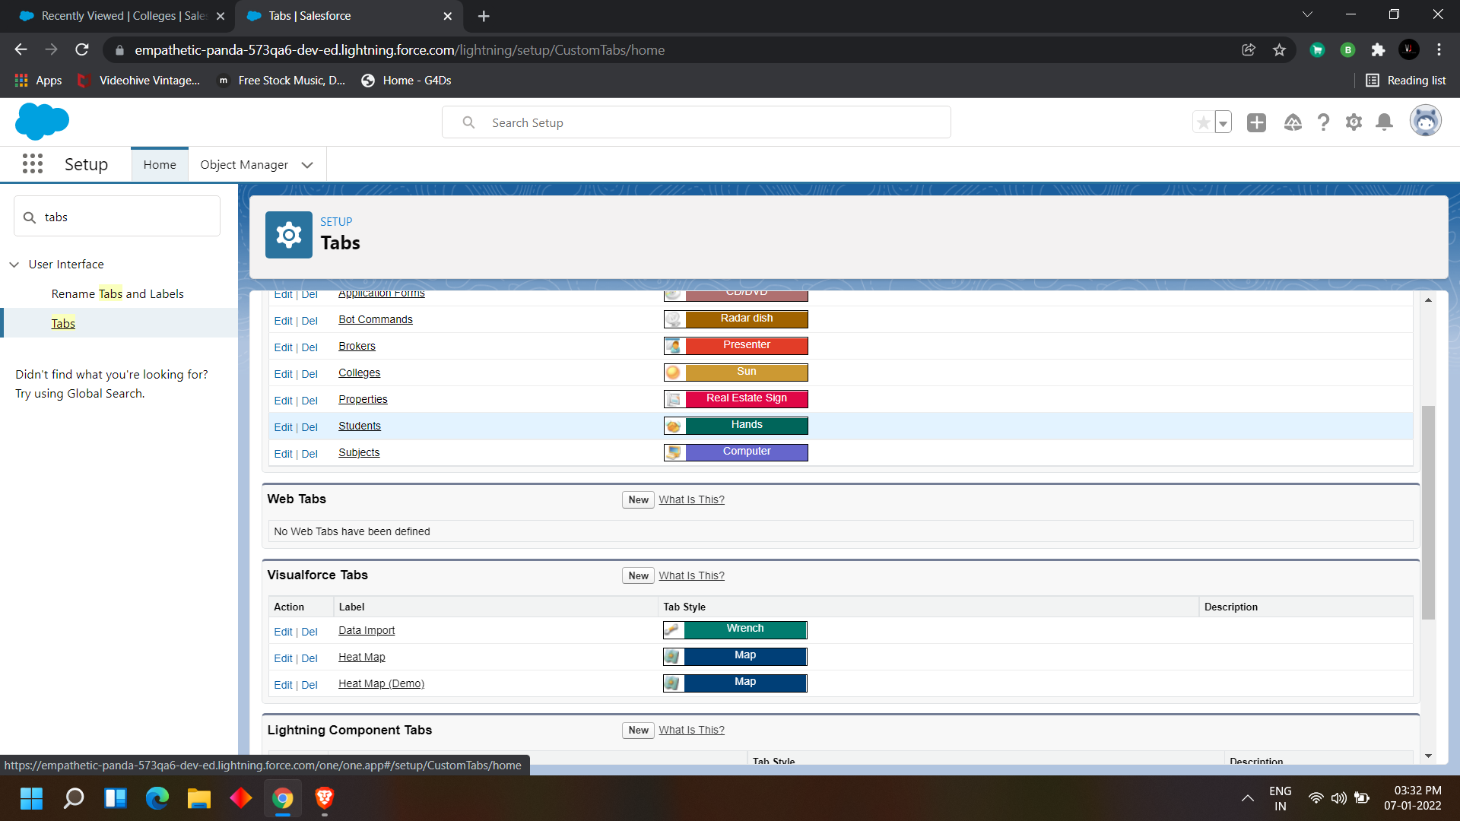

**DAY 3:**

**Topic: Milestone / Activities:** Create an app manager and creating global picklist

**Detailed Description:**

# Create an App manager for College Management Application:

we have to create an App for the college management application so

Navigate to Quick find box> search for App manager >click on app manager

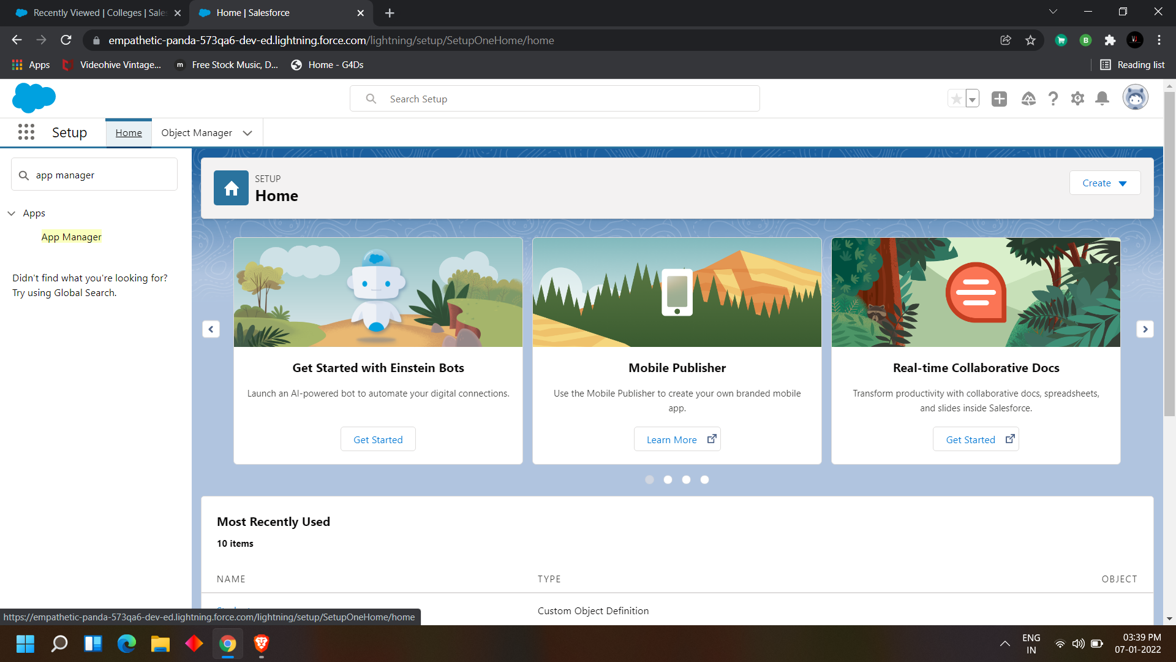

you can find the list of apps which are available now make sure we are going to create a new lighting builder so > click on New Lightning App

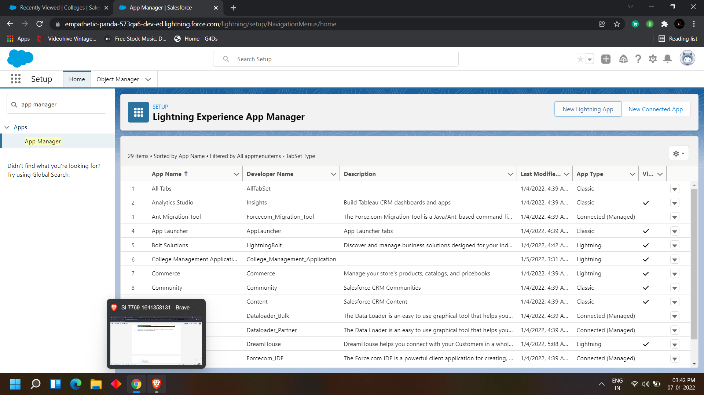

Select the name of the app and enter in the app details

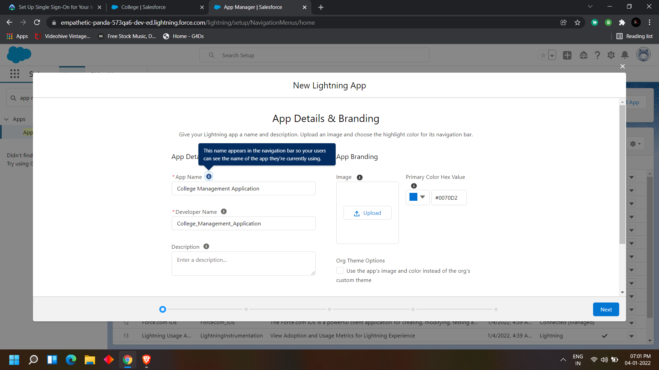

Later on fill details as per the Requirements

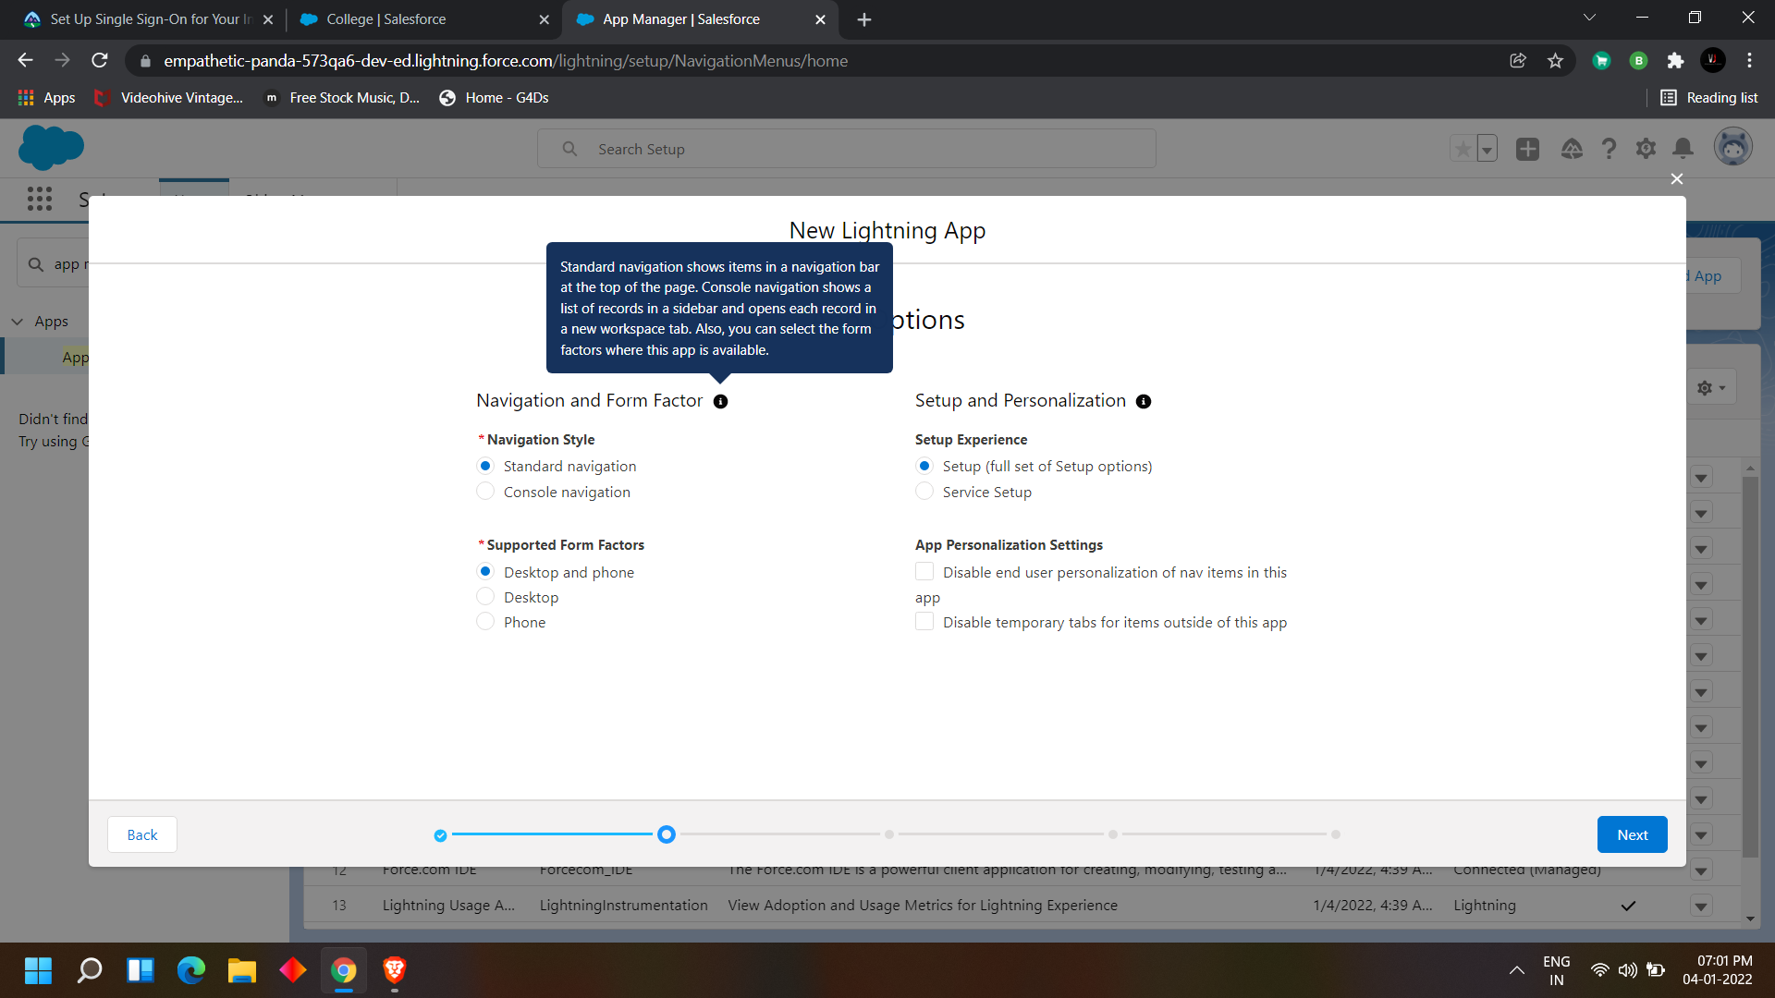

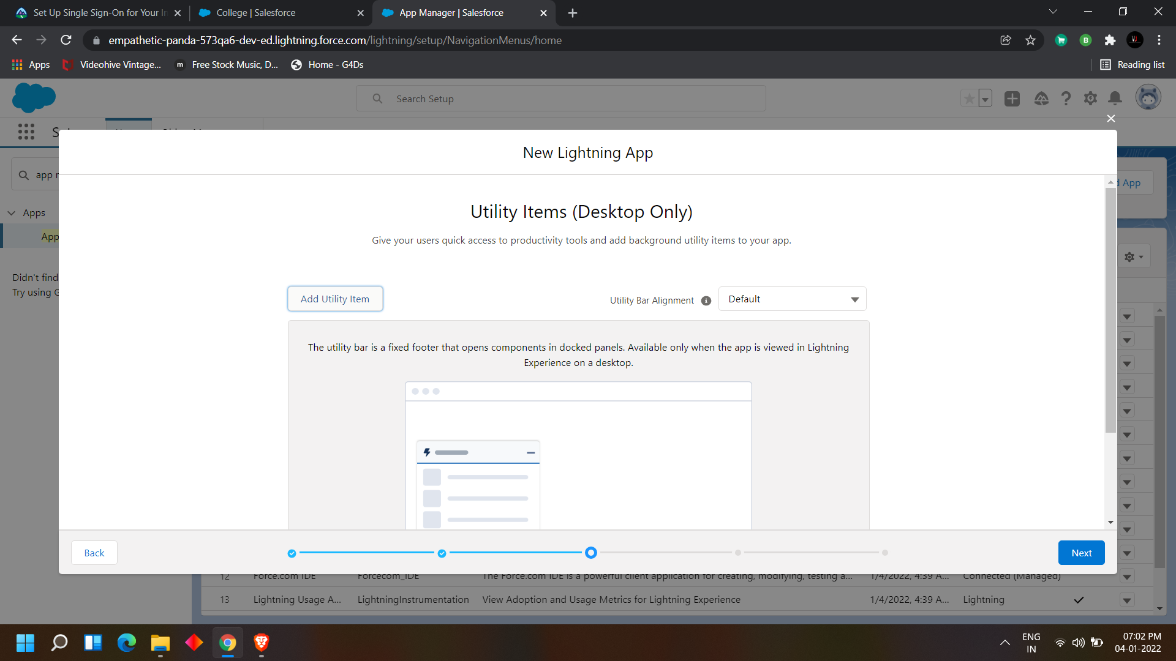

After creating the app manager navigate to App launcher and search for the app which you have created and open it

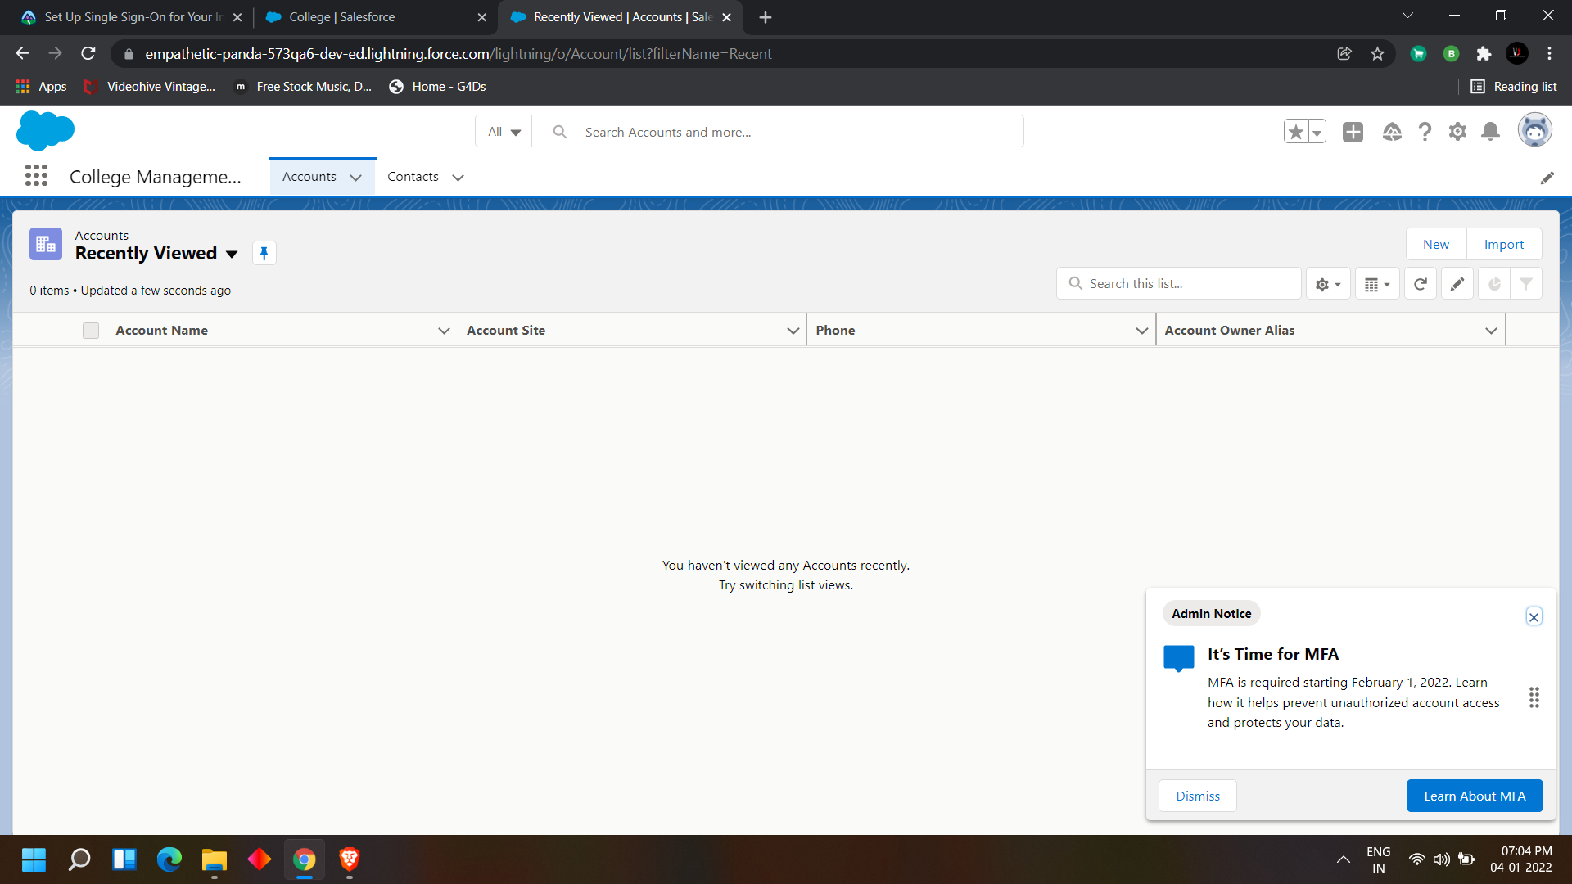

#### Creating global picklist values

when we declaring a field as picklist we can choose if we want custom picklist or global

picklist

we need to create the global picklist values before using this

so head to quick find box in the setup>picklist value sets

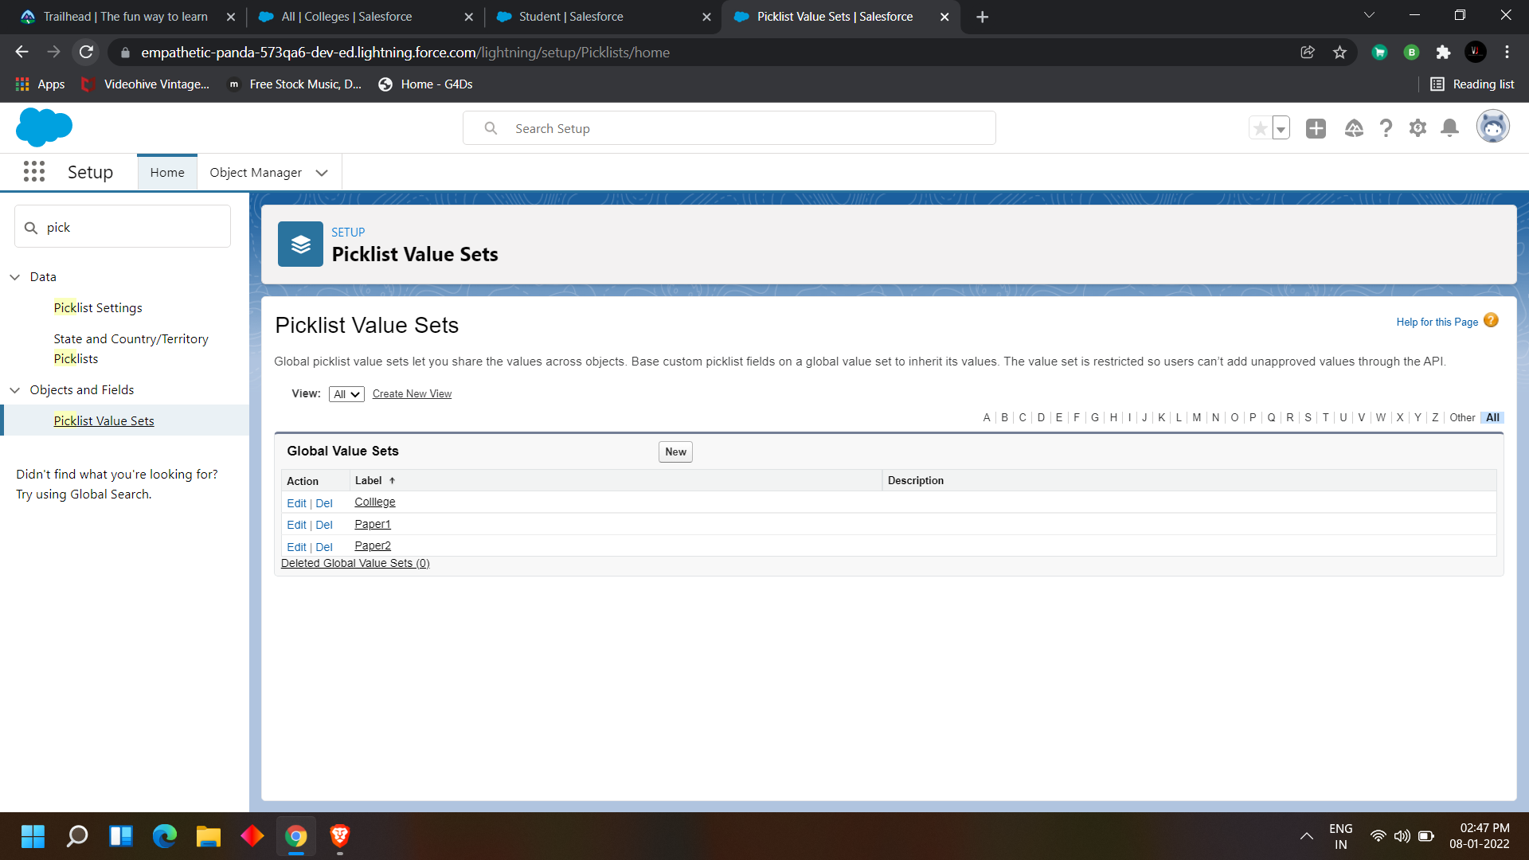

click on new>

enter the name of the global picklist>

enter the values which you want to give there>

save

college

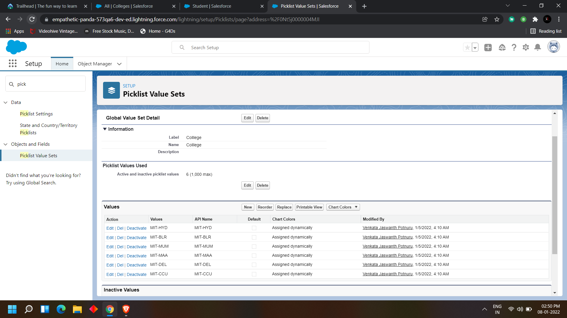

Paper1

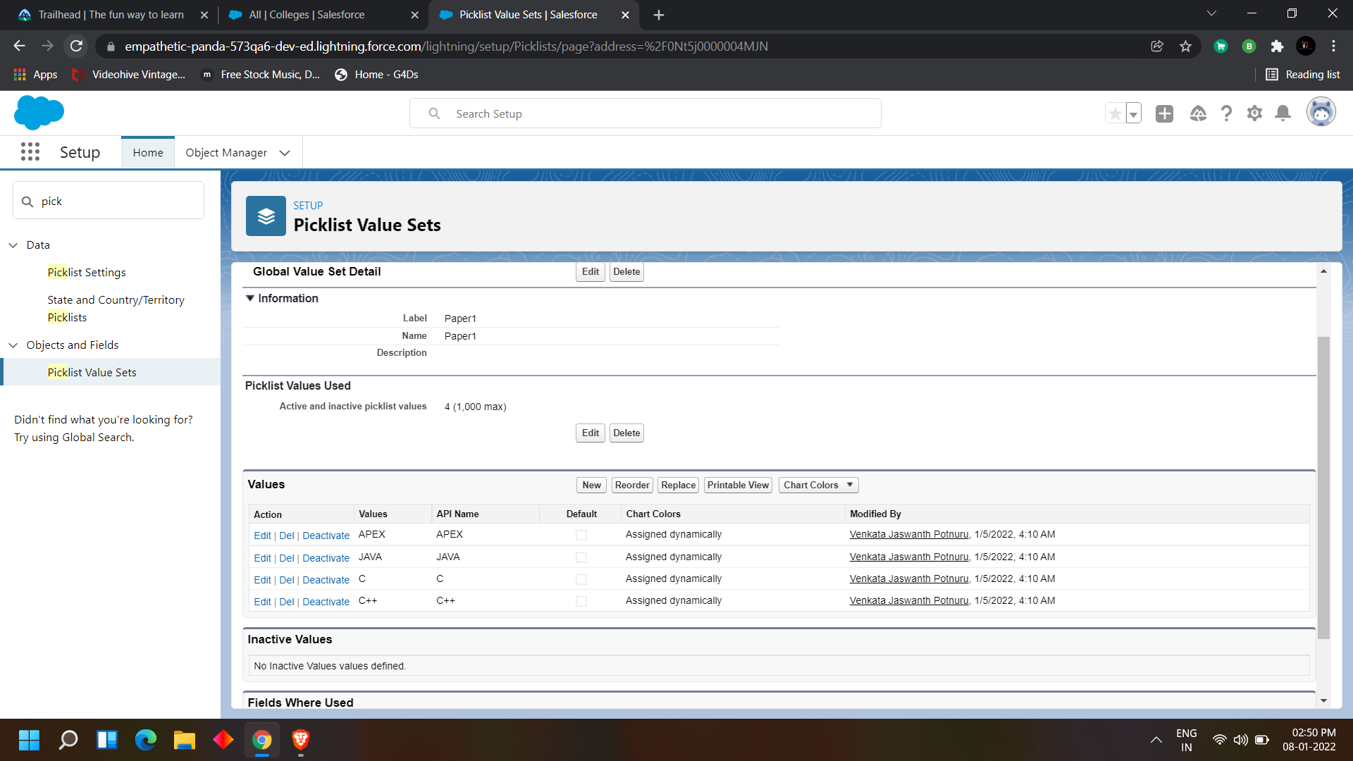

Paper2

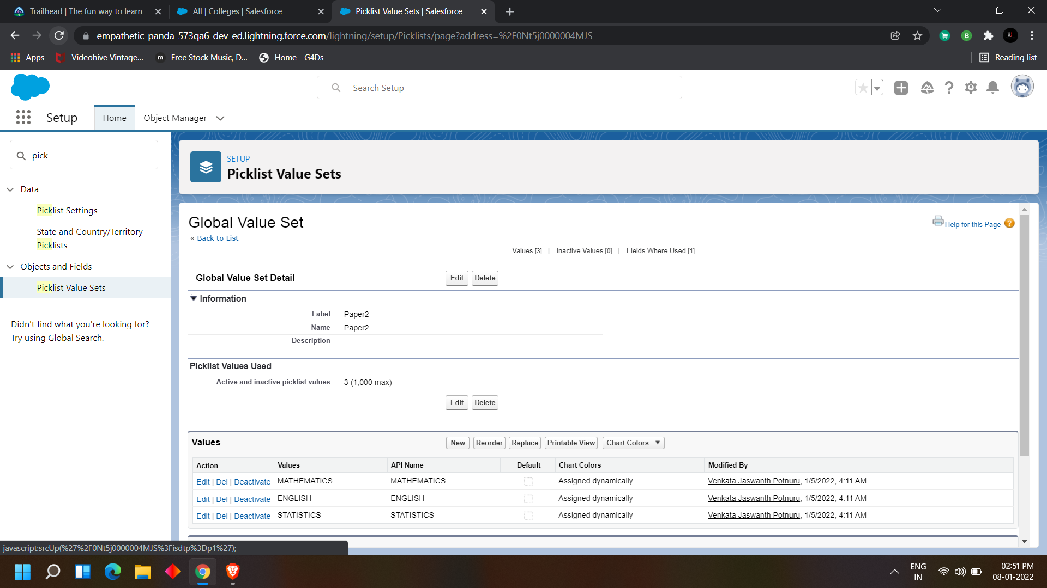

**DAY 4:**

**Topic: Milestone / Activities:** Creating fields for objects, and creating field dependiencies

**Detailed Description:**

### Creating fields for the objects which we have created (College, students, Sujects and

### Application form)

to create the fields in the object

click on the gear button> select setup> here we can see the object manager here we find the

all objects which are present

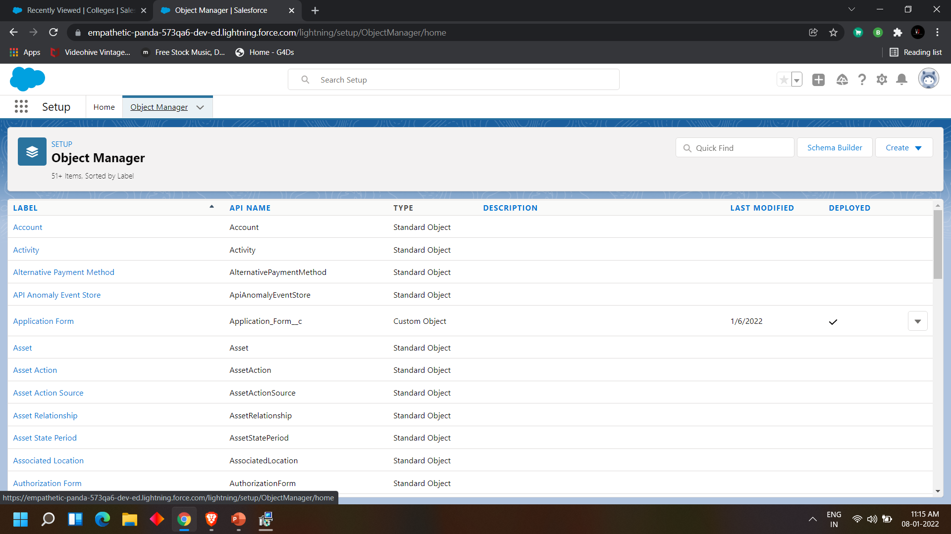

select a object

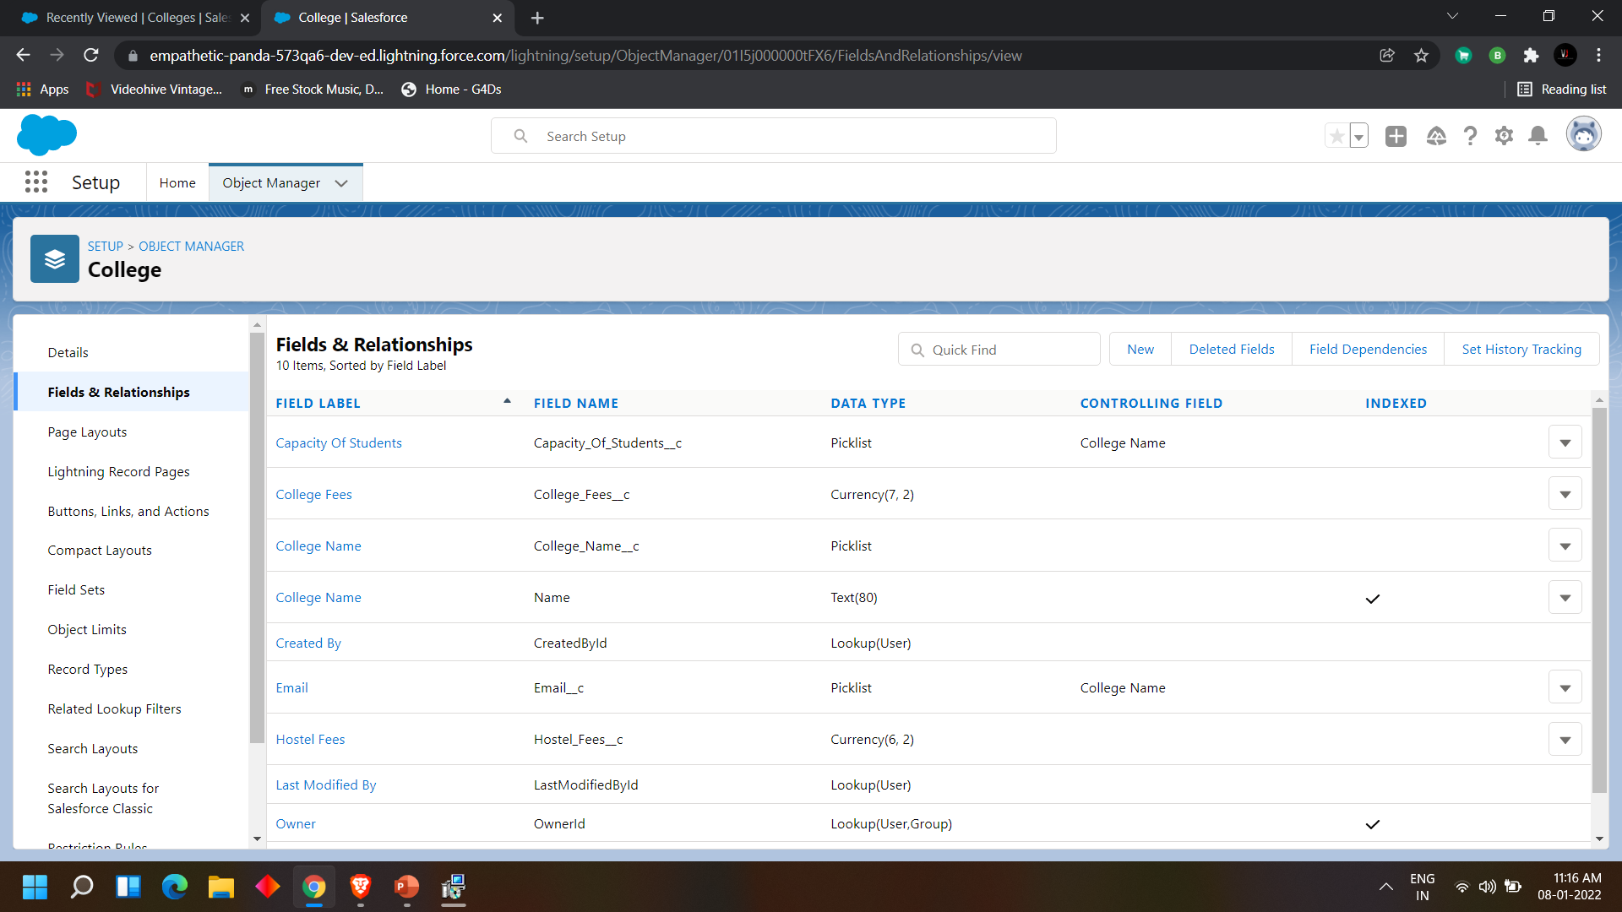

click on the fields and relationships

there we can see all the fields which are present in the object before.

So we can create new fields as per our requirements by clicking on new

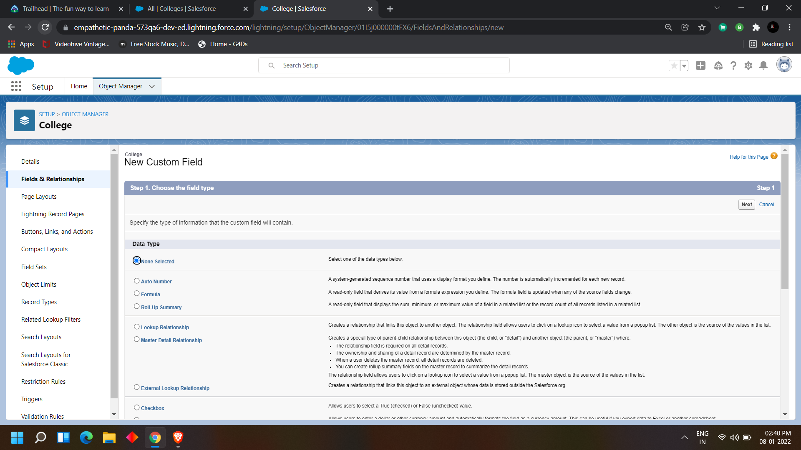

choose the field type

there we can find different data types

|  |  |  |  |
| --- | --- | --- | --- |
| **None Selected** | Select one of the data types below. | | |

|  |  |  |  |
| --- | --- | --- | --- |
| **VAuto Number** | A system-generated sequence number that uses a display format you define. The number is automatically incremented for each new record. | | |
| **ZFormula** | A read-only field that derives its value from a formula expression you define. The formula field is updated when any of the source fields change. | | |
| **1Roll-Up Summary** | A read-only field that displays the sum, minimum, or maximum value of a field in a related list or the record count of all records listed in a related list. | | |

|  |  |  |  |
| --- | --- | --- | --- |
| **YLookup Relationship** | Creates a relationship that links this object to another object. The relationship field allows users to click on a lookup icon to select a value from a popup list. The other object is the source of the values in the list. | | |
| **Y_MDMaster-Detail Relationship** | Creates a special type of parent-child relationship between this object (the child, or "detail") and another object (the parent, or "master") where:   * The relationship field is required on all detail records. * The ownership and sharing of a detail record are determined by the master record. * When a user deletes the master record, all detail records are deleted. * You can create roll up summary fields on the master record to summarize the detail records.   The relationship field allows users to click on a lookup icon to select a value from a popup list. The master object is the source of the values in the list. | | |
| **xExternal Lookup Relationship** | Creates a relationship that links this object to an external object whose data is stored outside the Salesforce org. | | |

|  |  |  |  |
| --- | --- | --- | --- |
| **BCheckbox** | Allows users to select a True (checked) or False (unchecked) value. | | |
| **CCurrency** | Allows users to enter a dollar or other currency amount and automatically formats the field as a currency amount. This can be useful if you export data to Excel or another spreadsheet. | | |
| **DDate** | Allows users to enter a date or pick a date from a popup calendar. | | |
| **FDate/Time** | Allows users to enter a date and time, or pick a date from a popup calendar. When users click a date in the pop-up, that date and the current time are entered into the Date/Time field. | | |
| **EEmail** | Allows users to enter an email address, which is validated to ensure proper format. If this field is specified for a contact or lead, users can choose the address when clicking Send an Email. Note that custom email addresses cannot be used for mass emails. | | |
| **gGeolocation** | Allows users to define locations. Includes latitude and longitude components, and can be used to calculate distance. | | |
| **NNumber** | Allows users to enter any number. Leading zeros are removed. | | |
| **PPercent** | Allows users to enter a percentage number, for example, '10' and automatically adds the percent sign to the number. | | |
| **HPhone** | Allows users to enter any phone number. Automatically formats it as a phone number. | | |
| **LPicklist** | Allows users to select a value from a list you define. | | |
| **QPicklist (Multi-Select)** | Allows users to select multiple values from a list you define. | | |
| **SText** | Allows users to enter any combination of letters and numbers. | | |
| **XText Area** | Allows users to enter up to 255 characters on separate lines. | | |
| **JText Area (Long)** | Allows users to enter up to 131,072 characters on separate lines. | | |
| **zText Area (Rich)** | Allows users to enter formatted text, add images and links. Up to 131,072 characters on separate lines. | | |
| **6Text (Encrypted)** | Allows users to enter any combination of letters and numbers and store them in encrypted form. | | |
| **fTime** | Allows users to enter a local time. For example, "2:40 PM", "14:40", "14:40:00", and "14:40:50.600" are all valid times for this field. | | |
| **UURL** | Allows users to enter any valid website address. When users click on the field, the URL will open in a separate browser window. | | |

choose as per the requirement   
  
fill the details like  
field name and all  
  
college object fields

|  |  |  |  |
| --- | --- | --- | --- |
| Field Name | Data Type | Required | Values |
| Record Info | Text |  |  |
| College Fees | Currency(7,2) | Yes |  |
| Hostel Fees | Currency(6,2) | Yes |  |
| College Name | Picklist(Refer Business Logic In Milestones) | Yes |  |
| Email | Picklist |  | blr@mit.co.in  hyd@mit.co.in  mum@mit.co.in  maa@mit.co.in  ccu@mit.co.in  del@mit.co.in |
| Capacity Of Students | Picklist |  | 500-1000, 1000-2500, 2500-6000, 6000-10000 |

Application form object fields

|  |  |  |  |
| --- | --- | --- | --- |
| Field Name | Data Type | Required | Values |
| Application Form ID | Auto number |  | F-{000000}  Starting Number=1 |
| Address | Text(255) | Yes |  |
| College | Master-Detail(College) | Yes |  |
| College Fees | Formula(Currency) |  |  |
| Hostel Fees | Formula(Currency) |  |  |
| date of Birth | Date | Yes |  |
| Email | Email(Unique) | Yes |  |
| Guardian Name | Text(30) | Yes |  |
| Looking For Hostel Stay | Checkbox(default=Uncheck) |  |  |
| Ready To Join | Checkbox(default=Uncheck) |  |  |
| Student Name | Text(30) | Yes |  |
| Phone | Phone | Yes |  |

student object fields

|  |  |  |  |
| --- | --- | --- | --- |
| Field Name | Data Type | Required | Values |
| Student Name | Text |  |  |
| Address | Text(255) | Yes |  |
| Application Form | Lookup(Application Form) |  |  |
| College Name | Formula(Text) |  |  |
| Date Of Birth | Date | Yes |  |
| Guardian Name | Text(30) | Yes |  |
| Phone | Phone | Yes |  |

subjects object fields

|  |  |  |  |
| --- | --- | --- | --- |
| Field Name | Data Type | Required | Values |
| Subject ID | AutoNumber |  | S-{000000}  Starting Number=1 |
| Paper 1 | Picklist(Refer Business Logic Milestone) |  |  |
| Paper2 | Picklist(Refer Business logic Milestone) |  |  |
| Student | Lookup(Student) |  |  |

after creating the values are

college object

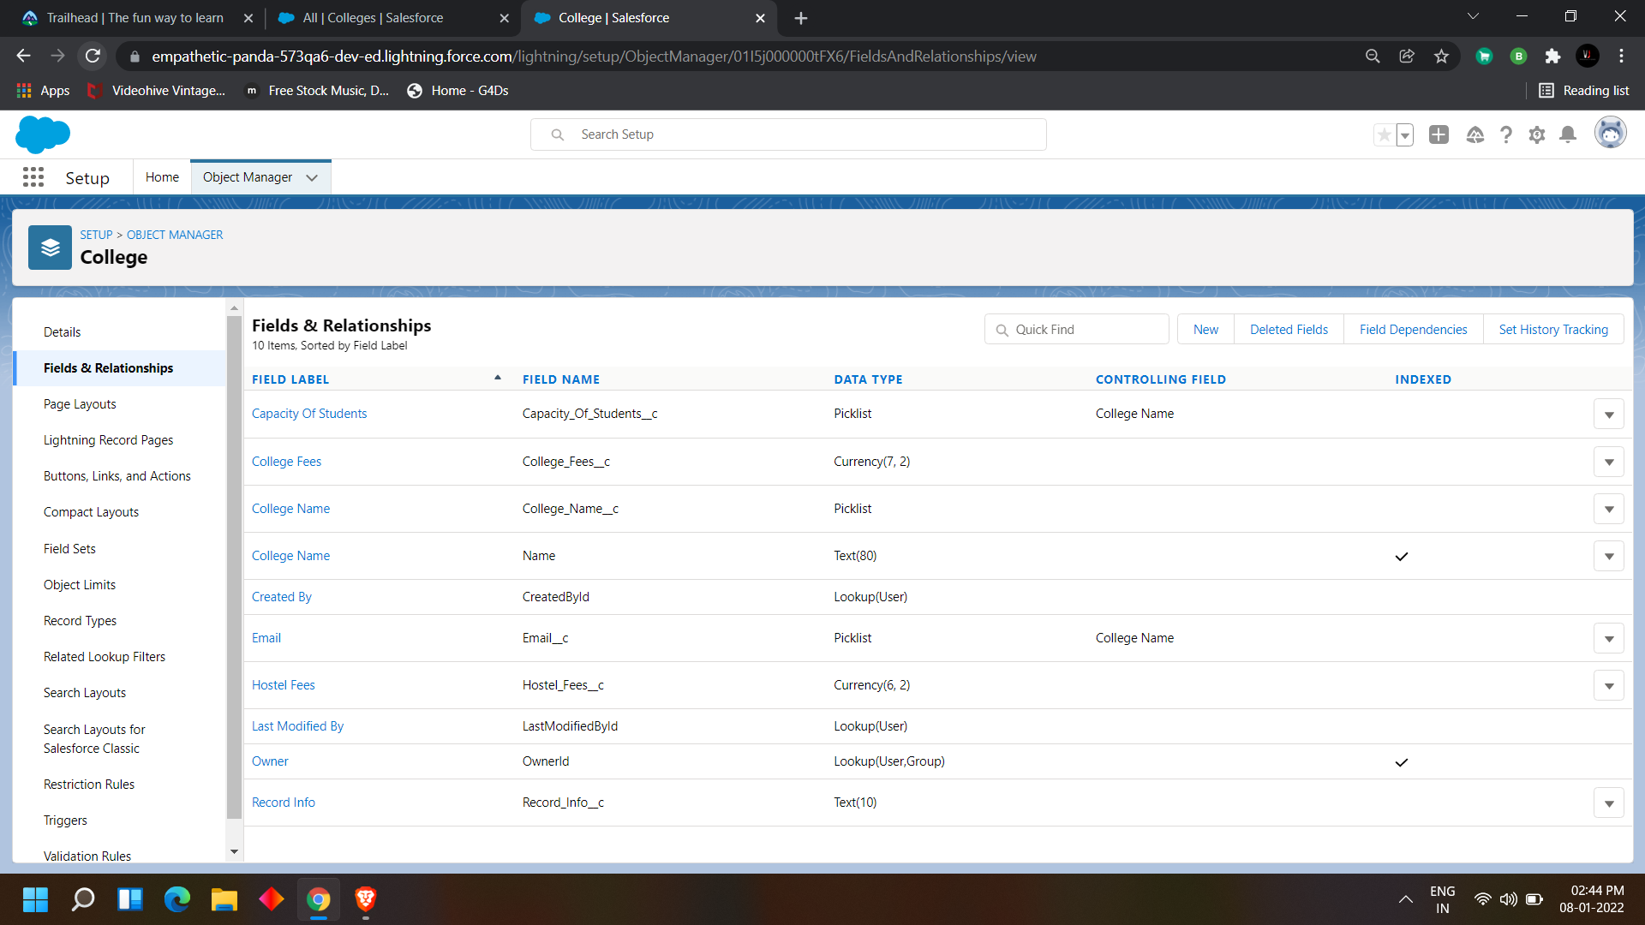

application form

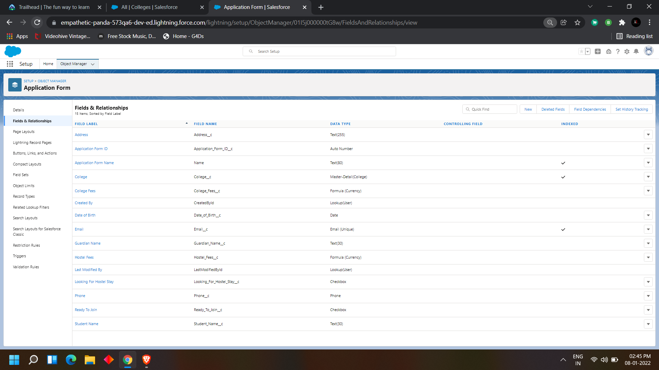

student object

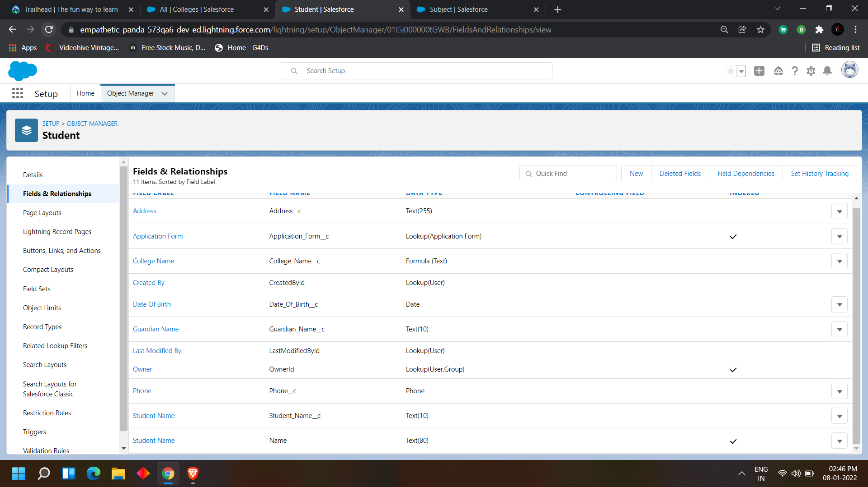

subjects object

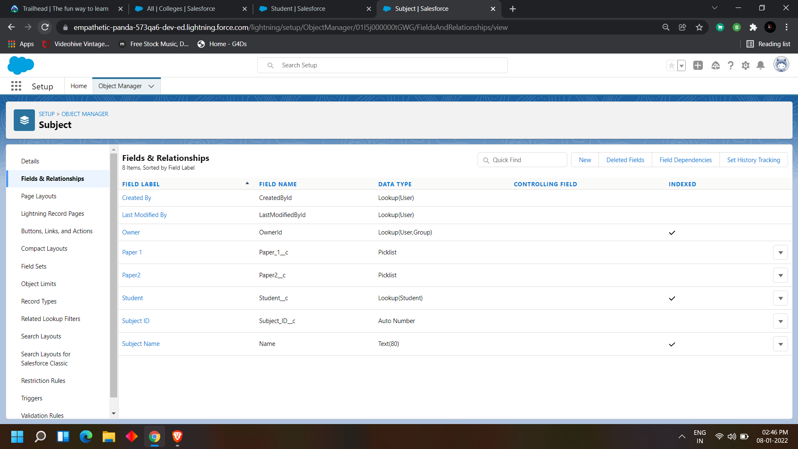

### Creating Field Dependencies

We have created some fields in every object so now we need to give some field dependencies

1. Create field dependency between college Name and Email, where the controlling field is college Name and dependent field is Email. Select the email ids according to the college names.

2. Create field dependency between college Name and capacity of students, where the controlling field is college Name and dependent field is Capacity of Students. Select the values according to your wish.

To assign field dependencies

go to setup>

object manager>

Go to the object which we have to assign the field dependencies>

fields and relationships

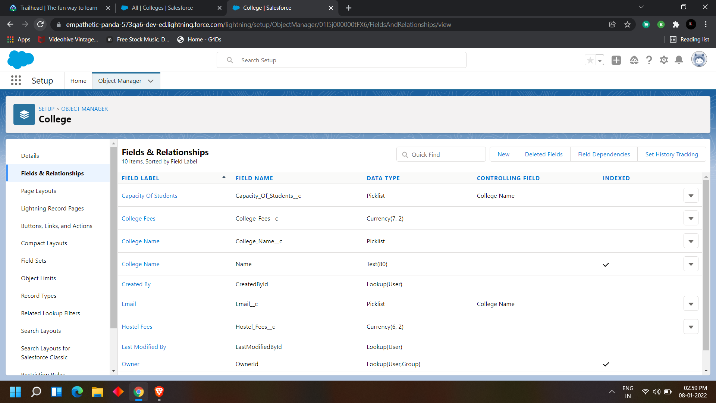

Click on field dependencies

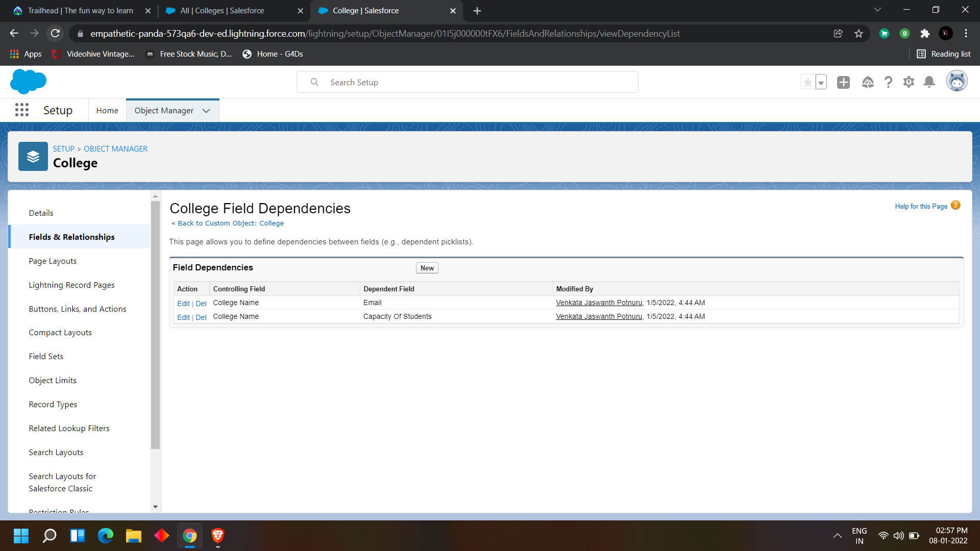

Click on new

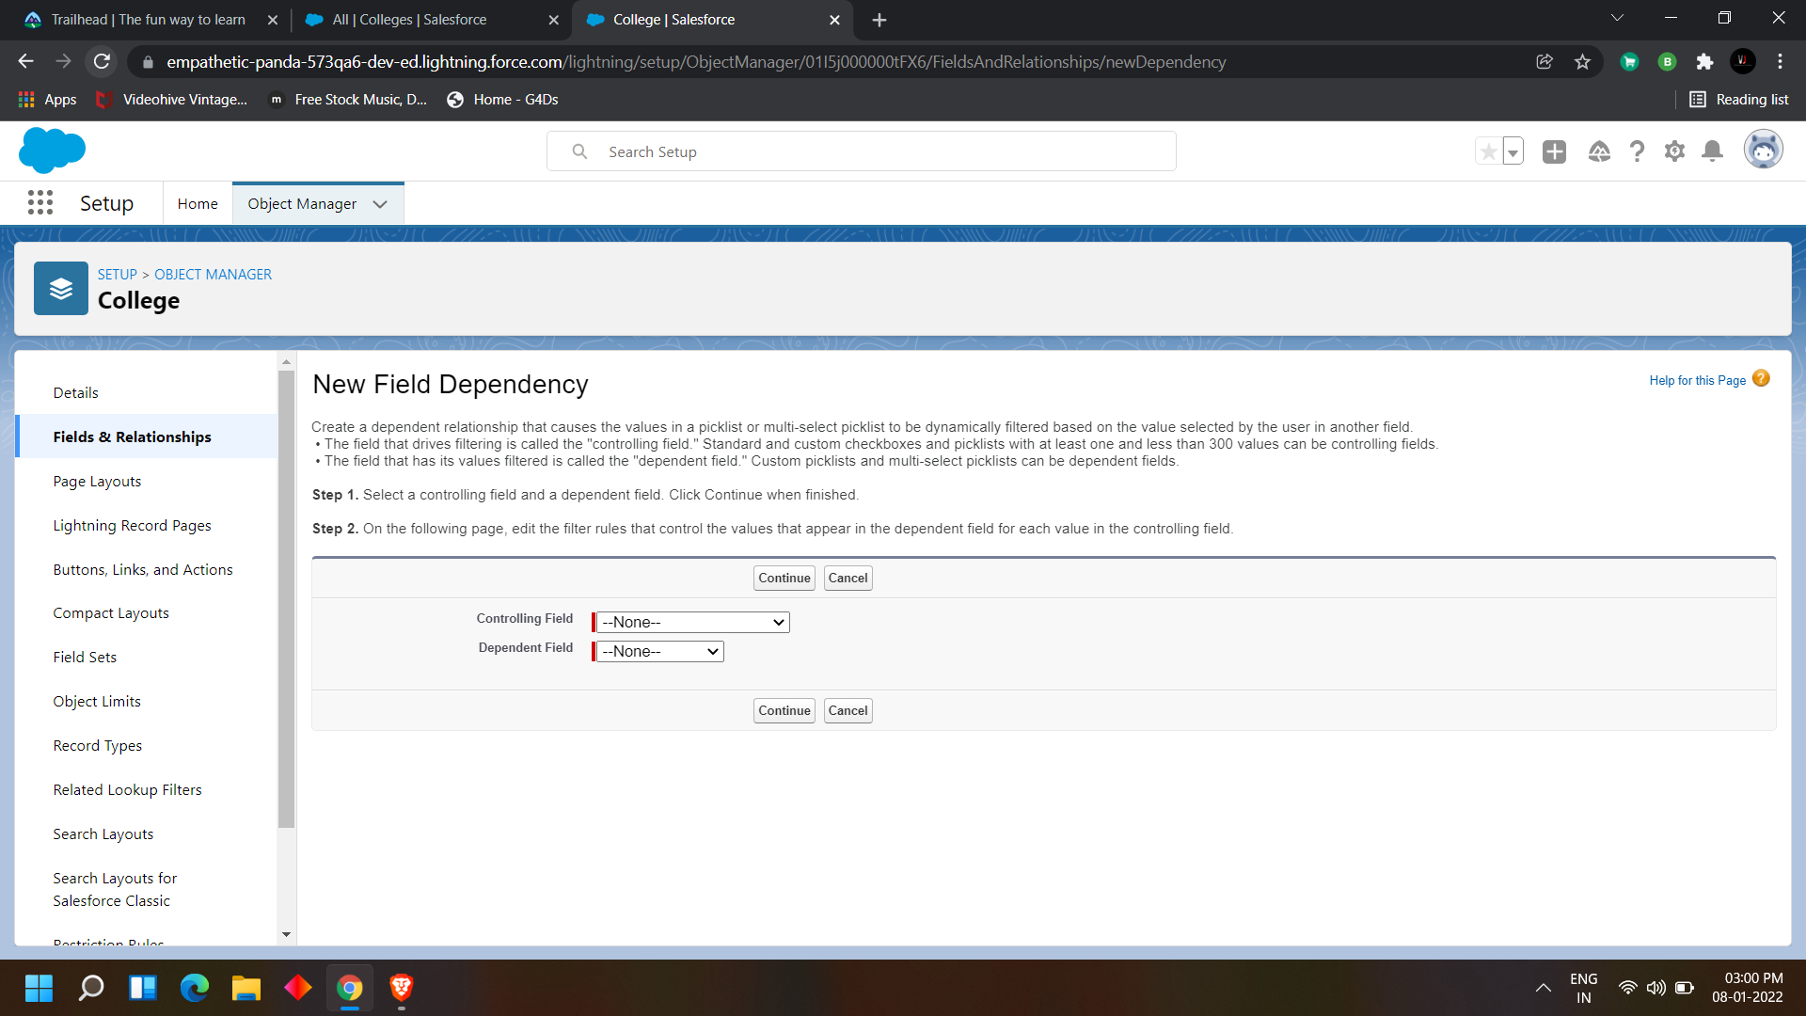

Fill the details and continue

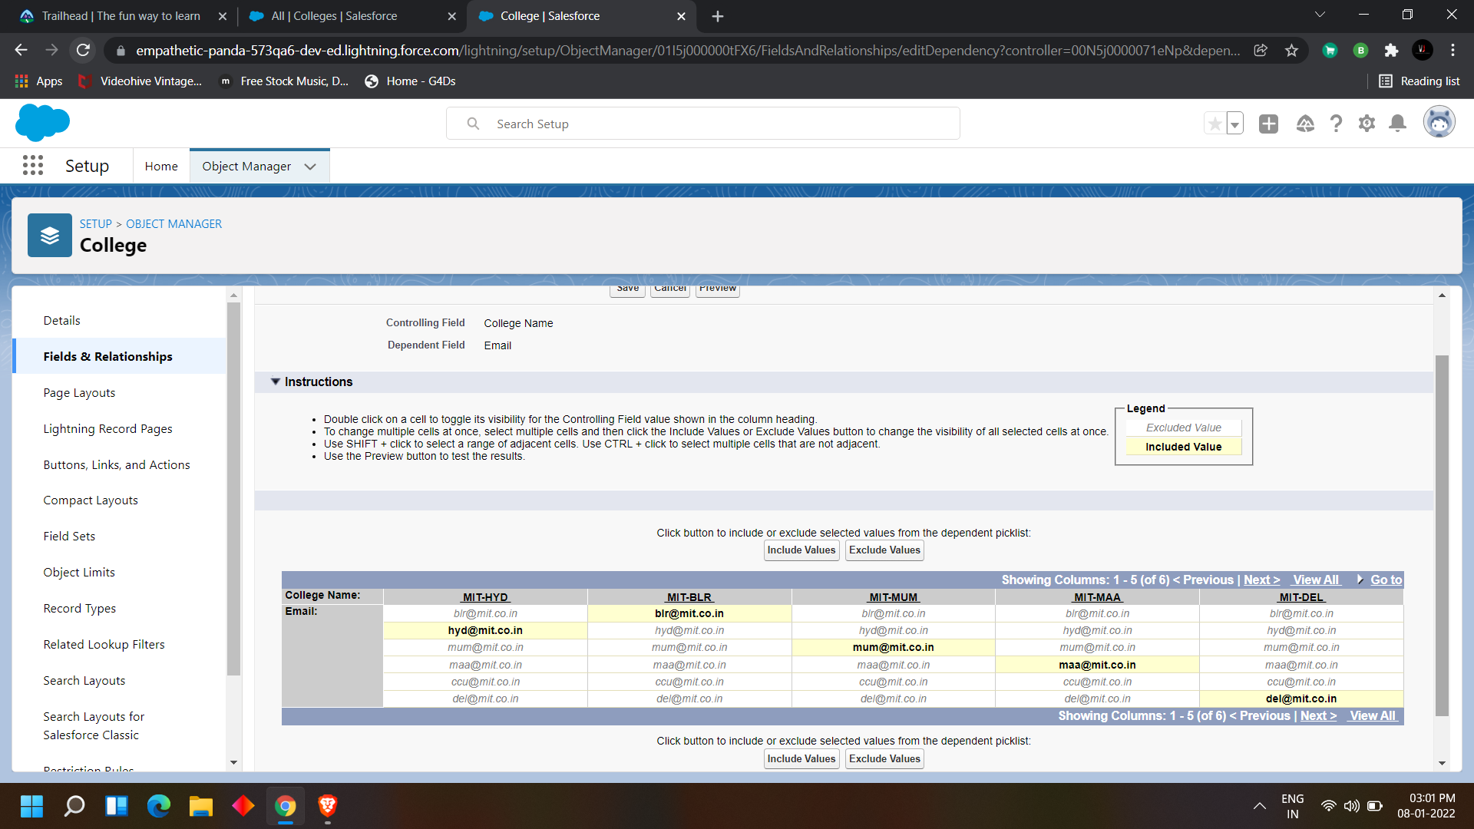

Select the values and click on include values

Click on save

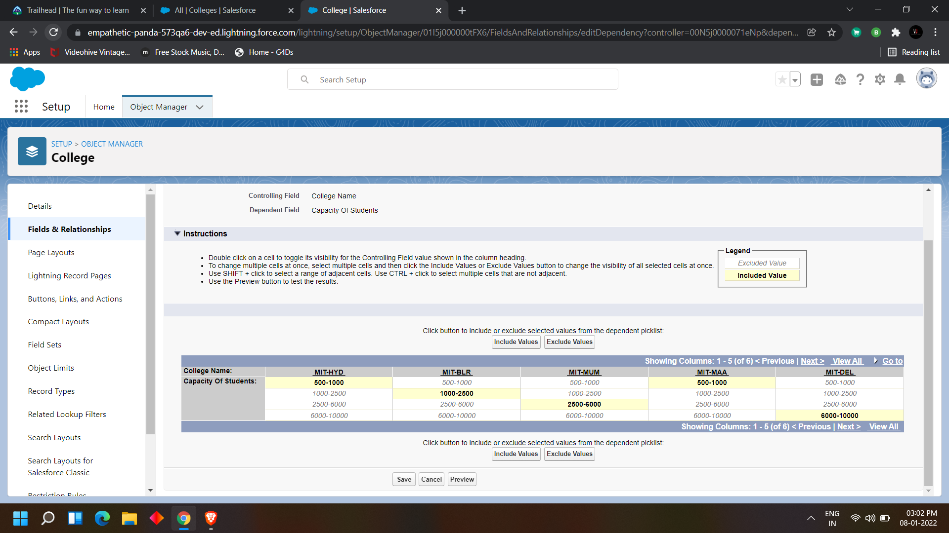

We can see that it was created in the field dependencies

lets test this

Navigate to the app launcher > select the app (college management application)

Click on create

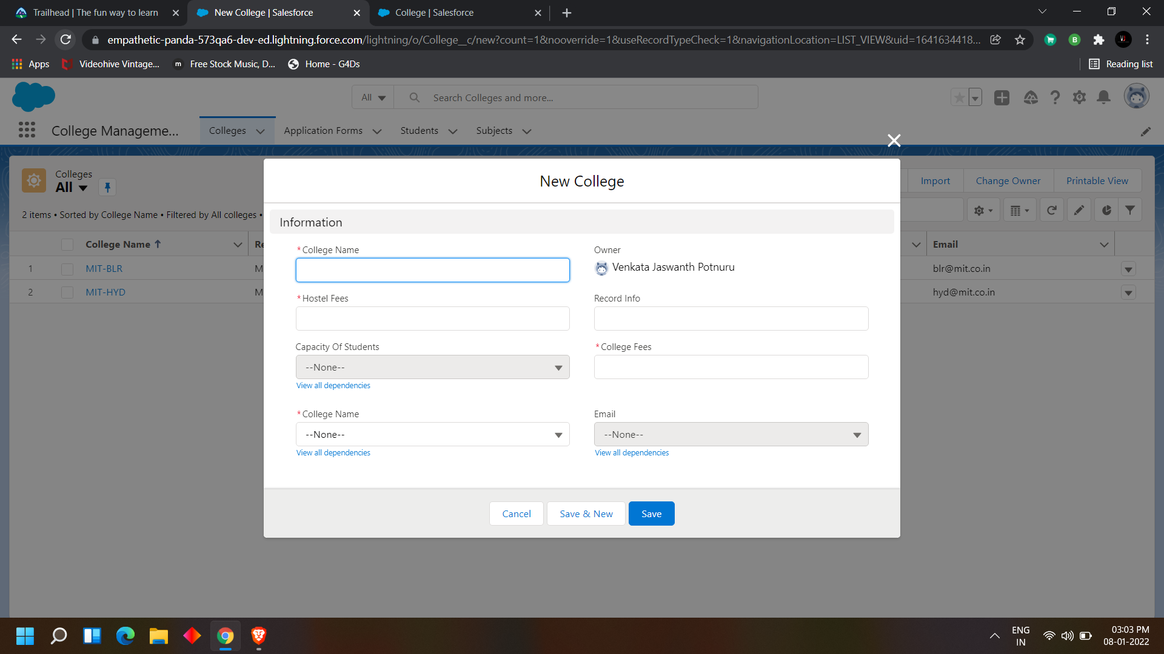

There we can see that email and capacity of students are disabled

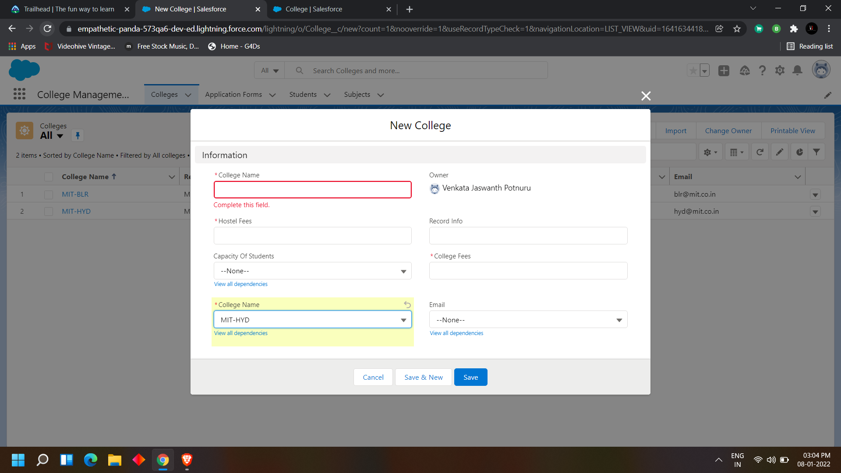

When I enter the college name it enables both the fields according to the dependencies

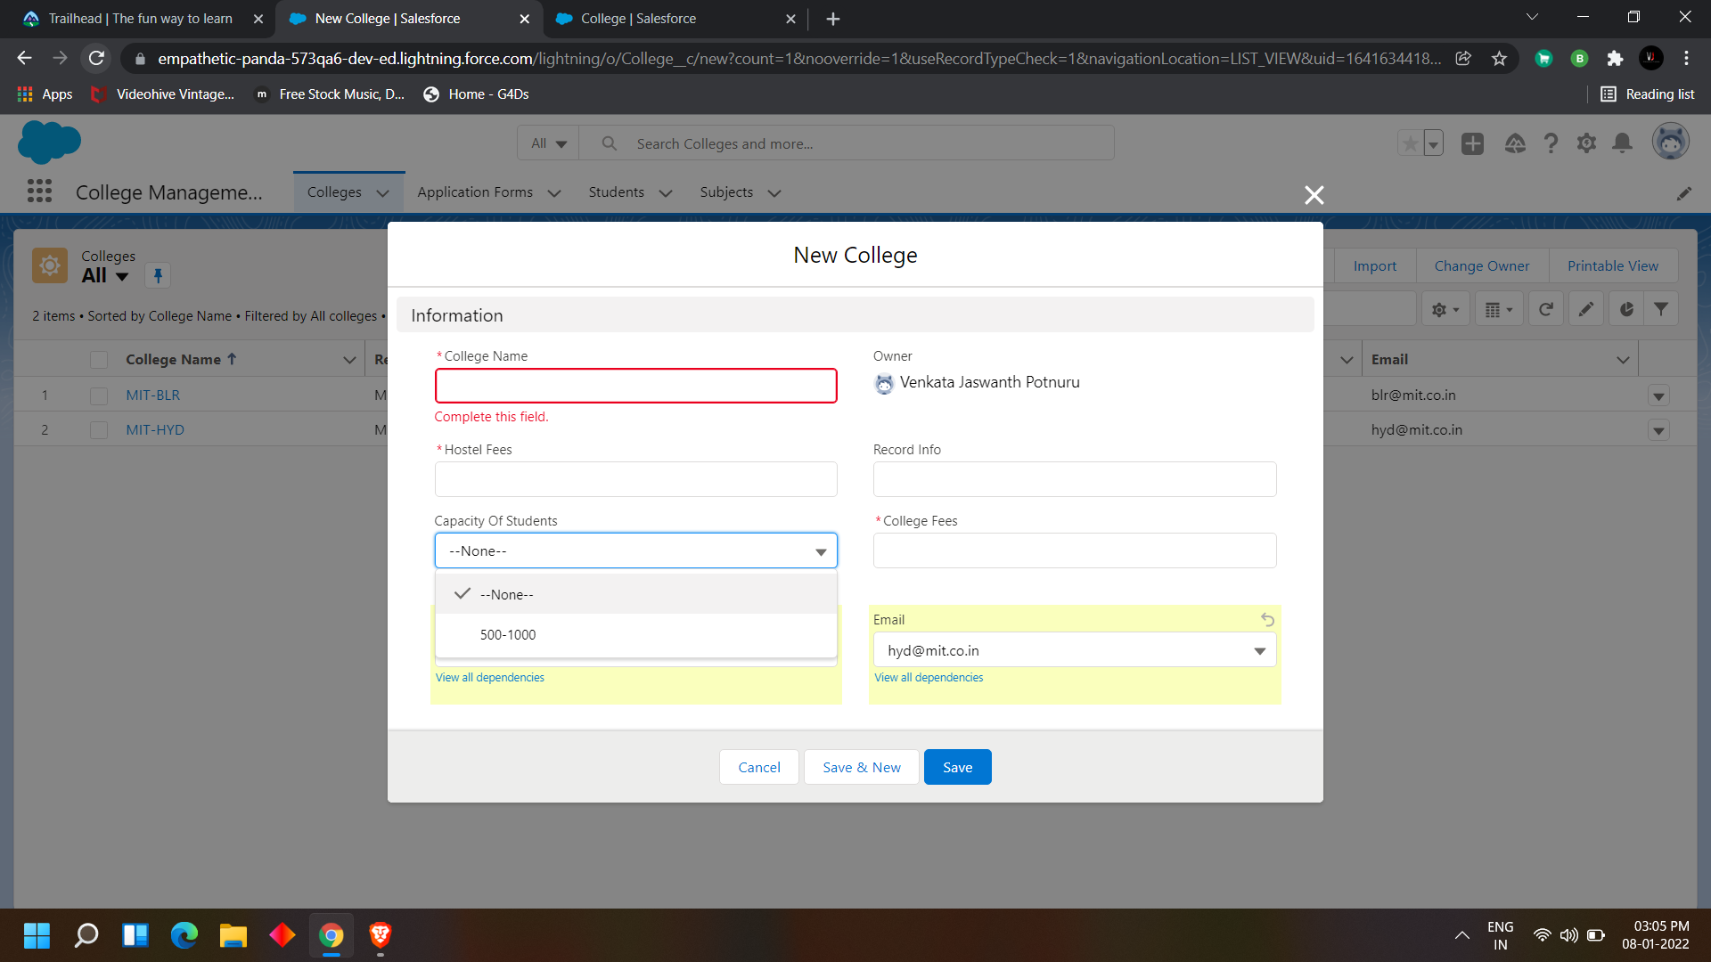

we have only 1 value because we include only one value there in the field dependencies before

**DAY 5:**

**Topic: Milestone / Activities:** Creating Validation rules, and creating process automation

**Detailed Description:**

#### Creating Validation Rules

1. Create a validation rule on the college object such that the college name and record info should have the same name.

TEXT(College_Name__c) <> Name.

2. Create a validation rule on the application form object to stop any modification on the application form once a student record is created.

AND( Ready_To_Join__c == true,  
OR(  
ISCHANGED( Address__c ) ,  
ISCHANGED( College__c ) ,  
ISCHANGED( Date_Of_Birth__c ),  
ISCHANGED( Email__c ) ,  
ISCHANGED( Guardian_Name__c ) ,  
ISCHANGED( Phone__c )  
)  
)

to create a validation rule  
In object manager go to the object >

We can find the validation rules there

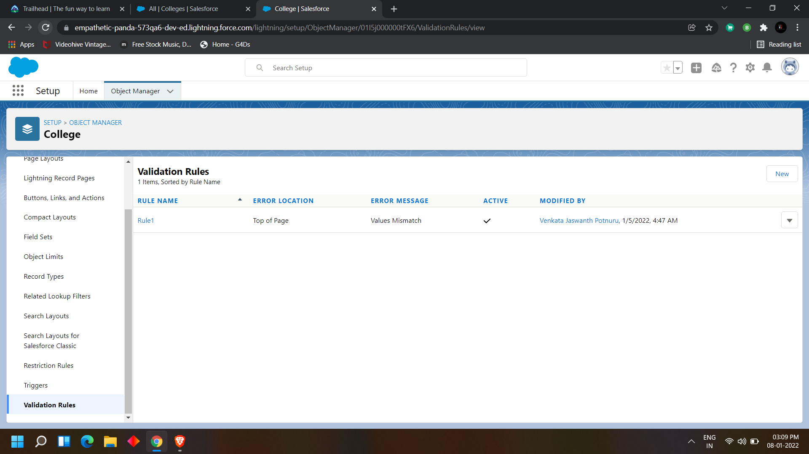

Click on new>

Enter the name

Enter the formula based on the validation rule

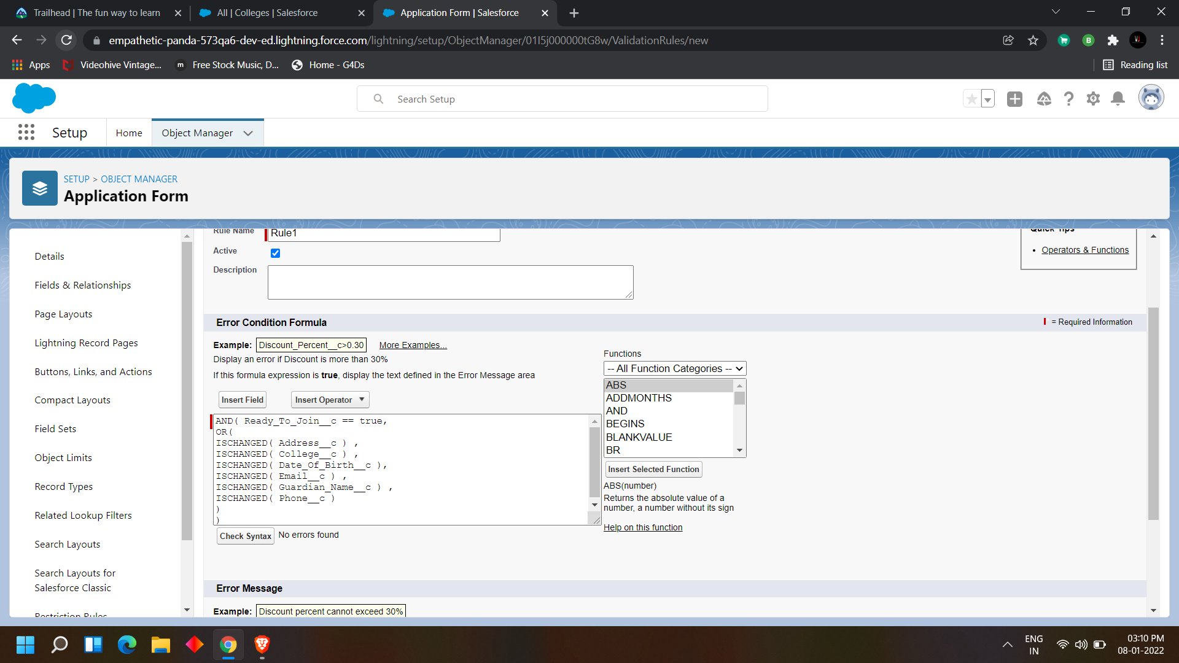

Click on check syntax to check whether the syntax is correct or not  
If there is no error click on save

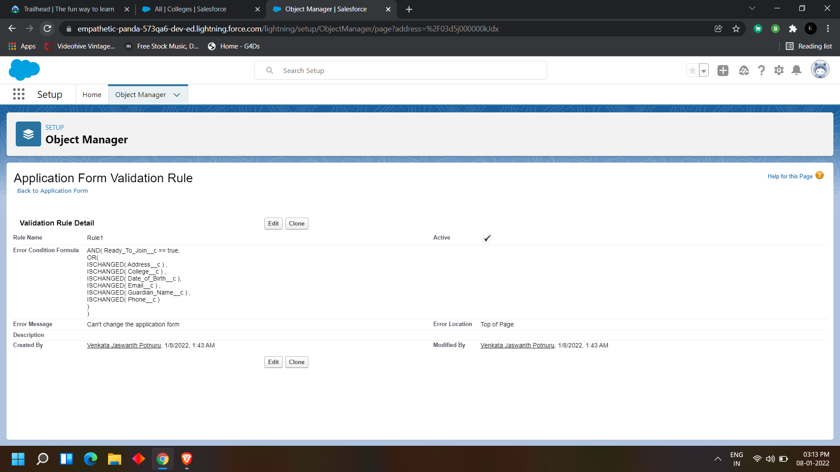

Once the validation rule is created you can see the validation rule in the validation rules

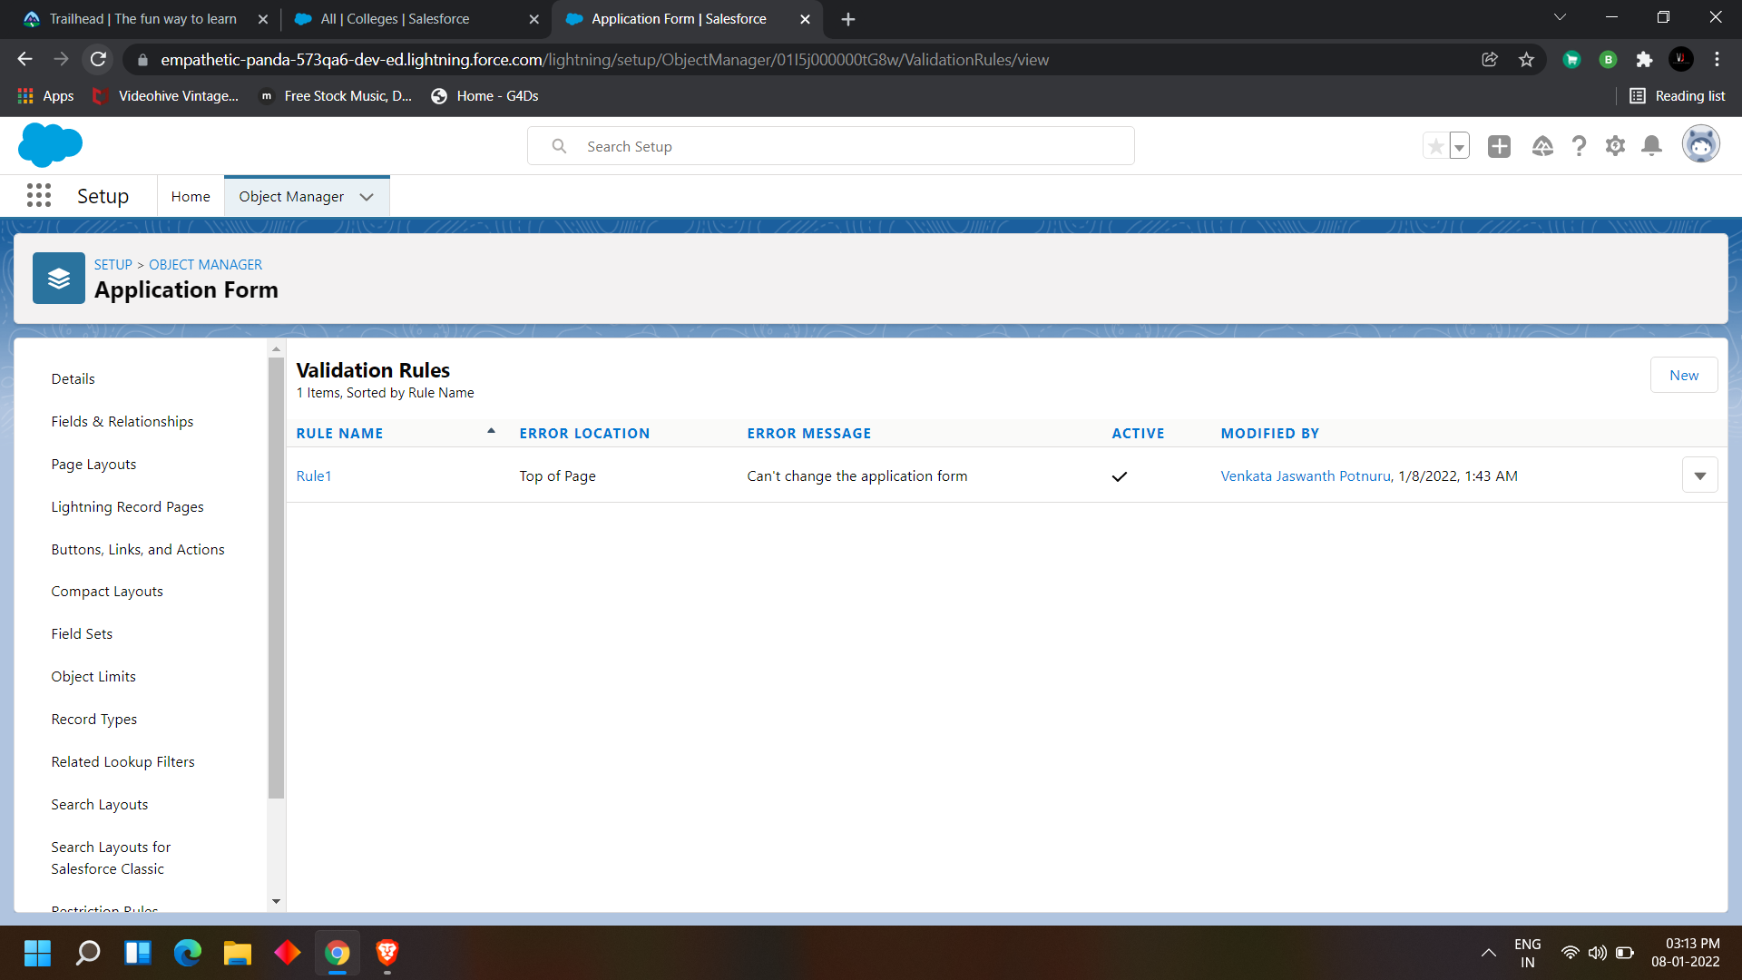

### Process automation

1. Create an automation process such that when the "ready to join" field is checked on the application form object we need to create the student record automatically with the information specified in the application form record.

2. Go to Setup -> select “Process Builder” from quick find. Create a Process Builder on the “Application Form” object with a condition as “When a record change”. And select “When a record is created or edited”.

a. In the diamond shape box(called nodes), select the criteria which trigger the Process builder to fire. In our example, it is “When Ready to Join field is checked.”

B Once the node is set up, click on the adjacent box called “Immediate action”. And select create a record on the student object. Please follow the below screenshot.

To create a Process Automation

In quick find box search for process builder

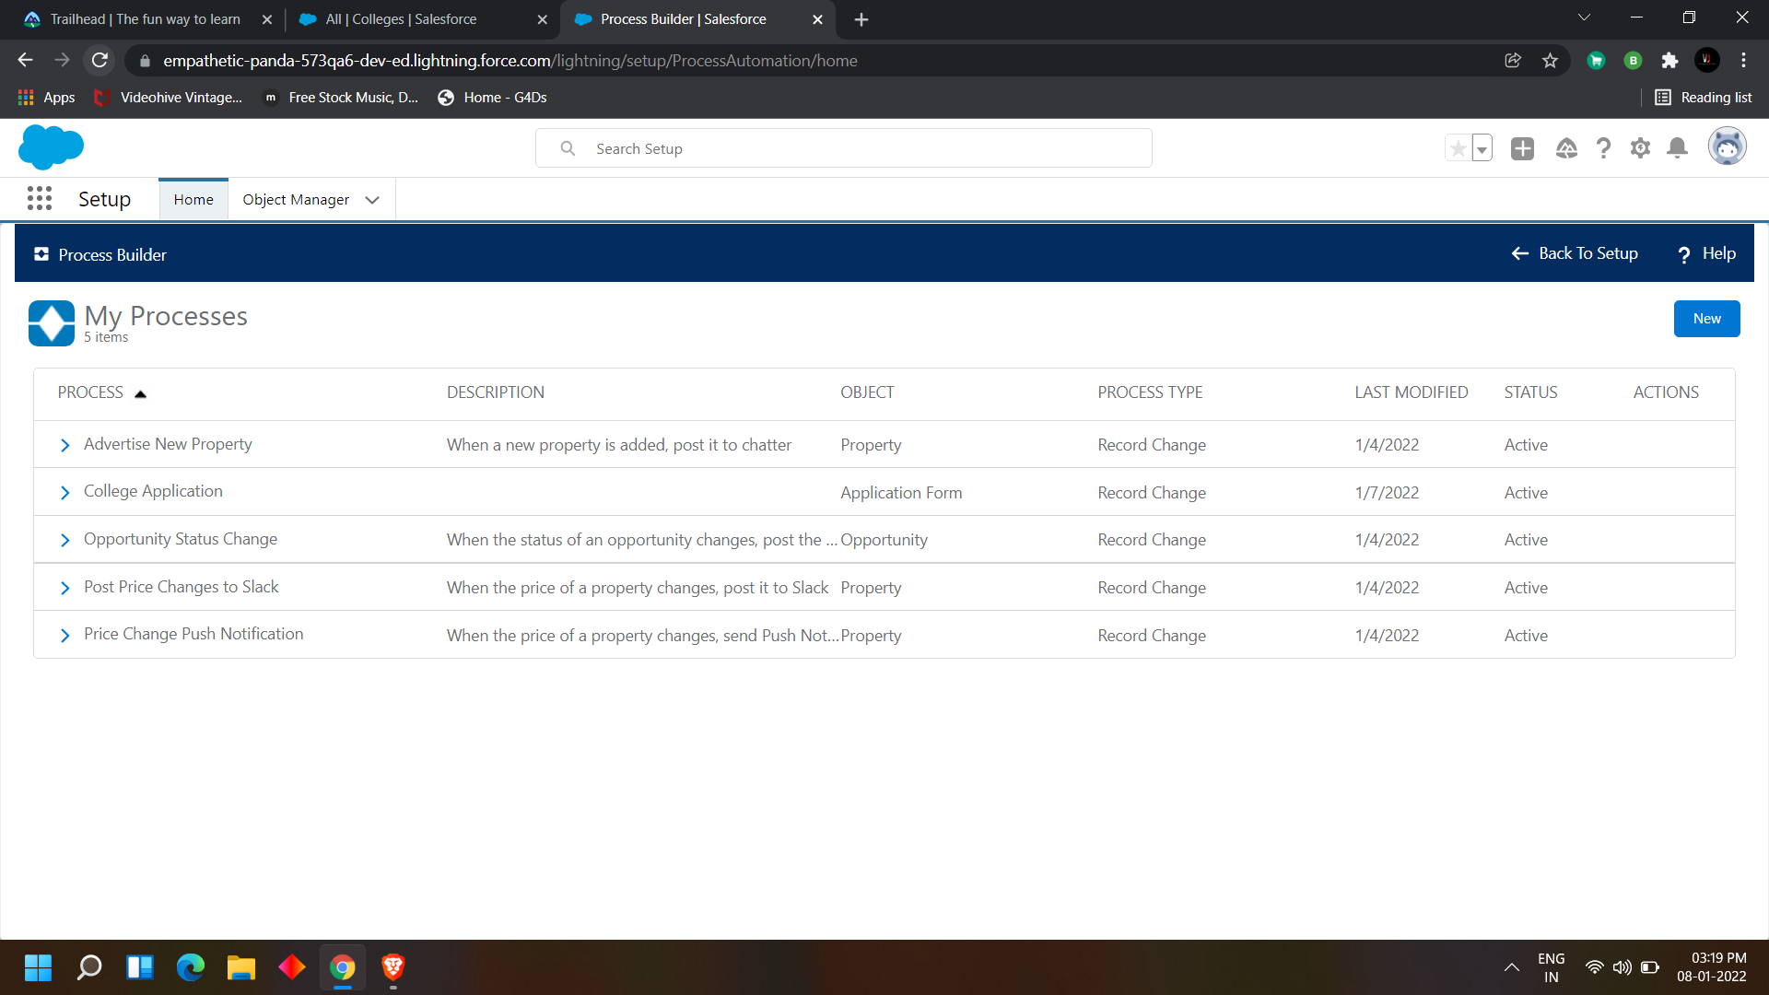

Click on new

Give the name of the process  
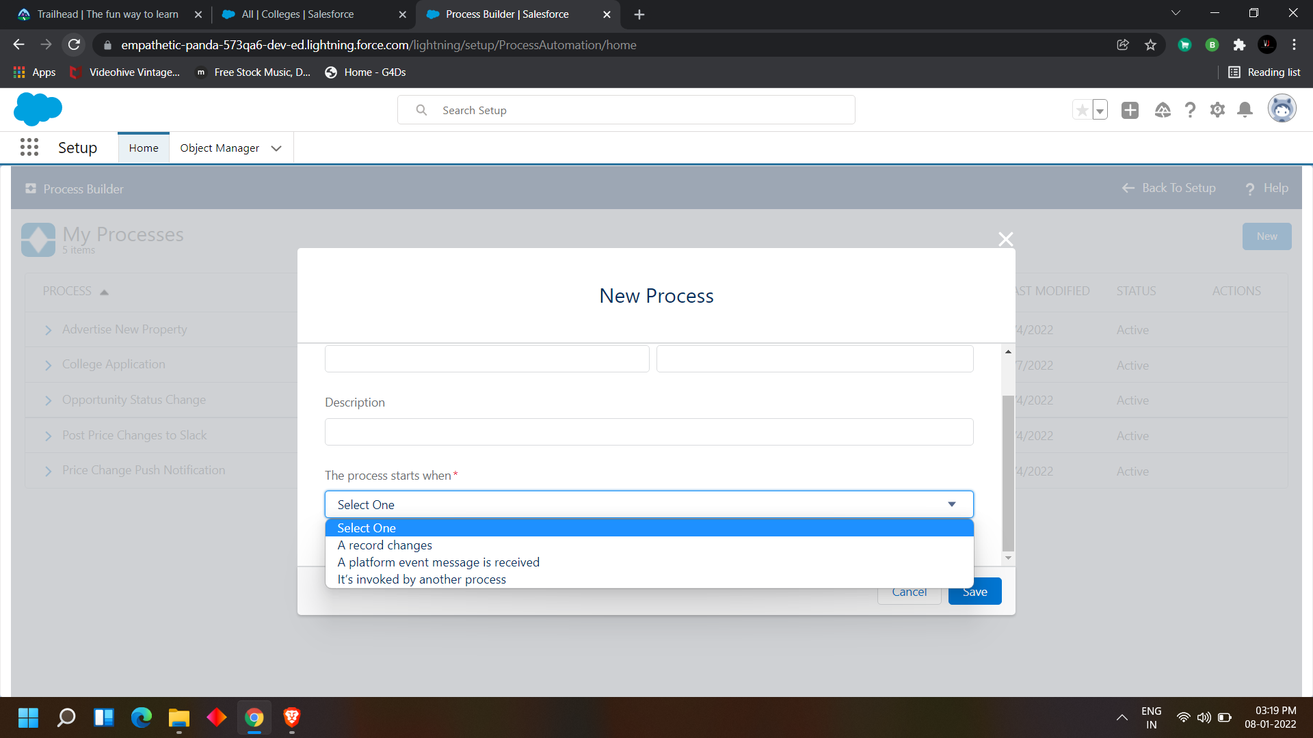

The process starts when is 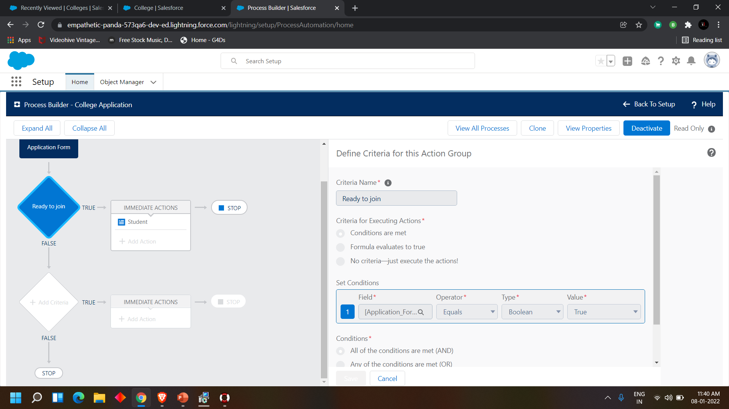to be selected as per the process intention

then next

select object name > Application form

add criteria >

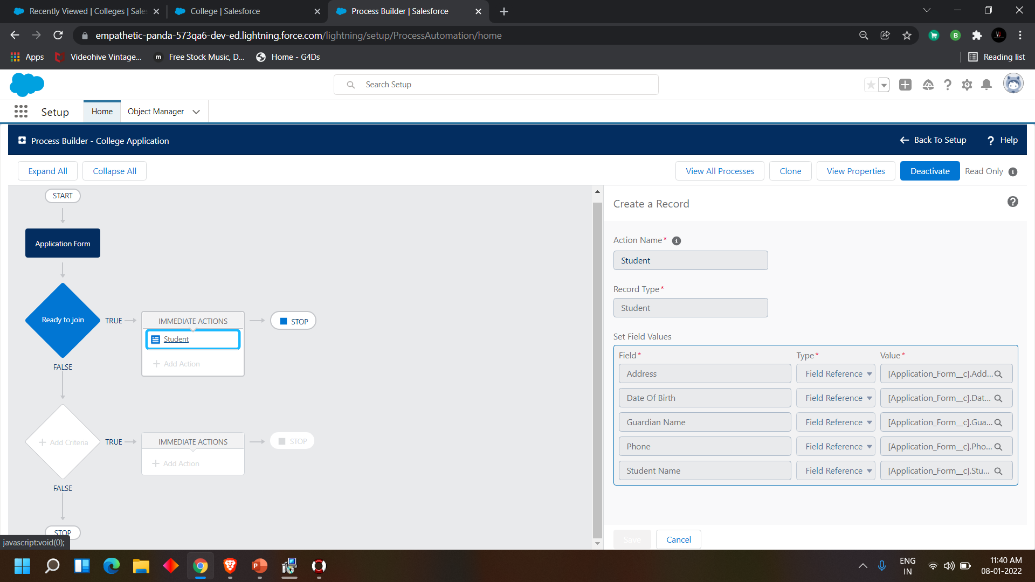

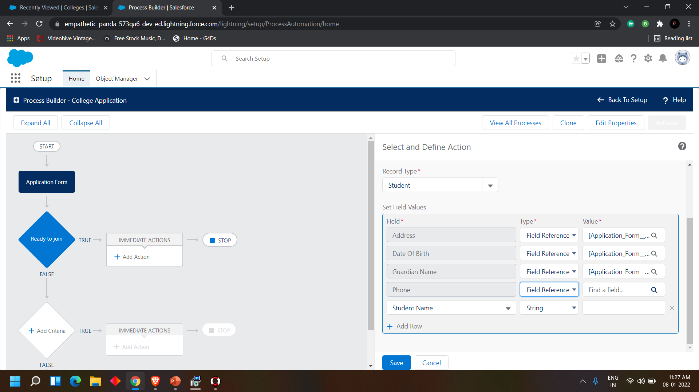

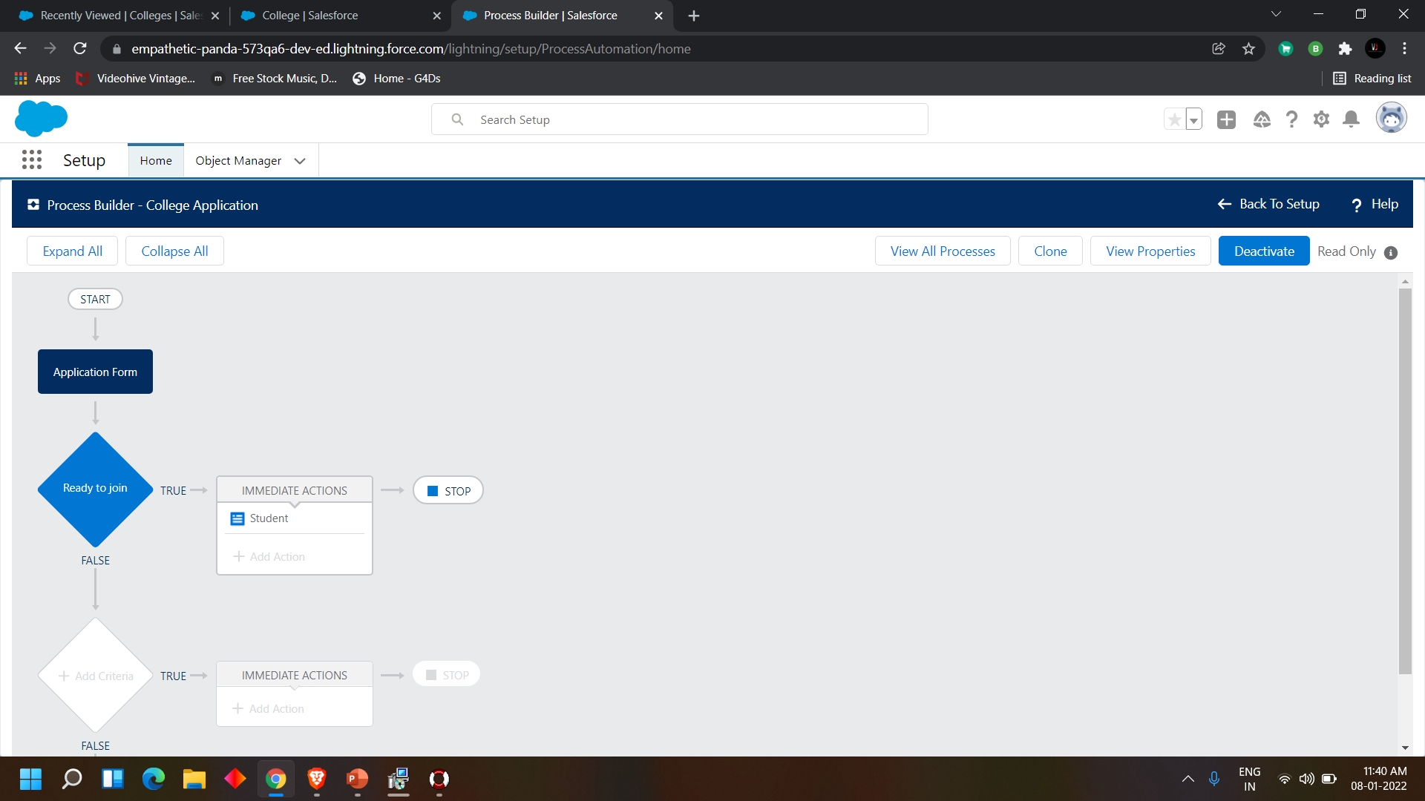

**DAY 6:**

**Topic: Milestone / Activities:** Create the student record using flow

### **Detailed Description:**

### Create the Student Record using Flow

**Skill Tags:**

**1. First deactivate the process builder which we created earlier.**

**2. Now search for flows and select new flow ->record triggered flow**

**3. For object select application form, in configure trigger select when the record is updated for entry criteria select as ready to join equals to true.**

**4. Now create a variable named student in the resource section.**

**5. Now add the assignment as follows.**

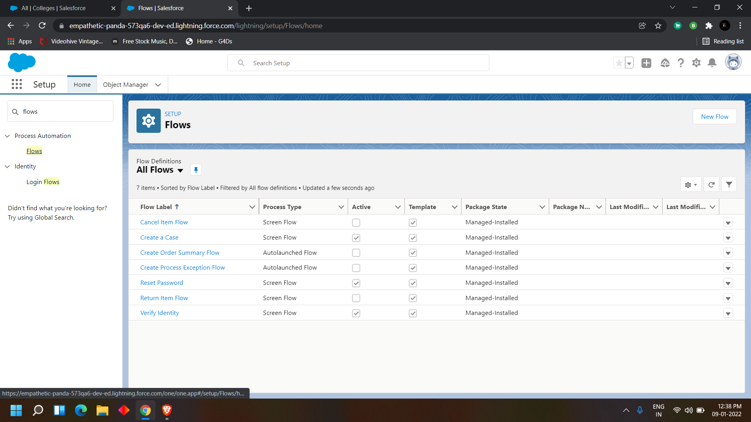

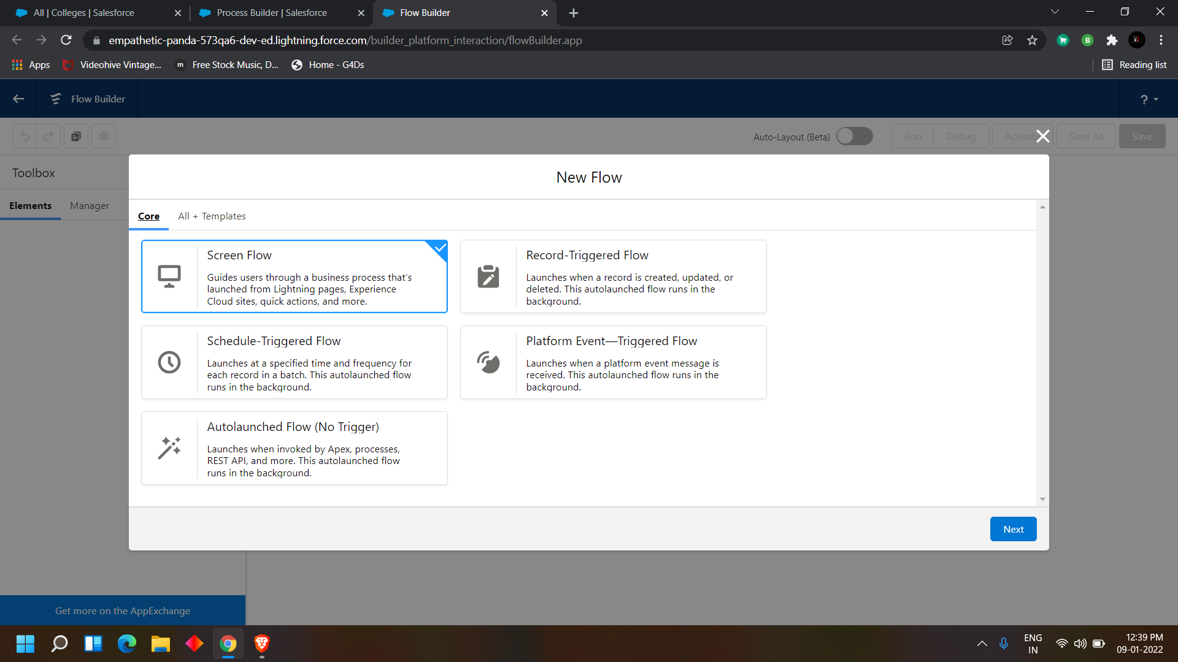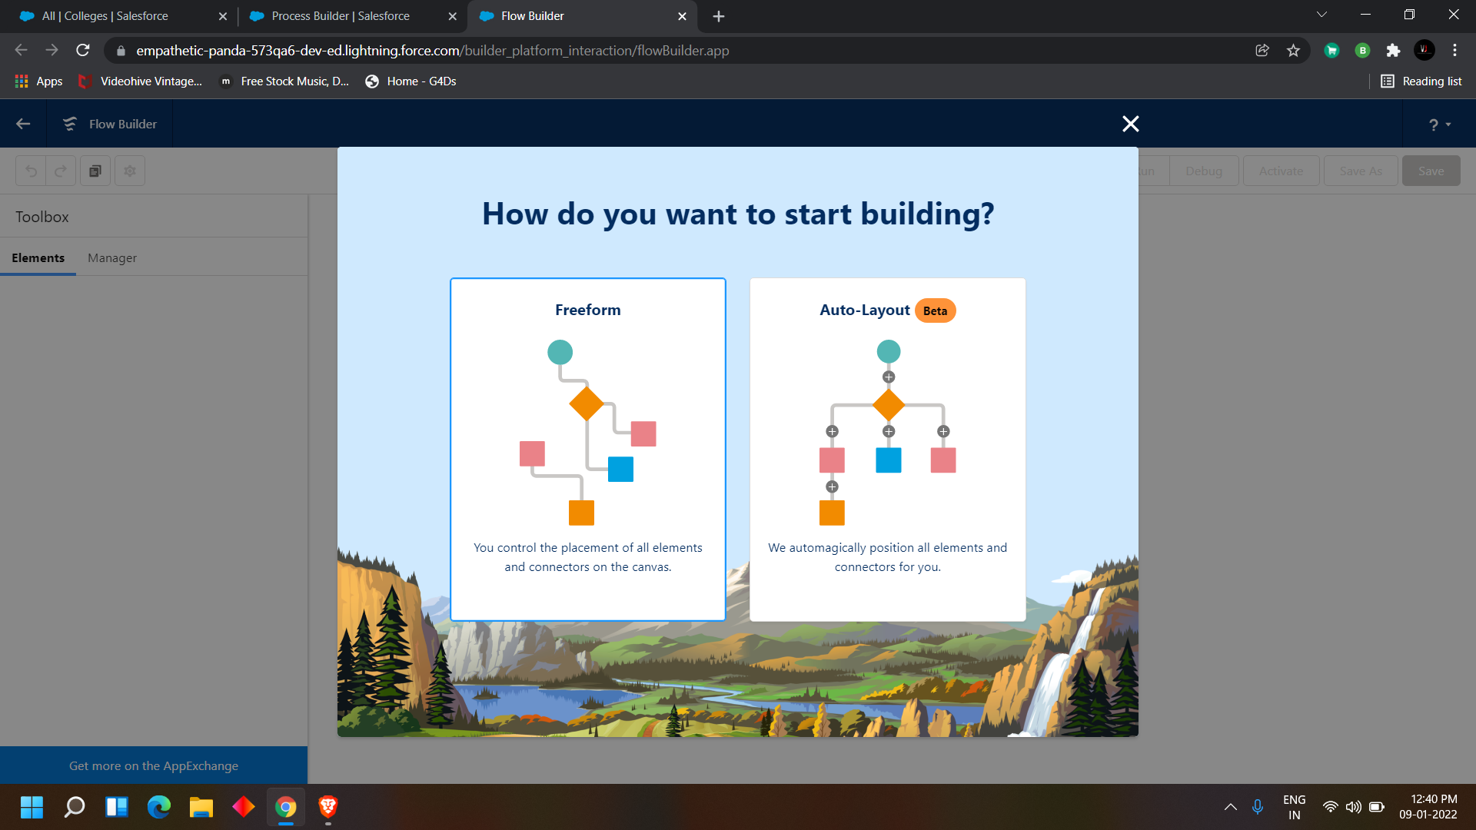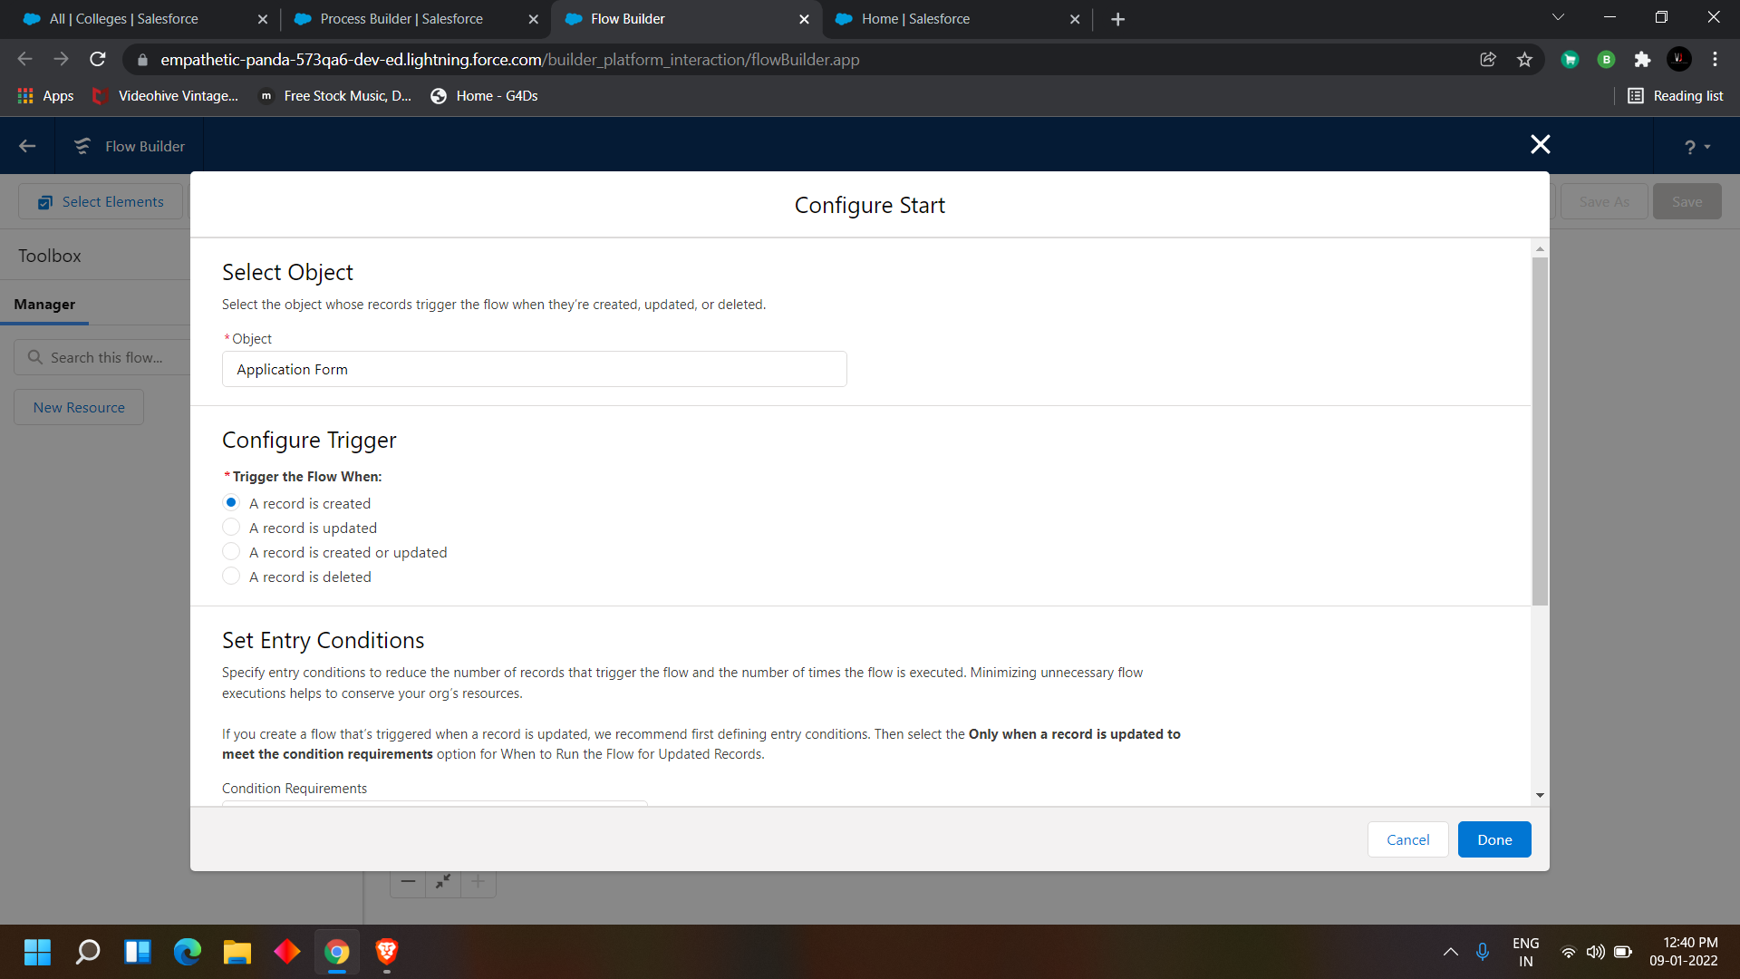

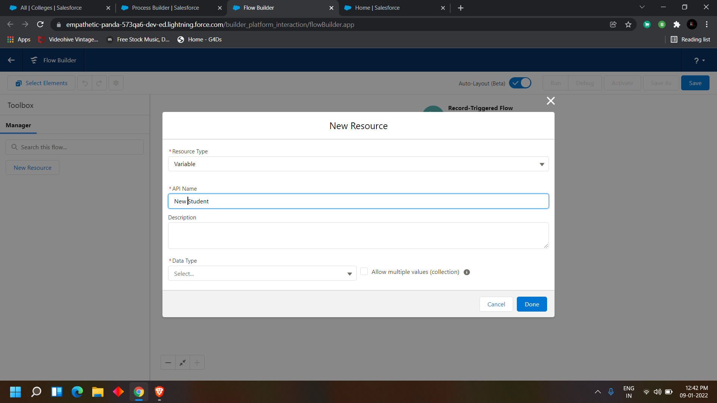

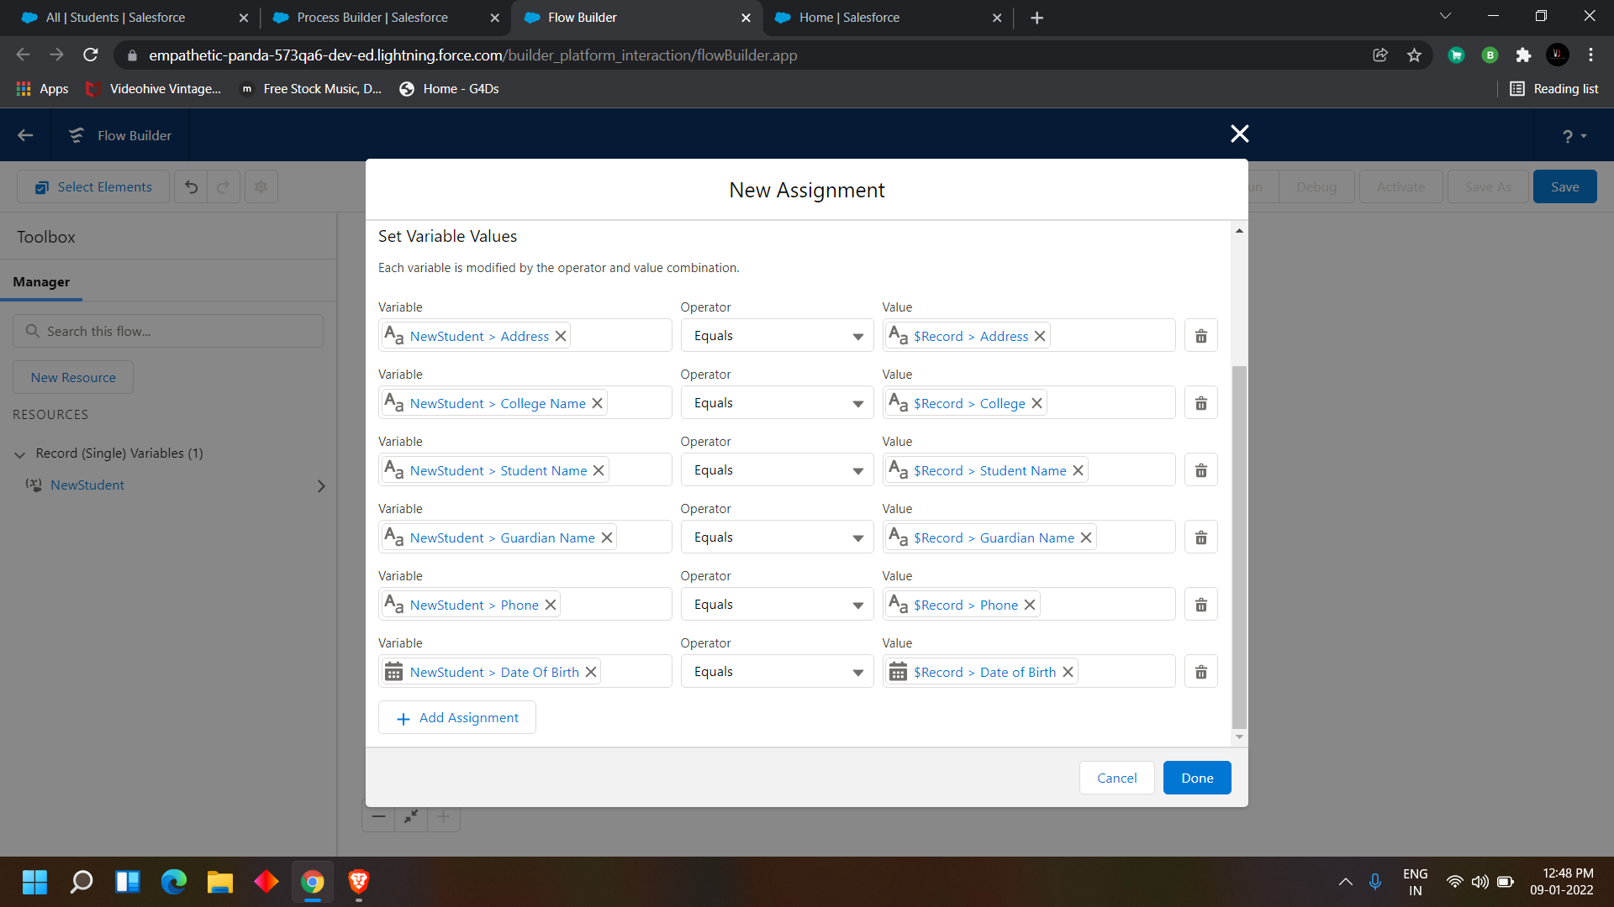

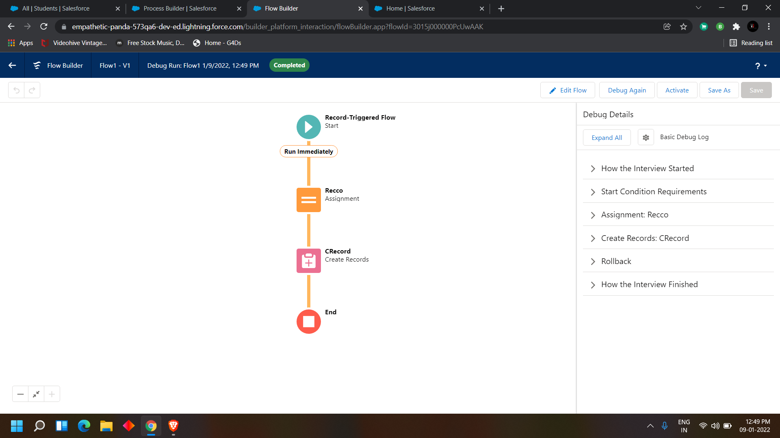

**DAY 7:**

**Topic: Milestone / Activities:** intro to Apex Programming

**Detailed Description:**

## What is Apex programming language?

* Apex is strongly typed object-oriented, on-demand programming language. It is compiled, stored, and run entirely on the Force.com platform (multi-tenant environment and is very controlled in its invocations and limits).
* Apex syntax looks mostly like Java and acts like stored procedures.
* Apex allows developers to attach business logic to the record save process
* Apex has built-in support for unit test creation and execution.

As a language apex is Integrated, Easy to use, Data focused, Rigorous, Hosted, Multi-tenant aware, automatically up-gradable, easy to test and versioned.

There are only two places you can write code in Salesforce:

1. [Sandbox](http://help.salesforce.com/help/doc/en/create_test_instance.htm) – most people will want to code here! Sandboxes are developer-friendly copies of your normal org and they’re [easy to create](http://help.salesforce.com/help/doc/en/data_sandbox_create.htm).
2. [Developer Edition](http://wiki.developerforce.com/page/Developer_Edition) – if you don’t have an instance of Salesforce to call home, you can practice here.

You can follow along in either version! If you want to eventually deploy into your normal “production” org though, you’ll want to use a sandbox.

To open up the trigger coding UI in either version, navigate here:

**Setup >> Customize >> Users >> Triggers >> New**

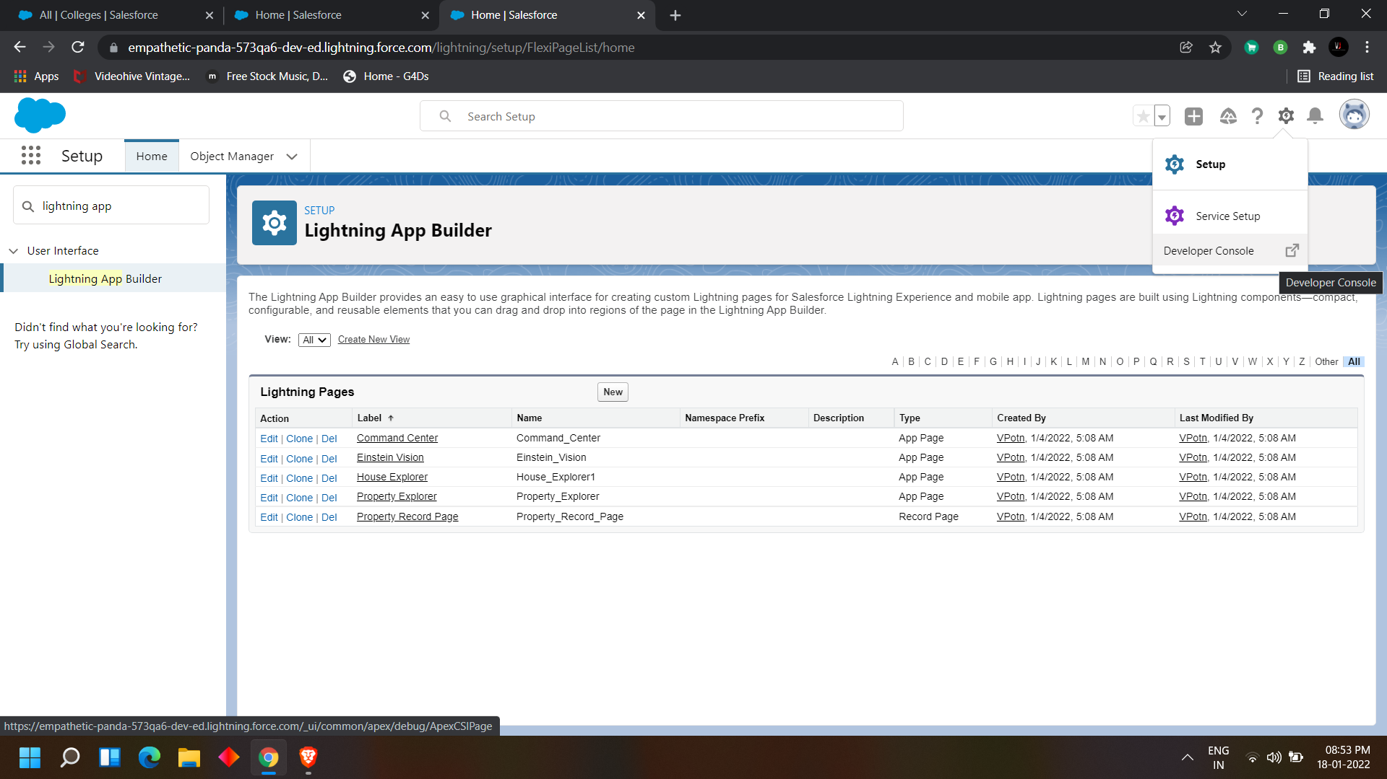

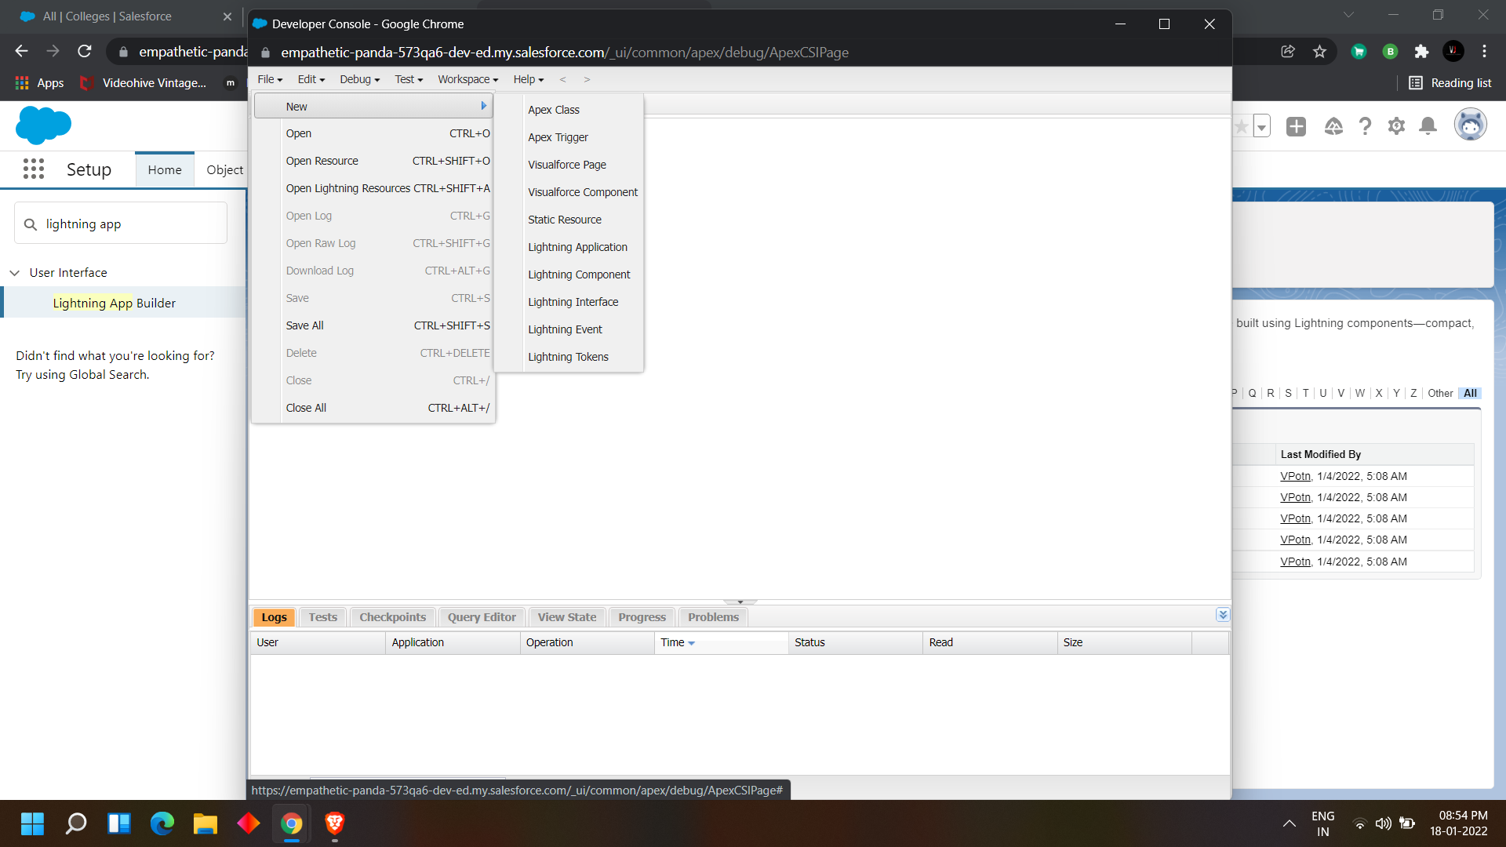

### What is the apex class and Triggers?

**Apex Classes:** It is a collection of variables and a library of methods that can be reused.

**Apex Trigger:** It is a script that executes before or after a specific data manipulation language (DML) event on a particular Salesforce object.

Apex should be used as a solution when:

* You need to apply complex business logic to rows of data being saved by any means.
* You need to create additional web services API functionality for exposing logic either within Salesforce or to external applications.
* You need to call out to external Web service and process the results.
* You need to handle incoming or outgoing emails in ways more complex than the declarative functionality.

Apex triggers execute no matter how the triggering data is being saved.

Apex executes regardless of whether the action originates in the user interface, through AJAX toolkit, or from web services API.

## Primitive Type Keyword

Below are the primitive data type keywords used in apex langue to declare variables.

### 1. Blob

This data type represents binary data stored as a single object.

Example

Blob b1 = Blob.valueof('idea');

### 2. Boolean

This data type represents Value that can only be assigned true, false, or null.  
Example:

Boolean isvar = true;

### 3. Date

This data type represents particular day.  
Example:

Date myDateVar = Date.today();  
Date weekStart = myDateVar.toStartofWeek();

### 4. Datetime

This data type represents particular time and date.

Example:

Datetime myDateTimeVar = Datetime.now();  
Datetime newd = myDateTimeVar. addMonths(5);

### 5. Decimal

This data type represents Number that includes a decimal  
point. Decimal is an arbitrary precision number.

Example:

Decimal myVar = 12.4567;  
Decimal divDecVar = myVar.divide(7, 2, System.RoundingMode.UP);  
system.assertEquals(divDecVar,1.78);

### 6. Double

Represents 64-bit number that includes a decimal point. Minimum value -2^63. Maximum value of 2^63-1.

Example:

Double d=3.14159;

### 7. ID

Represents 18-character Force.com record identifier.  
Example:

ID id='00300000003T2PGAA0';

### 8. Integer

32-bit number that doesn’t include a decimal point. Minimum value  
-2,147,483,648 — maximum value of 2,147,483,647

Example:

Integer i = 1;

### 9. Long

Represents 64-bit number that doesn’t include a decimal point. minimum value of -263 — maximum value of 263-1.

Example:

Long l = 2147483648L;

### 10. String

Represents Set of characters surrounded by single quotes.

Example:

String s1 = 'Hello';

### 11. Time

Represents particular time.  
Example:

Time myTimeVar = Time.newInstance(18, 30, 2, 20);  
Integer myMinutes = myTimeVar.  
minute();

## List Type Keywords

Below are the Collection Type keyword used in Apex:

### 1. List

Ordered collection of typed primitives, sObjects, objects, or collections that are distinguished by their indices.

Example:

// Create an empty list of String  
List<String> my_list = new List<String>();  
My_list.add('first');  
String x = my_list.get(0);  
// Create list of records from a query  
List<Account> accs = [SELECT Id, Name FROM Account LIMIT 1000];

### 2. Map

Collection of key-value pairs where each unique key maps to a single value. Keys can be any primitive data type, while values can be a primitive, sObject,  
collection type, or an object.

Example:

Map<String, String> mys = new Map<String,String>();  
Map<String, String> mys = new Map<String,  
String>{'a' => 'b', 'c' => 'd'.toUpperCase()};  
Account myAcct = new Account();  
Map<Integer, Account> m = new  
Map<Integer, Account>();  
m.put(1, myAcct);

### 3. Set

Unordered collection that doesn’t contain any duplicate elements.

Example:

Set<Integer> s = new Set<Integer>();  
s.add(1);  
s.add(1);  
System.assert(s.size()==1);

**DAY 8:**

**Topic: Milestone / Activities:** Create a apex batch class

### Detailed Description:

1--> Created A Batchapex For Application Form  
  
 In developer console we created apex class with class name as ApplicationBatchTest. Apex Batch Class consists three methods called

1. From the developer console create a new apex class and enter the following code.

Public class ApplicationBatchTest implements Database.Batchable<sObject>{

//start(), execute(). finish()

public Integer totalForms = 0; // total no of application form

public Integer totalConvertedForms = 0; // total no of students

public Database.QueryLocator start(Database.BatchableContext bc){

// gathers the data for you

String applicationQuery = 'select id, Name, Ready_To_Join__c from ApplicationForm__c';

return Database.getQueryLocator(applicationQuery);

}

public void execute(Database.BatchableContext bc, List<ApplicationForm__c> formList){

// process the data

for(ApplicationForm__c af : formList){

totalForms++;

if(af.Ready_To_Join__c){

totalConvertedForms++;

}

}

}

public void finish(Database.BatchableContext bc){

// emails ,

Messaging.SingleEmailMessage mail = new Messaging.SingleEmailMessage();

// address, subject, content( data to sent to admins)

mail.setSubject(' Application form and student record data as of today ');

mail.setPlainTextBody(' Total no of application form records are : '+totalForms+ ' out of which no of students as per today : '+totalConvertedForms);

String[] emailAddess = new String[]{'your email address'};

mail.setToAddresses(emailAddess);

Messaging.sendEmail(new Messaging.SingleEmailMessage[]{ mail } );

}

}

1-->start()  
 2-->execute()  
 3-->finish()  
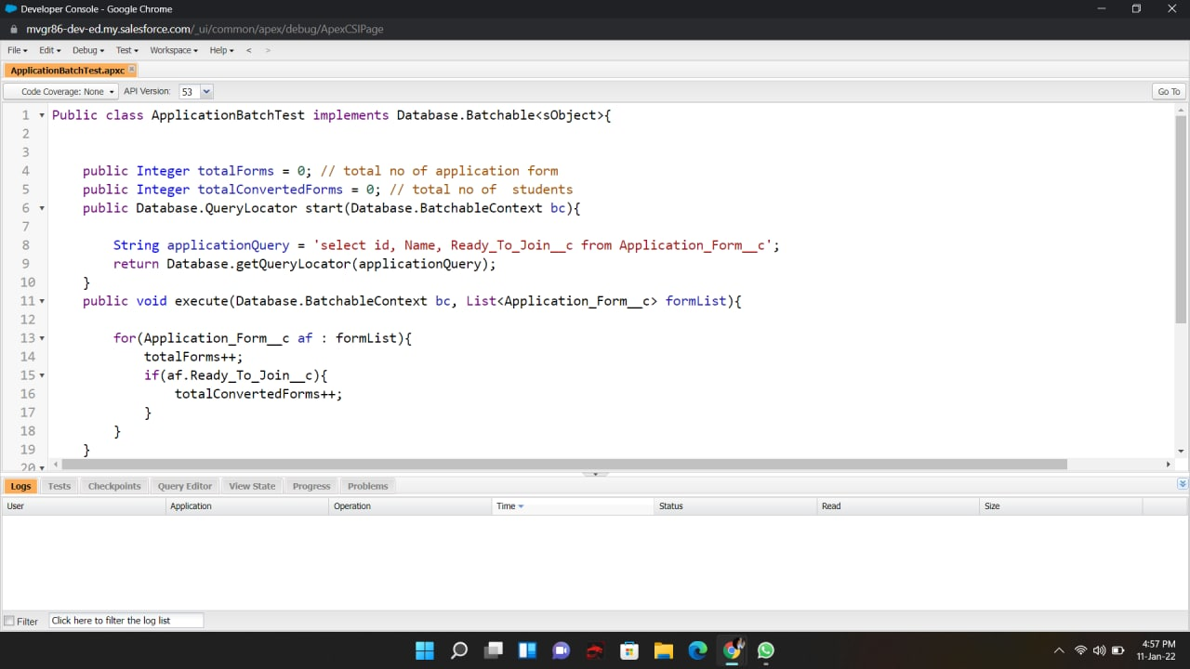

2--> Created a Scheduler Class in the developer class

From the developer console create a new apex class and enter the following code.

public class applicationschedule implements Schedulable{

public void execute(SchedulableContext sc){

ApplicationBatchTest abt = new ApplicationBatchTest();

Database.executeBatch(abt, 400); // 200 to 2000

}

}

From setup search for apex class and click on schedule jobs and fill the details as per your requirements.

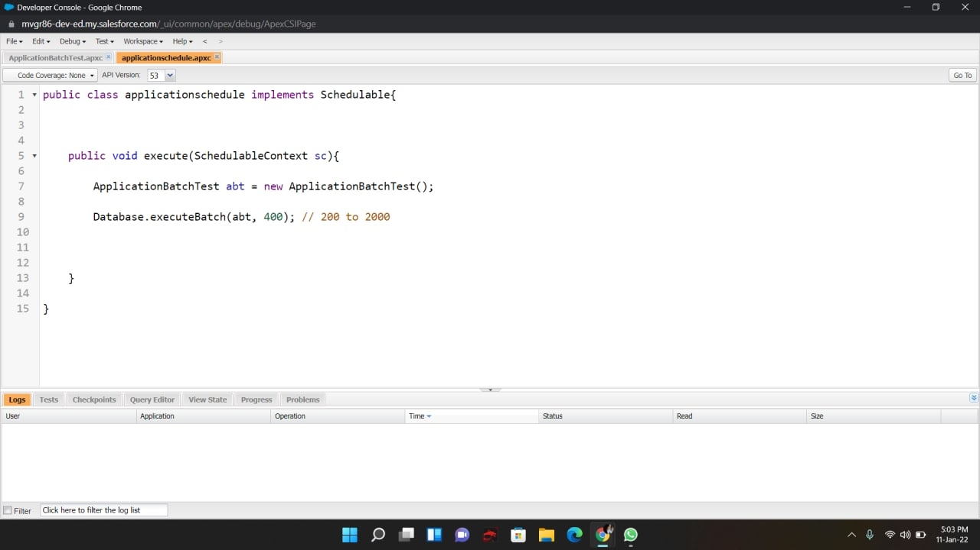  
  
Then went to Setup and searched for Apex Classes and click on Schedule Apex to schedule a Apex Class according to our requirements. After scheduling this scheduled class will be visible in Apex Jobs.

**DAY 9:**

**Topic: Milestone / Activities:** overview of LWC and installation of visual studio

### **Detailed Description:**

### Lightning Web Components

Lightning Web Components (LWC) is a stack of modern lightweight frameworks built on the latest web standards. It is a DOM (Document Object Model), element created through reusable code and is used to generate a dynamic interface without using JavaScript or building a Library. This feasibility makes it quick and seamless, saving the developers a ton of time and effort on the Web Stack. Let’s look at some of its remarkable features:

* Improved performance of the component as most of the code is recognized by the native web browser engine and web stack
* Ability to compose applications using smaller chunks of code since the crucial elements that are required to create a component is part of the native web browser engine and web stack
* Increase in the robustness of the applications built using LWCs as they are inclusive of the said modern web standards.
* Parallel interoperability and feasibility to use both Lightning Web Components and Aura components together in the applications with no visible differentiation to the end-users
* **Create College DataTable Component( APEX CLASS)**
* **Create College DataTable Component (HTML FILE)**
* **Create College DataTable Component(JAVA SCRIPT FILE)**
* **Create College DataTable Component(META FILE)**

Before going into this

we need to install

#### Visual Studio

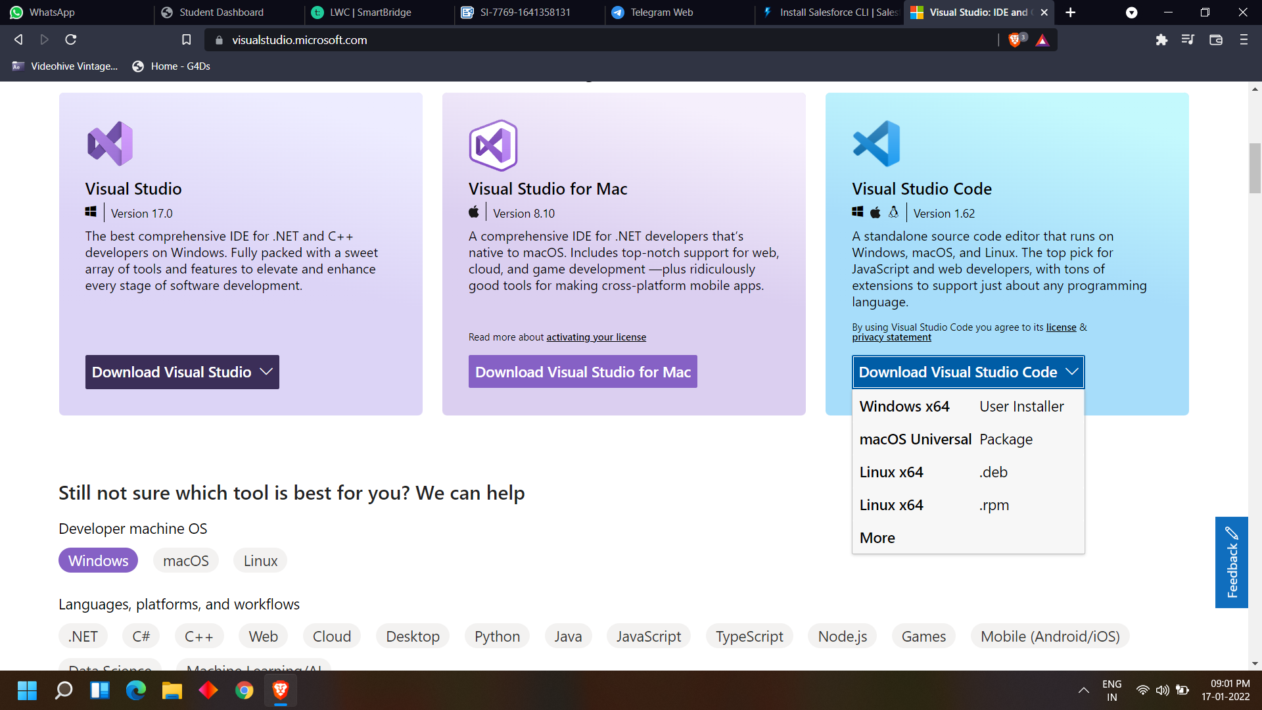

<https://visualstudio.microsoft.com/>

#### Salesforce LWS Editor

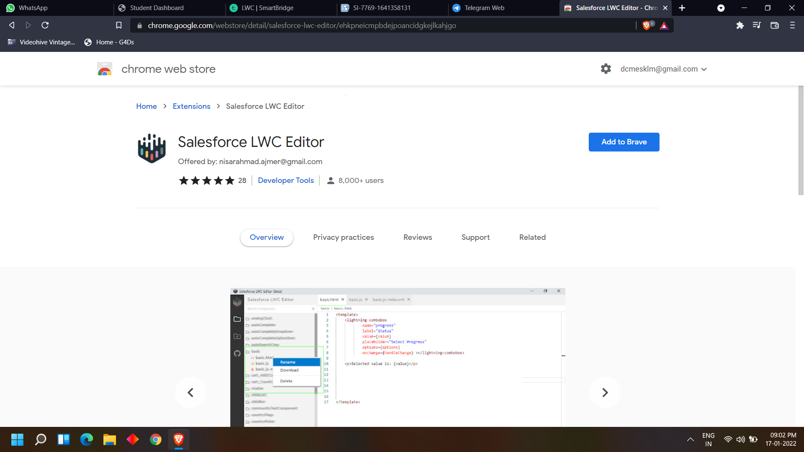

<https://chrome.google.com/webstore/detail/salesforce-lwc-editor/ehkpneicmpbdejpoancidgkejlkahjgo>

#### 

#### 

#### Install CLI

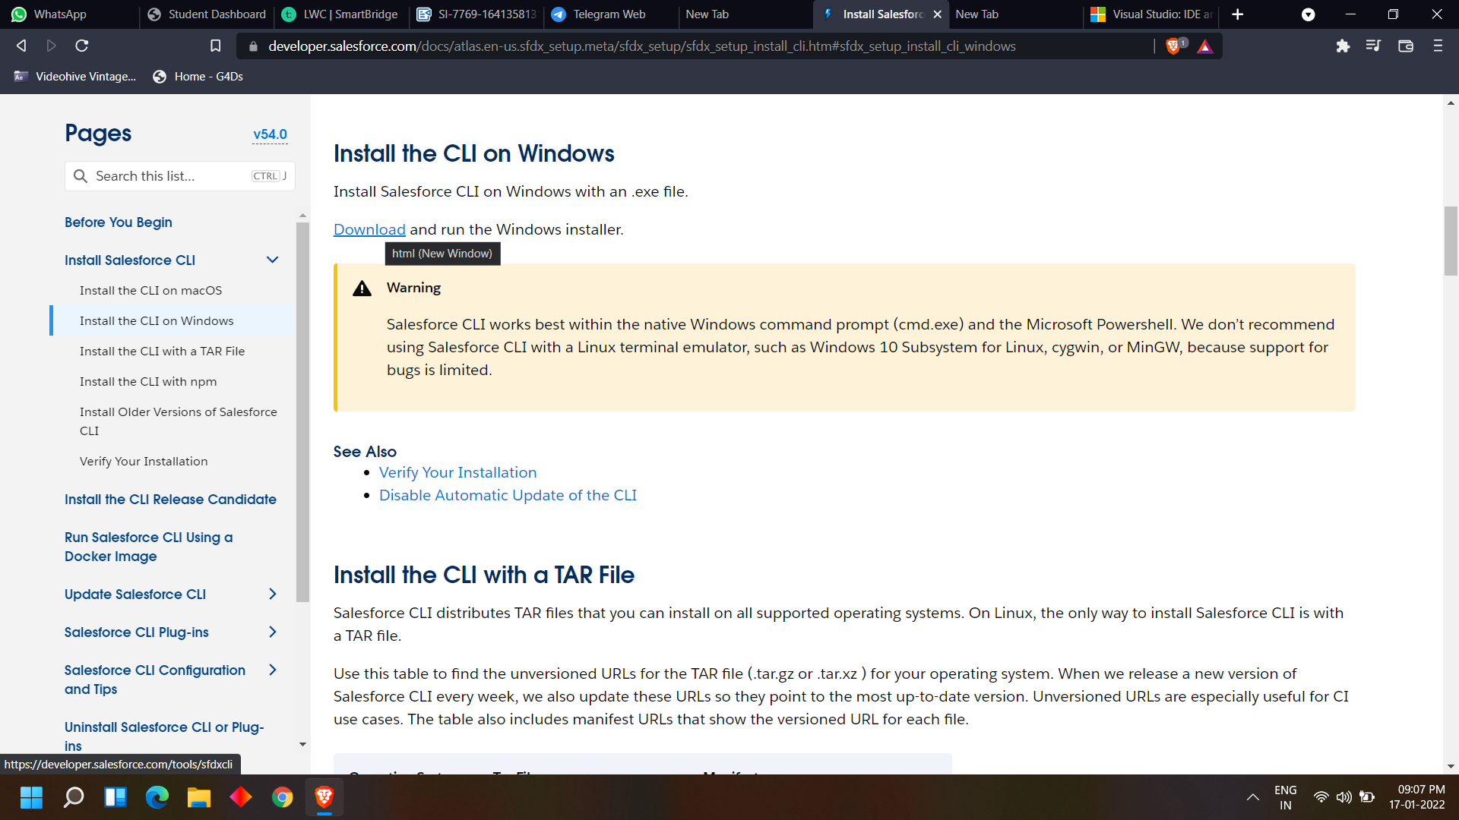

<https://developer.salesforce.com/docs/atlas.en-us.sfdx_setup.meta/sfdx_setup/sfdx_setup_install_cli.htm#sfdx_setup_install_cli_windows>

**DAY 10:**

**Topic: Milestone / Activities:** create college data table components(APEX CLASS,HTML FILE)

### Detailed Description:

### Create College DataTable Component( APEX CLASS)

Here we are going to create the college data table, for this we need to create an apex class, from which we are going to retrieve the data and Html, javascript files for UI .

Create an Apex Class With The Required Functionality

public class GetapplicationDetails

{

@AuraEnabled(cacheable=true)

public static List<ApplicationForm__c> getapplicationvalues(id CollegeId)

{

List<ApplicationForm__c> formlist = [SELECT ID, College_Fees__c,Name,

Date_Of_Birth__c,Email__c,Hostel_Fees__c, Student_Name__c FROM

ApplicationForm__c WHERE College__c =:CollegeId];

return formList;

}

}

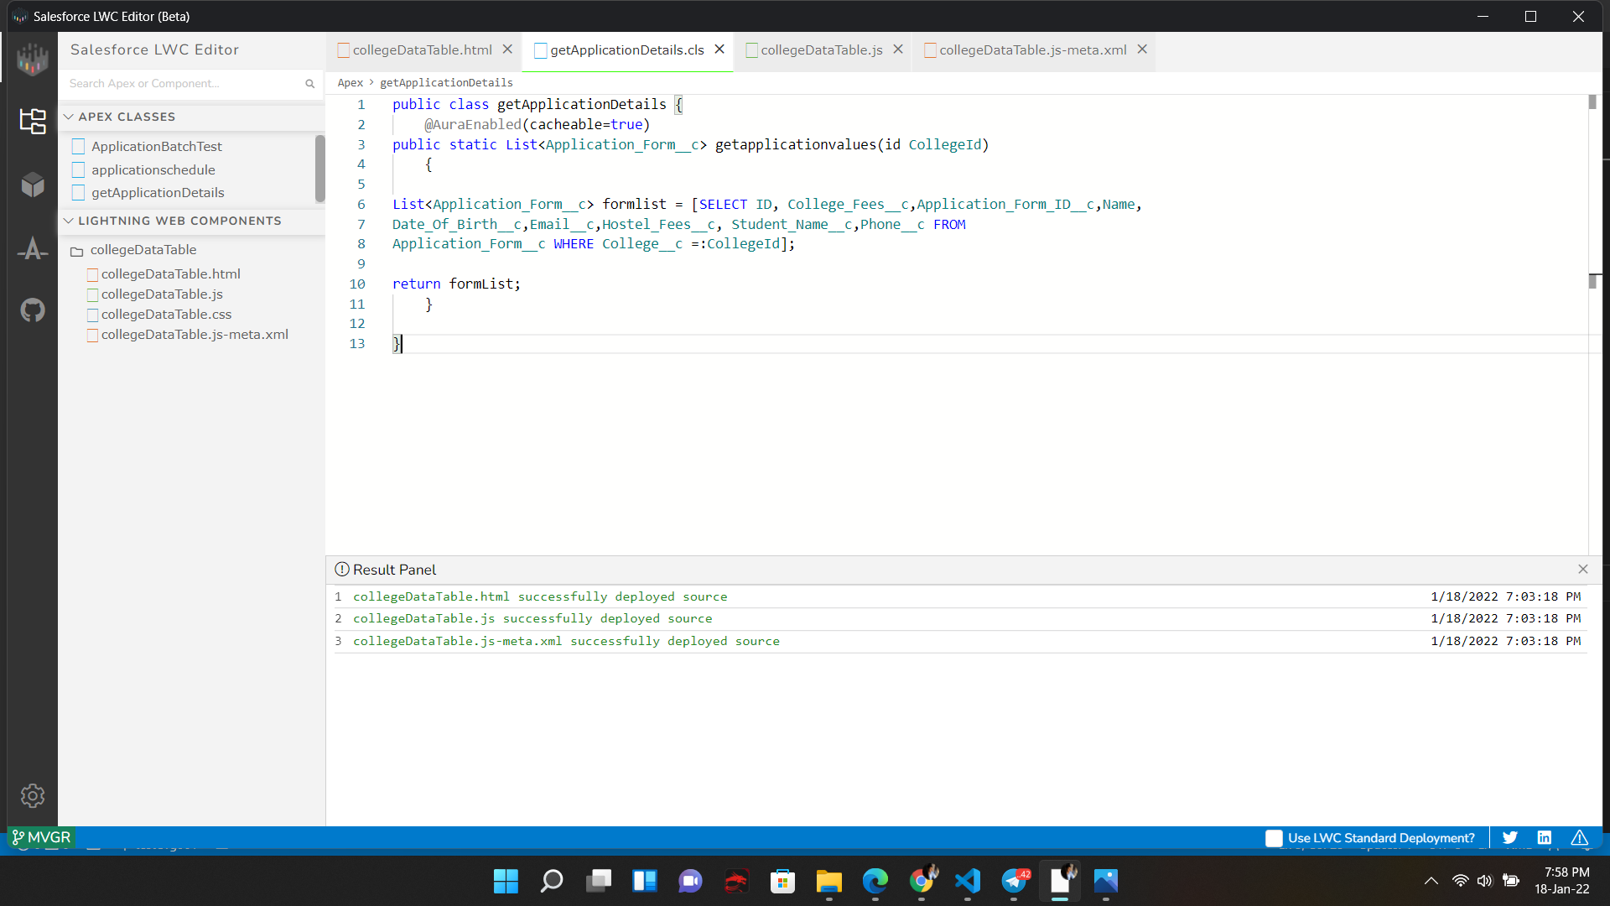

### Create College DataTable Component (HTML FILE)

Create the component with the following files.

HTML:

<template>

<h1> College and Application form list table </h1>

<template if:true={recordList}>

<lightning-datatable

key-field="id"

data={recordList}

show-row-number-column

hide-checkbox-column

columns={columnsList}

>

</lightning-datatable>

</template>

<template if:true={error}>

{error}

</template>

</template>

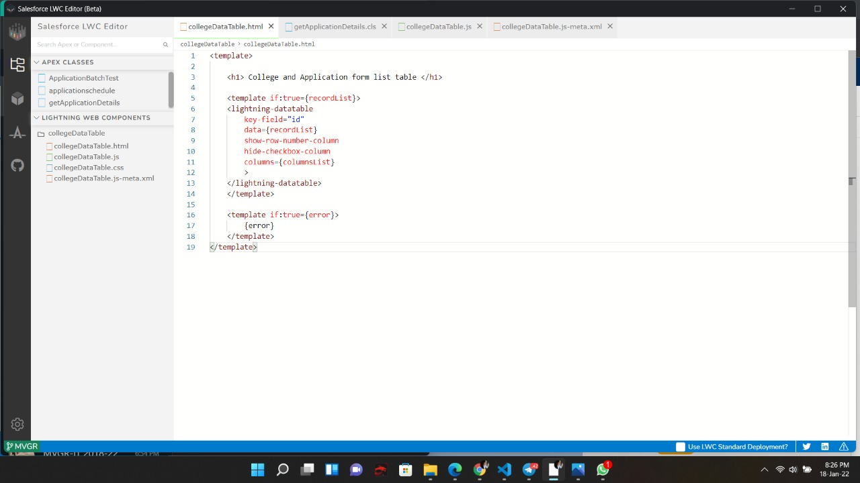

**DAY 11:**

**Topic: Milestone / Activities:** create college data table components(JAVA SCRIPT FILE,XML FILE)

**Detailed Description:**

### Create College DataTable Component(JAVA SCRIPT FILE)

After the creation of the Html file create the following js file

import { LightningElement, api, wire } from 'lwc';

import getapplicationvalues

from'@salesforce/apex/GetapplicationDetails.getapplicationvalues';

export default class CollegeDataTable extends LightningElement {

columnsList = [

{label : 'Application Form' , fieldName : 'Name', type:'text' },

{label : 'College Fees' , fieldName : 'College_Fees__c', type:'currency' },

{label : 'Date Of Birth' , fieldName : 'Date_Of_Birth__c', type:'date' },

{label : 'Email' , fieldName : 'Email__c', type:'email' },

{label : 'Hostel Fees' , fieldName : 'Hostel_Fees__c', type:'Currency' },

{label : 'StudentName' , fieldName : 'Student_Name__c', type:'text' }

];

@api recordId;

recordList;

error;

@wire(getapplicationvalues, {CollegeId : '$recordId'})

wiredCollegeData({data, error}){

if(data){

this.recordList = data;

}

else if(error){

this.error = error;

this.recordList = undefined;

}

}

}

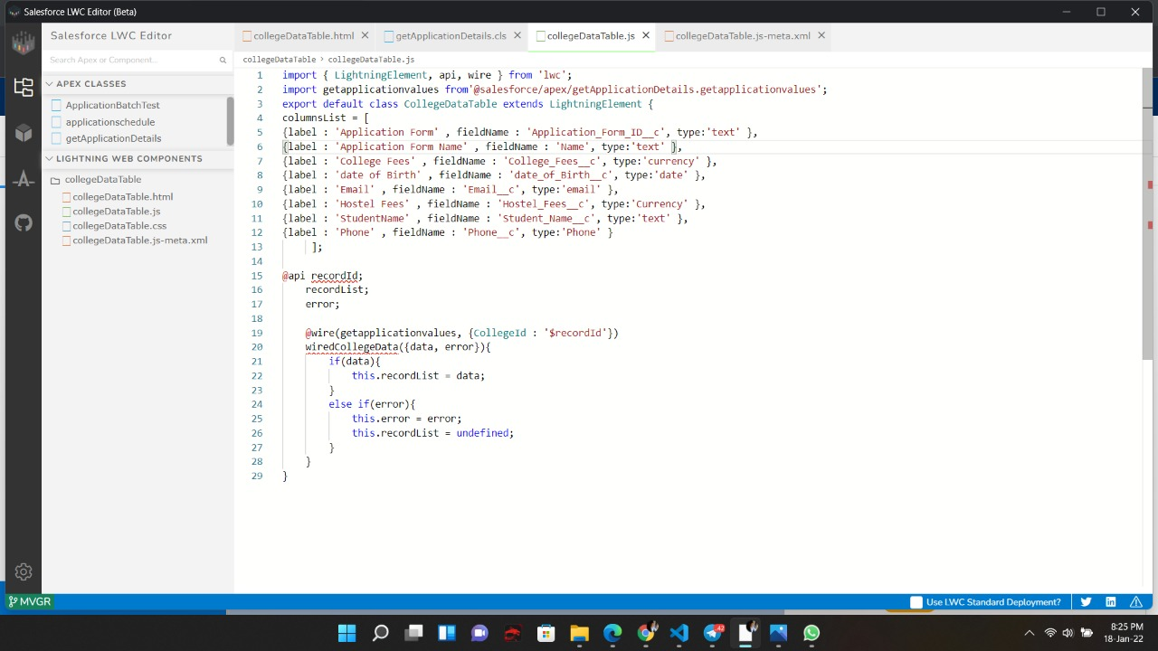

### Create College DataTable Component(META FILE)

Change the Meta File as follows:

<?xml version="1.0"?>

<LightningComponentBundle

xmlns="http://soap.sforce.com/2006/04/metadata">

<apiVersion>51.0</apiVersion>

<isExposed>true</isExposed>

<targets>

<target>lightning__RecordPage</target>

<target>lightning__AppPage</target>

<target>lightning__HomePage</target>

</targets>

</LightningComponentBundle>

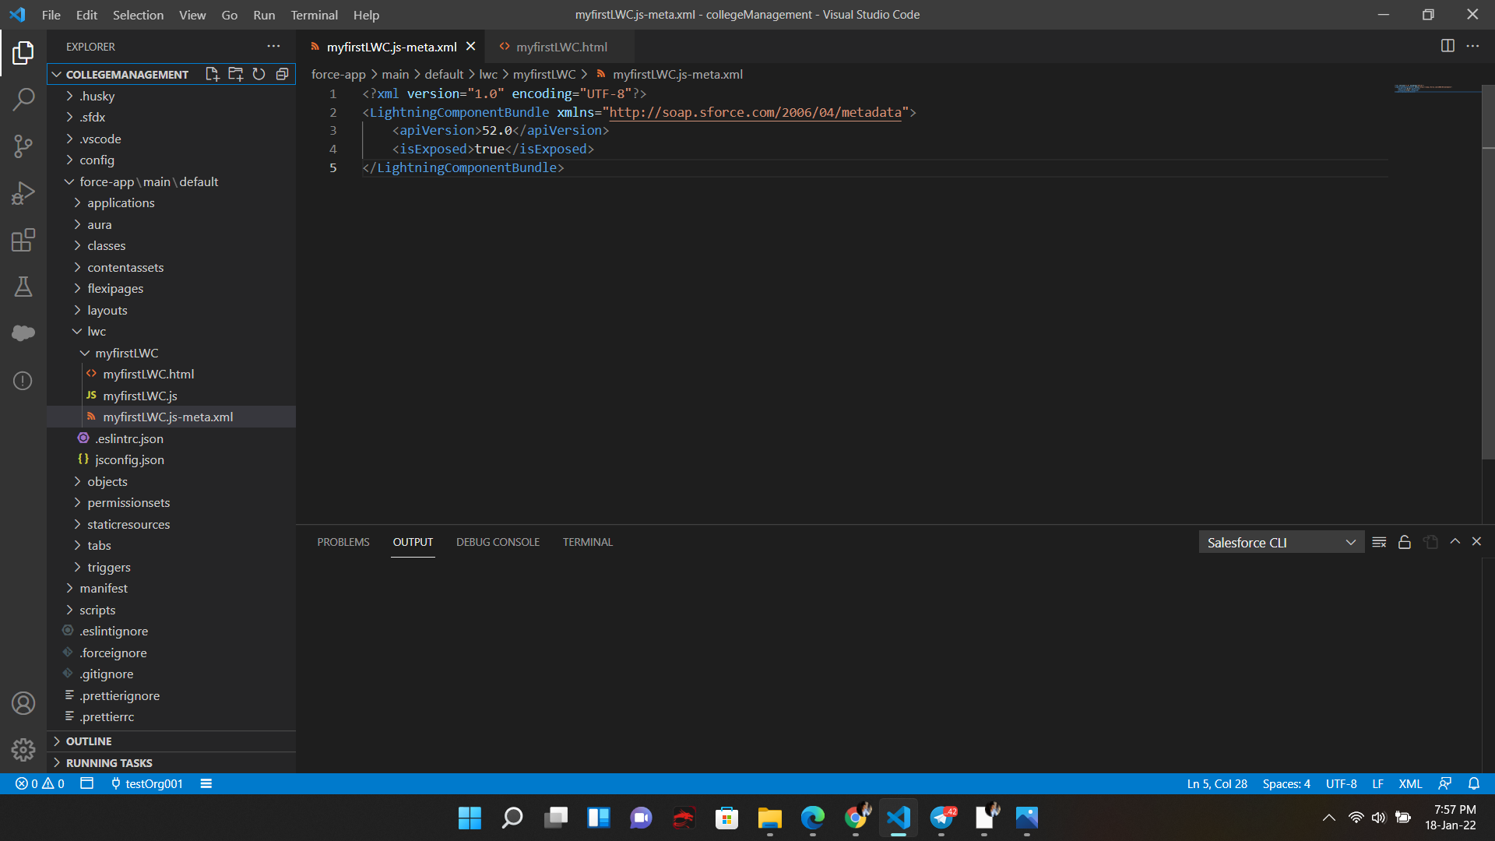

**DAY 12:**

**Topic: Milestone / Activities:** checking all the data in the college management application

**Detailed Description:**

As we have done all the tasks now we need to check in the college managment application app which we have created   
  
go to the college management application from the app launcher

now--->

click edit page then we have to create another tab for data table

And then drag the college data table in that tab

now you can see the data table in the

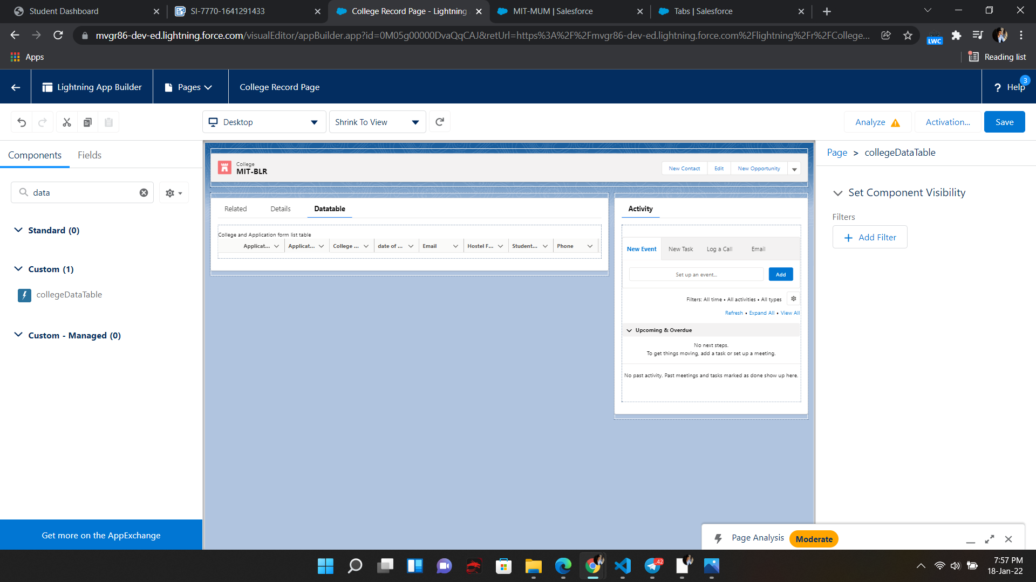

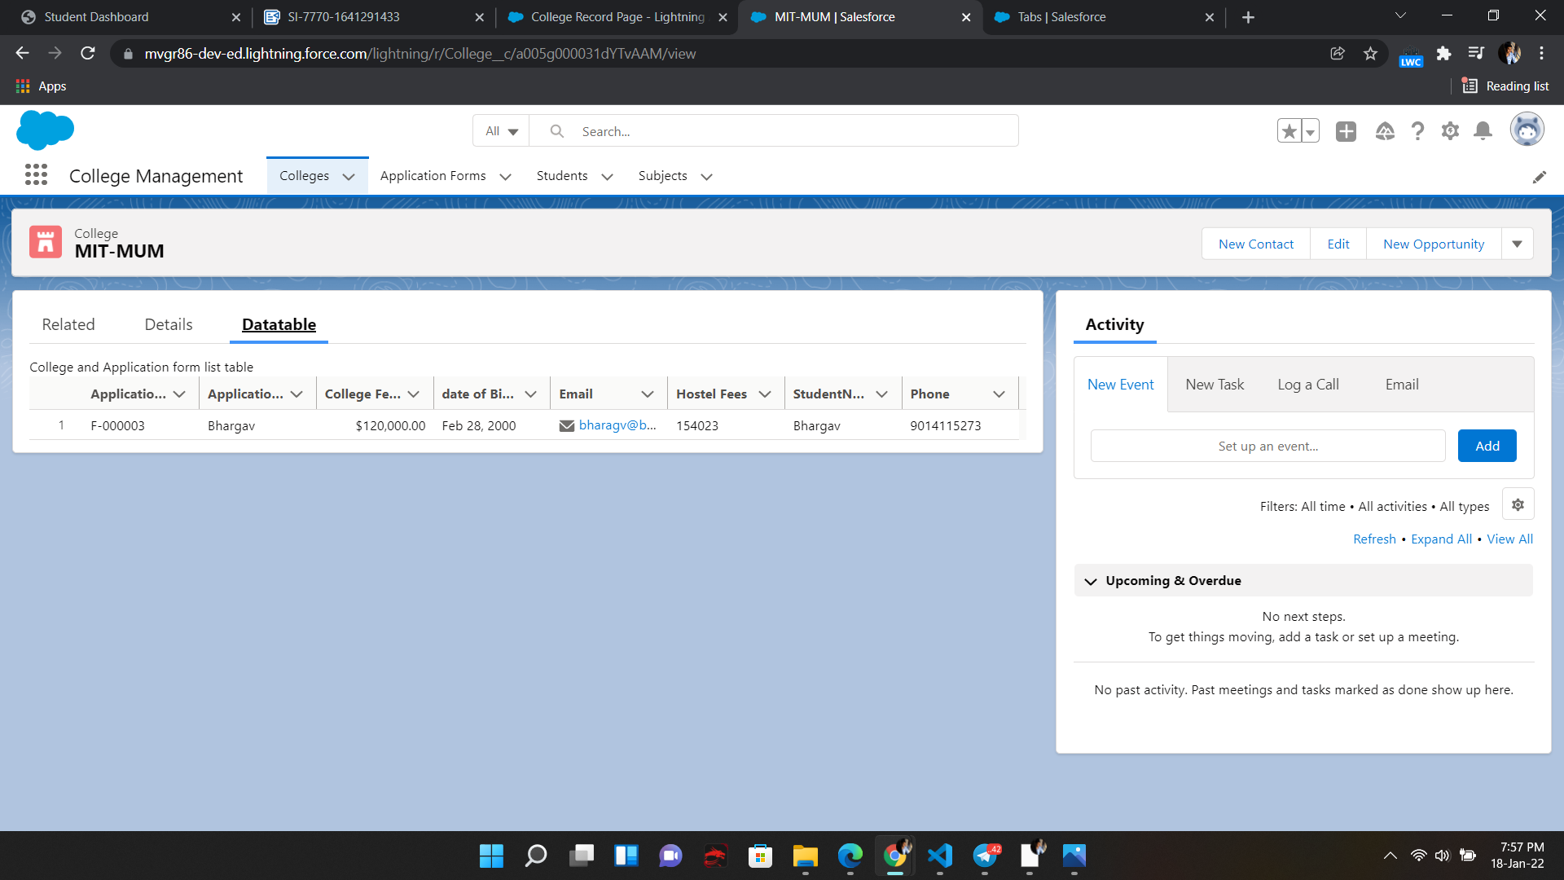

here we can see the details of the applicant with all his personal details which are given when

registered